# UNIVERSITY OF PATRAS

**DEPARTMENT OF ELECTRICAL AND COMPUTER**

**ENGINEERING**

**DIVISION of electronics and computers (PC)**

**INTERACTIVE TECHNOLOGIES LABORATORY**



**Design and Development of a Location-Based Customer support application for Supermarkets**

**D I P L O M A T H E S I S**

## PANAGIOTIS ARVANITIS

**SUPERVISOR: NIKOLAOS AVOURIS**

**PATRAS –2024**

University of Patras, Department of Electrical and Computer Engineering.

Panagiotis Arvanitis

© 2024 – All rights reserved

The whole work is an original work, produced by Panagiotis Arvanitis, and does not violate the rights of third parties in any way. If the work contains material which has not been produced by him/her, this is clearly visible and is explicitly mentioned in the text of the work as a product of a third party, noting in a similarly clear way his/her identification data, while at the same time confirming that in case of using original graphics representations, images, graphs, etc., has obtained the unrestricted permission of the copyright holder for the inclusion and subsequent publication of this material.

# ABSTRACT

**Design and Development of a Location-Based Customer support application for Supermarkets**

|  |  |
| --- | --- |
| **STUDENT NAME, SURNAME:**  **ARVANITIS PANAGIOTIS** | **SUPERVISOR NAME, SURNAME:**  **AVOURIS NIKOLAOS** |

The subject of this thesis was the development and design of a location-based customer support application for supermarkets. The application aims to enhance customer experience by providing real-time assistance and personalized shopping recommendations. Customers can input their shopping list, and based on various factors such as weather, distance, means of transport, cost at each supermarket, and time of day, an AI model recommends the optimal supermarket for their shopping. The system integrates geolocation technologies to provide accurate guidance and suggestions, improving the overall shopping experience.

Key technologies used in the implementation include React and Bootstrap for the front end, offering a responsive and dynamic user interface. React's component-based architecture and Bootstrap's pre-designed components facilitate efficient UI development. Vite was used as the build tool for its fast development server and optimized build process. Node.js and Express power the backend, providing a robust and scalable server environment. Flask is employed alongside scikit-learn for the AI recommendation system, with the GradientBoostingRegressor algorithm implemented in Jupyter notebooks to handle the recommendation logic. Flask's lightweight framework and scikit-learn's extensive machine learning tools ensure efficient and effective AI model deployment.

Testing scenarios demonstrate the application's effectiveness in offering tailored shopping advice, leading to improved customer satisfaction and operational efficiency. A usability study evaluates the application's performance, providing insights into user interaction and potential areas for enhancement. The findings suggest that the application significantly enhances the customer support experience, making it a valuable tool for modern retail environments.

Keywords: Location-Based Services, Customer Support, Supermarket Application, Geolocation, AI Recommendations, React, Bootstrap, Vite, Node.js, Express, Flask, scikit-learn, GradientBoostingRegressor, Jupyter Notebook, User Experience, Retail Technology, Mobile Application Development.

# ΕΚΤΕΤΑΜΕΝΗ ΕΛΛΗΝΙΚΗ ΠΕΡΙΛΗΨΗ

**Μελέτη συστήματος ανίχνευσης τηλεφωνικής απάτης σε πραγματικό χρόνο με τεχνολογία μηχανικής μάθησης**

**ΟΝΟΜΑΤΕΠΩΝΥΜΟ ΦΟΙΤΗΤΗ: ΟΝΟΜΑΤΕΠΩΝΥΜΟ ΕΠΙΒΛΕΠΟΝΤΟΣ:**

**ΑΡΒΑΝΙΤΗΣ ΠΑΝΑΓΙΩΤΗΣ ΑΒΟΥΡΗΣ ΝΙΚΟΛΑΟΣ**

Αντικείμενο της παρούσας διπλωματικής εργασίας ήταν η ανάπτυξη και ο σχεδιασμός μιας εφαρμογής υποστήριξης πελατών με βάση την τοποθεσία για σούπερ μάρκετ. Η εφαρμογή στοχεύει στη βελτίωση της εμπειρίας των πελατών παρέχοντας βοήθεια σε πραγματικό χρόνο και εξατομικευμένες προτάσεις αγορών. Οι πελάτες μπορούν να εισάγουν τη λίστα με τα ψώνια τους και με βάση διάφορους παράγοντες, όπως ο καιρός, η απόσταση, το μέσο μεταφοράς, το κόστος σε κάθε σούπερ μάρκετ και η ώρα της ημέρας, ένα μοντέλο τεχνητής νοημοσύνης συνιστά το βέλτιστο σούπερ μάρκετ για τα ψώνια τους. Το σύστημα ενσωματώνει τεχνολογίες γεωεντοπισμού για να παρέχει ακριβή καθοδήγηση και προτάσεις, βελτιώνοντας τη συνολική εμπειρία αγορών.

Οι βασικές τεχνολογίες που χρησιμοποιήθηκαν στην υλοποίηση περιλαμβάνουν το React και το Bootstrap για το front end, προσφέροντας μια ευέλικτη και δυναμική διεπαφή χρήστη. Η αρχιτεκτονική του React που βασίζεται σε συστατικά και τα προσχεδιασμένα συστατικά του Bootstrap διευκολύνουν την αποτελεσματική ανάπτυξη του UI. Το Vite χρησιμοποιήθηκε ως εργαλείο κατασκευής για τον γρήγορο διακομιστή ανάπτυξης και τη βελτιστοποιημένη διαδικασία κατασκευής. Το Node.js και η Express τροφοδοτούν το backend, παρέχοντας ένα στιβαρό και κλιμακούμενο περιβάλλον διακομιστή. Το Flask χρησιμοποιείται παράλληλα με το scikit-learn για το σύστημα συστάσεων AI, με τον αλγόριθμο GradientBoostingRegressor να υλοποιείται σε Jupyter Notebook για να χειριστεί τη λογική των συστάσεων. Το ελαφρύ framework του Flask και τα εκτεταμένα εργαλεία μηχανικής μάθησης του scikit-learn εξασφαλίζουν την αποδοτική και αποτελεσματική ανάπτυξη μοντέλων AI.

Τα σενάρια δοκιμών καταδεικνύουν την αποτελεσματικότητα της εφαρμογής στην παροχή εξατομικευμένων συμβουλών αγορών, οδηγώντας σε βελτιωμένη ικανοποίηση των πελατών και λειτουργική αποτελεσματικότητα. Μια μελέτη ευχρηστίας αξιολογεί την απόδοση της εφαρμογής, παρέχοντας πληροφορίες σχετικά με την αλληλεπίδραση των χρηστών και τους πιθανούς τομείς για βελτίωση. Τα ευρήματα υποδηλώνουν ότι η εφαρμογή βελτιώνει σημαντικά την εμπειρία υποστήριξης πελατών, καθιστώντας την πολύτιμο εργαλείο για σύγχρονα περιβάλλοντα λιανικής πώλησης.

Λέξεις-κλειδιά: Υπηρεσίες βάσει τοποθεσίας, Υποστήριξη πελατών, Εφαρμογή σούπερ μάρκετ, Γεωεντοπισμός, Συστάσεις AI, React, Bootstrap, Vite, Node.js, Express, Flask, scikit-learn, GradientBoostingRegressor, Jupyter Notebook, Εμπειρία χρήστη, Τεχνολογία λιανικής, Ανάπτυξη εφαρμογών για κινητά.

# ACKNOWLEDGEMENTS

With the completion of this dissertation, I conclude my studies at the University of Patras. I would like to express my deepest gratitude to my supervisor, Mr. Nikolaos Avouris, for his invaluable support and guidance throughout this journey. His insights and expertise were crucial in navigating the challenges I encountered, and I am sincerely thankful for his continuous encouragement.

I would also like to extend my heartfelt thanks to my parents, girlfriend, and friends. Their unwavering support, belief in me, and constant presence by my side were instrumental in my success.

# Table Of Contents

Table Of Figures ....................................................................................................................... 14

1. Introduction ......................................................................................................................... 17
2. Analysis of the problem under research ............................................................................. 18
   1. Vishing attacks and methods ........................................................................................ 18
      1. Typical Vishing Attack Examples ............................................................................. 20
   2. Current Approaches and Emerging Frontiers in Vishing Detection .............................. 20
   3. Why Real-Time In-Call Detection Is Essential ............................................................... 21
   4. Addressing the Identified Problem ............................................................................... 22
3. PySpark ................................................................................................................................ 23
   1. Apache Spark Fundamentals ........................................................................................ 23
      1. Spark Architecture .................................................................................................. 23
      2. Spark Components ................................................................................................. 24
      3. Spark Core .............................................................................................................. 24
         1. Resilient Distributed Dataset ........................................................................... 24
   2. Spark SQL ...................................................................................................................... 25
   3. Spark’s Machine Learning Package ............................................................................... 26
      1. Spark MLlib ......................................................................................................... 26
      2. Spark ML ............................................................................................................. 27
         1. Machine Learning Pipelines API .................................................................. 27
         2. Spark ML Model Tuning ............................................................................... 28
   4. Spark Structured Streaming .......................................................................................... 29
4. Speech-To-Text .................................................................................................................... 30
   1. Technology Analysis ...................................................................................................... 30
   2. Google Speech-To-Text API .......................................................................................... 31
5. Dataset Creation .................................................................................................................. 33
   1. Generative Pretrained Transformers ............................................................................ 33
      1. Transformers .......................................................................................................... 33
      2. Generative Pretrained Transformers ..................................................................... 34
         1. Utilizing GPT for Dataset Generation .............................................................. 34
   2. Data Generation with Chat GPT API ............................................................................. 35
      1. API Overview .......................................................................................................... 35
      2. Prompt Engineering ................................................................................................ 35
      3. Data Collection Strategy ......................................................................................... 36
      4. Data Quality and Future Improvements ................................................................. 37
   3. Dataset Preparation ...................................................................................................... 38
   4. Final Labelling Process .................................................................................................. 39
6. Dataset Preprocessing ......................................................................................................... 40
   1. Initial Preprocessing ...................................................................................................... 40
      1. Numeric Character Replacement ........................................................................... 40
      2. Special Character Removal ..................................................................................... 40
      3. Tokenization ........................................................................................................... 41
      4. Stemming ................................................................................................................ 42
   2. Preprocessing Pipeline for Model Training ................................................................... 43
      1. Flatten Transformer................................................................................................ 43
      2. TF-IDF ...................................................................................................................... 44
         1. HashingTF Transformer ................................................................................... 44
         2. IDF Transformer ............................................................................................... 45
      3. Vector Assembler Transformer .............................................................................. 45
   3. Preprocessing Pipeline for Deployment ....................................................................... 46
7. Model Architecture – Training – Tuning .............................................................................. 47
   1. Machine Learning Basics ............................................................................................... 47
   2. Pre-Modeling Considerations ....................................................................................... 48
      1. Overfitting .............................................................................................................. 49
      2. Cross-Validation ...................................................................................................... 51
      3. Model Evaluation Metrics ...................................................................................... 51
      4. Optimizers .............................................................................................................. 52
   3. Model Architecture ....................................................................................................... 53
      1. Logistic Regression ................................................................................................. 53
      2. Support Vector Machine ........................................................................................ 55
      3. Random Forest ....................................................................................................... 56
         1. Decision Trees ............................................................................................. 56
      4. Gradient Boosted Trees .......................................................................................... 58
      5. Neural Networks ..................................................................................................... 59
         1. LSTM Neural Networks .................................................................................... 64
   4. Model Training - Tuning – Results ................................................................................ 66
      1. Logistic Regression ................................................................................................. 66
      2. Random Forest ....................................................................................................... 67
      3. Support Vector Machines ....................................................................................... 68
      4. Gradient Boosted Trees .......................................................................................... 69
      5. Neural Network ...................................................................................................... 70
      6. LSTM Neural Network ............................................................................................ 72
      7. Overall Results ........................................................................................................ 75
8. Overall System Functionality ............................................................................................... 76
   1. Stage One ...................................................................................................................... 76
   2. Stage Two...................................................................................................................... 77
   3. Stage Three ................................................................................................................... 78
   4. Challenges and Future Enhancements ......................................................................... 78
9. Experimental Results ........................................................................................................... 80
   1. Model Performance on Familiar 'Vishing' Conversation .............................................. 81
   2. Model Performance on Unknown ‘Vishing’ Conversation ........................................... 82
   3. Model Performance on Familiar ‘Normal’ Conversation .............................................. 84
   4. Model Performance on Unknown ‘Normal’ Conversation ........................................... 85
   5. Response Time Performance Evaluation ...................................................................... 86
   6. Overall Results .............................................................................................................. 86
10. Deductions, Limitations and Future Research................................................................... 88

Bibliography ............................................................................................................................ 89

# Table Of Figures

Fig 1: Mobile Phone Phishing Attack ....................................................................................... 18

Fig 2: Spark Cluster Architecture [16] ...................................................................................... 23

Fig 3: Spark Main Components [17] ........................................................................................ 24

Fig 4: RDD lineage graph [13] .................................................................................................. 25

Fig 5: Spark SQL Interaction with Spark and RDDs [15] ........................................................... 25

Fig 6: Key Features of Spark’s Machine Learning package [18] .............................................. 26

Fig 7: Spark Machine Learning Pipeline Example [23] ............................................................. 28

Fig 8: Typical Streaming Process [24] ...................................................................................... 29

Fig 9: General Speech to Text Architecture [26] ..................................................................... 30

Fig 10: Speech to Text: Analog to Digital signal conversion .................................................... 31

Fig 11: The Transformer – Model Architecture [30]................................................................ 33

Fig 12: The Original Generative Pretrained Transformer Model [28] ..................................... 34

Fig 13: Dataset Creation Pipeline ............................................................................................ 36

Fig 14: Result of a normal (non-scam) conversation from Chat GPT API. ............................... 37 Fig 15: Result of a scam conversation from Chat GPT API. ..................................................... 37

Fig 16: Conversation Split to Support Better Training with the aim of supporting Real-Time

functionality. ........................................................................................................................... 38 Fig 17: Example of the above Dataset Preparation ................................................................. 38

Fig 18: Initial Preprocessing Pipeline ....................................................................................... 40

Fig 19: Word Tokenization Example [34]................................................................................. 41

Fig 20: Example of Stemming in the English language [38] ..................................................... 42

Fig 21: Indicative Data Post Initial Preprocessing .................................................................... 42

Fig 22: Example Output from the Initial Preprocessing Pipeline ............................................. 43

Fig 23: Preprocessing Pipeline for Model Training .................................................................. 43

Fig 24: Example of Data Post-Processing Through the Model Training Preprocessing Pipeline

................................................................................................................................................. 45

Fig 25: Example of Overfitting [53]. ......................................................................................... 49

Fig 26: Example of Early Stopping Point [50]........................................................................... 49

Fig 27: Diagram of K-fold cross-validation [54] ....................................................................... 51

Fig 28: Example of SVM hyperplane [60] ................................................................................ 55

Fig 29: Support Vectors [61] .................................................................................................... 55

Fig 30: A decision tree illustrating analysis of survival in Titanic Sinking [62] ......................... 56

Fig 31: Sequential Construction of Trees in Gradient Boosting [68] ....................................... 58

Fig 32: Depiction of the Structure of a Neural Network [69] .................................................. 59

Fig 33: Depiction of Neuron’s Output Calculation [70] ........................................................... 60

Fig 34: Simple Example of Neural network Structure ............................................................. 63

Fig 35: LSTM Cell Structure [78] .............................................................................................. 64

Fig 36: LSTM Neural Network Structure Example ................................................................... 65

Fig 37: Hyperparameter range of values for Logistic Regression ............................................ 67

Fig 38: Logistic Regression Training Results ............................................................................ 67

Fig 39: Hyperparameter range of values for Random Forest .................................................. 68 Fig 40: Random Forest Training Results .................................................................................. 68

Fig 41: Hyperparameter range of values for Support Vector Machines ................................. 68

Fig 42: Support Vector Machines Training Results .................................................................. 69

Fig 43: Hyperparameter Range of Values for Gradient Boosted Trees ................................... 69

Fig 44: Gradient Boosted Trees Training Results ..................................................................... 69

Fig 45: Optimal Hyperparameters as a result of the tuning process for the Neural Network 71

Fig 46: Neural Network Training Numerical Results ............................................................... 72

Fig 47: Hyperparameter Tuning Ranges for the LSTM Model Tuning ..................................... 73

Fig 48: Optimal Hyperparameters as a result of the tuning process for the LSTM Network .. 73

Fig 49: LSTM Network Training Results ................................................................................... 74

Fig 50: All Model Results ......................................................................................................... 75

Fig 51: Complete System Functionality Workflow .................................................................. 76

Fig 52: Stage One of the Complete System Workflow ............................................................ 76

Fig 53: Stage Two of the Complete System Workflow ............................................................ 77

Fig 54: Stage Three of the Complete System Workflow .......................................................... 78

Fig 55: Testing Workflow ......................................................................................................... 80

Fig 56: ‘Vishing' Conversation with Known Formatting .......................................................... 81

Fig 57: Model Results on Familiar ‘Vishing’ Conversation....................................................... 81

Fig 58: Vishing conversation with Unknown formatting ......................................................... 82

Fig 59: Model Results on Unknown ‘Vishing’ Conversation .................................................... 83

Fig 60: Normal conversation with Known Formatting. ........................................................... 84

Fig 61: Model Results on Familiar ‘normal’ Conversation ....................................................... 84

Fig 62: Normal conversation with Unknown Formatting. ....................................................... 85

Fig 63: Model Results on Unknown ‘normal’ Conversation .................................................... 85

# 1. Introduction

The motivation for this project stemmed from observing my parents' constant efforts to find the best deals on supermarket products through TV ads and flyers. Their dedication to saving money on groceries inspired me to think about how technology could simplify and enhance this process. With the rise of big tech platforms like Skroutz, which aggregate prices and deals from various online stores, I saw an opportunity to create a similar tool for supermarket shopping. My aim was to develop an application that harnesses the power of AI and machine learning to provide real-time, personalized recommendations on where to find the best deals, making it easier for families like mine to save both time and money.

Moreover, I was driven by a desire to merge the worlds of AI/ML and full-stack application development. This project represents a confluence of my interests in cutting-edge technology and practical, user-centric design. By incorporating AI algorithms, such as the GradientBoostingRegressor, and using tools like React, Bootstrap, Node.js, Express, Flask, and scikit-learn, I aimed to create a robust, scalable, and user-friendly application. The challenge was to build a system that not only performs complex data analysis and provides accurate recommendations but also delivers a seamless and engaging user experience. This endeavor allowed me to explore and integrate multiple technological domains, pushing the boundaries of what a supermarket shopping assistant could achieve.

Ultimately, the goal of this project is to develop an application that can be used by everyone, democratizing access to the best supermarket deals and enhancing the overall shopping experience. By leveraging location-based services and AI-driven recommendations, the app aims to provide users with real-time assistance and tailored shopping suggestions based on factors such as weather, distance, transportation means, and current supermarket prices. This application not only helps users save money but also promotes smarter and more efficient shopping habits. In doing so, it contributes to the broader objective of making everyday life easier and more cost-effective for people from all walks of life.

# 2. Analysis of the problem under research

## 2.1 Understanding the Problem Context

When creating a location-based customer support application for supermarket shopping, several critical factors must be considered. These factors influence the recommendation of the best supermarket for a user, based on real-time conditions and user-specific preferences. The primary objective is to aid users in making informed decisions that optimize for cost, convenience, and time efficiency.

## 2.2 Real-Life Scenarios and Challenges

Consider the scenario where a user has created their grocery list, but it is raining, and they are on foot. The app needs to determine whether it is more beneficial to visit a farther, cheaper supermarket or a closer, slightly more expensive one. Another scenario might involve the user shopping late in the day, with supermarkets closing soon. Here, the decision revolves around whether to risk going to a distant, cheaper supermarket or opting for a nearby one to ensure they make it in time. These examples highlight the practical dilemmas the app is designed to resolve by using AI-driven recommendations.

**User Stories:**

* **User Story 1:** As a pedestrian during rainy weather, I want the app to recommend whether I should go to a closer, slightly more expensive supermarket or a farther, cheaper one, so that I can make an informed decision without getting caught in the rain unnecessarily.
* **User Story 2:** As a shopper late in the day, I want the app to suggest whether I should risk going to a distant, cheaper supermarket or choose a nearby one to ensure I can shop before closing time, optimizing both cost and convenience.

## 2.3 Technological and AI Integration

To address these challenges, the application integrates advanced technologies such as geolocation services, AI models, PostgreSQL for database management, and pgAdmin for database administration. The AI component, leveraging machine learning algorithms like GradientBoostingRegressor from scikit-learn, processes various input factors to generate optimal shopping recommendations. This approach ensures that the recommendations are not just based on static data but adapt to real-time conditions and user-specific contexts, providing a personalized and efficient shopping experience.

**Technologies Used:**

* **Geolocation Services:** Utilized to pinpoint the user's location accurately and facilitate recommendations based on proximity to supermarkets.
* **AI and Machine Learning:** Employed GradientBoostingRegressor from scikit-learn to analyze dynamic factors such as weather conditions, time of day, and transportation means. This allows the app to generate tailored recommendations that optimize for cost, convenience, and real-time conditions.
* **Database Management:** PostgreSQL used to store and manage application data efficiently, ensuring robust data handling and retrieval capabilities.
* **Database Administration:** pgAdmin employed for database administration tasks such as monitoring, querying, and managing PostgreSQL databases, providing a user-friendly interface for database management.
* **Frontend Technologies:** Developed using React.js and Bootstrap for a responsive and user-friendly interface, ensuring seamless interaction and intuitive navigation.
* **Backend Technologies:** Implemented with Node.js and Express.js to handle server-side operations, manage data, and integrate with external APIs for real-time updates.
* **Data Science Tools:** Leveraged Flask in conjunction with scikit-learn for backend AI model deployment and Flask-RESTful for creating APIs that interact with the AI models.

**User Stories:**

* **User Story 3:** As a user of the app, I expect it to utilize AI-driven algorithms to consider factors like weather conditions, time of day, and transport means when recommending supermarkets, ensuring the suggestions are tailored to my current situation.

## 2.4 Enhancing User Decision-Making

The primary goal is to shift user decision-making from intuition-based choices to data-driven recommendations. By considering a comprehensive set of factors including weather, distance, transportation means, and store operation hours, the app aims to provide users with the most convenient and cost-effective shopping options. This shift not only enhances the shopping experience but also contributes to significant savings in time and money for the users.

**User Stories:**

* **User Story 4:** As a shopper, I want the app to help me make data-driven decisions by providing recommendations based on factors like cost, distance, and real-time conditions, ensuring I can optimize my grocery shopping experience.

## 2.5 Conclusion

The application addresses a common problem faced by many shoppers by integrating AI and full-stack development to provide practical solutions. By making use of real-time data and personalized recommendations, it effectively enhances user decision-making, ensuring an improved overall shopping experience. This innovation represents a significant advancement in retail technology, offering tangible benefits to consumers.

**User Stories:**

* **User Story 5:** As a frequent shopper using the app, I want to save and access my grocery lists for different days, and receive recommendations based on these lists in advance, enabling me to plan my shopping trips efficiently and effectively.

# 3. Application Ecosystem

Achieving our goals of creating a well-structured full stack web application while also seamlessly merging Machine learning and AI recommendations requires a complex and well-integrated technology ecosystem. This involves leveraging various technologies and frameworks at different layers to ensure scalability, efficiency, and maintainability. Below is a detailed overview of the technologies used across different layers of our web application architecture:

Εικόνα που περιέχει κείμενο, στιγμιότυπο οθόνης, διάγραμμα

Περιγραφή που δημιουργήθηκε αυτόματα

## 3.1. Frontend / Client Layer

### React

* **Description**: React [16] is a free and open-source JavaScript library used for developing user interfaces. It is widely recognized as the most popular solution for the rapid and efficient creation of complex user interfaces, and it is employed in the development of both web and mobile applications. Applications developed with React are divided into smaller parts called components, each with specific functionality. For example, a navigation bar at the top of a webpage could be a separate component. This modular approach results in a large and complex component, a webpage, that is composed of many smaller components [16]. One of the main advantages of using React is the ease it offers in application development. React achieves this speed through a Virtual DOM (Document Object Model). The Virtual DOM tracks the application's data, comparing previous states and updating only the elements in the actual DOM where a change is detected, instead of fully refreshing the page as in conventional web applications. React.js also benefits from a large and active community, providing a wealth of resources, libraries, and add-ons that can be easily integrated into applications. Overall, React.js is a suitable choice for creating dynamic and responsive user interfaces due to its component-based architecture, Virtual DOM, and efficient rendering.
* **Advantages**: Component-based architecture, fast rendering with Virtual DOM, and a strong ecosystem of libraries.
* **Used for**: Front end development

### ****Material-UI (MUI)****

* **Description**: A popular React UI framework that implements Google's Material Design.
* **Advantages**: Provides a comprehensive set of components, consistent design, and easy customization.
* **Used for**: Design purposes

### ****Leaflet****

* **Description**: An open-source JavaScript library for interactive maps.
* **Advantages**: Lightweight, easy to use, and highly customizable with a variety of plugins.
* **Used for**: Geolocation map rendering

## 3.2 API Layer

### **Web Services API**

* **Description**: This layer serves as the interface between the frontend and backend, handling HTTP requests and responses.
* **Advantages**: Decouples the frontend from the backend, facilitating independent development and scalability.
* **Used for**: Exchanging information between client and sever

## 3.3 Backend / Server Layer

### ****Node.js****

* **Description**: Node.js [15] is a free and open-source JavaScript runtime environment that has become one of the most popular choices for developers in web application development. Over the years, various programming languages have been used to process requests from web browsers on a server, such as PHP, Ruby, Python, ASP, and Java. In contrast, JavaScript was primarily used in browsers to provide interactivity on websites, such as dropdown menus [15]. In 2009, Ryan Dahl created Node.js, which is built on the V8 engine of the Google Chrome browser, enabling the execution of server-side JavaScript code. This allowed JavaScript to be used for developing applications on both the server side and the client side. Node.js implements an asynchronous, non-blocking input/output model through the use of events, using a single execution thread. Thus, when performing an input/output operation, such as reading data from a database, Node.js continues executing until the data is available instead of blocking the execution thread. Applications developed in Node.js are characterized by high speed and efficiency, making Node.js a suitable choice for applications that require high interactivity and real-time data updates. Another advantage of using Node.js is the ability to use a common language for developing both frontend and backend
* **Advantages**: Non-blocking, event-driven architecture, which allows handling multiple connections concurrently.
* **Used for**: Web server development

### ****Express.js****

* **Description**: Express.js [10] is a free and open-source library/framework for Node.js, used for the rapid and easier development of web servers that process requests from browsers. Express.js provides a higher level of abstraction compared to Node, making it easier for developers to utilize its functionality and additional capabilities [10]. One of the significant advantages of using Express.js is the use of JavaScript for both frontend and backend development in a web application. Therefore, developers do not need to learn or use any other language. Additionally, since it is based on the V8 engine of the Google Chrome browser, Express.js is an ideal choice for applications requiring fast response times and request processing, as well as for real-time applications.
* **Advantages**: Minimal and flexible, with a rich set of HTTP utility methods and middleware.
* **Used for**: Web server development

## 3.4. AI / Recommendation Layer

### Jupyter

* **Description**: Jupyter [23] is an open-source platform that provides interactive notebooks for data analysis, visualization, and machine learning. It supports various programming languages, including Python, R, and Julia, making it a versatile tool for data scientists and researchers. One of the significant advantages of using Jupyter is its ability to combine code, text, and visualizations in a single document, facilitating exploratory data analysis and collaboration. Jupyter notebooks enable users to document their analysis process, share insights, and reproduce results easily. Additionally, Jupyter's integration with various data science libraries and tools enhances its functionality, making it a powerful platform for data-driven projects.
* **Advantages**: Interactive data analysis and visualization, widely used in the data science community.
* **Used for**: Recommendation AI model development

### **scikit**-learn****

* **Description**: Scikit-learn [24] is a free and open-source machine learning library for Python. It provides simple and efficient tools for data mining and data analysis, built on top of NumPy, SciPy, and matplotlib. One of the main advantages of using Scikit-learn is its ease of use and consistency, offering a wide range of algorithms for classification, regression, clustering, and dimensionality reduction. Scikit-learn's comprehensive documentation and examples make it accessible for both beginners and experienced practitioners. The library's efficient implementation of machine learning algorithms ensures high performance and scalability, making it suitable for various data science and machine learning tasks.
* **Advantages**: Easy to use, well-documented, and integrates well with other scientific libraries like NumPy and SciPy.
* **Used for**: Recommendation AI model creation

### Flask

* **Description**: Flask [25] is a lightweight and flexible web framework for Python, designed for building web applications and services. It provides the essential components needed for web development, such as routing, templates, and request handling, while allowing developers to choose additional tools and libraries as needed. One of the primary advantages of using Flask is its simplicity and minimalism, enabling developers to quickly set up and build applications without unnecessary complexity. Flask's modular design allows for easy integration with other tools and extensions, making it adaptable to various project requirements. Additionally, Flask's active community provides extensive documentation, tutorials, and support, making it a popular choice for Python web development.
* **Advantages**: Lightweight, easy to set up, and suitable for building small to medium-sized web applications.
* **Used for**: Recommendation AI model server creation

## 3.5 Database Management

### **PostgreSQL**

* **Description**: PostgreSQL is a free and open-source object-relational database management system (ORDBMS) known for its robustness, scalability, and compliance with SQL standards. Originating from the POSTGRES project at the University of California, Berkeley, PostgreSQL has grown to become one of the most reliable and feature-rich database systems available today. It supports a wide range of data types and offers advanced features such as indexing, transaction management, and extensibility.
* **Advantages**: Robust features, support for advanced data types, and strong performance for complex queries.
* **Used for**: Database creation

### **pgAdmin**

* **Description**: pgAdmin [21] is a popular open-source administration and development platform for PostgreSQL databases. It provides a graphical interface for managing PostgreSQL databases, offering features like query execution, database design, and performance monitoring. One of the main advantages of using pgAdmin is its user-friendly interface, which simplifies database management tasks for both beginners and experienced users. pgAdmin supports advanced features like SQL editing, debugging, and database maintenance, making it a powerful tool for database administrators and developers. Additionally, pgAdmin's active community provides extensive documentation and support, ensuring that users can effectively manage their PostgreSQL databases.
* **Advantages**: User-friendly, comprehensive administrative tools, and supports multiple PostgreSQL versions.
* **Used for**: Database management.

## 3.6 Administrative Layer

### ****Netlify****

* **Description**: Netlify [18] is a modern platform for deploying and managing web projects. It offers a seamless and straightforward process for developers to deploy static websites and web applications. Netlify automates the entire deployment pipeline, from code changes to live updates on the web, providing continuous deployment from Git repositories. One of the major advantages of using Netlify is its ability to handle complex build processes and optimizations, allowing developers to focus on writing code without worrying about deployment complexities. Netlify also provides features like form handling, serverless functions, and split testing, which enhance the development and deployment process. The platform ensures high performance and security, making it an excellent choice for developers looking to streamline their deployment workflows.
* **Advantages**: Simplified deployment process, built-in CI/CD, and powerful build settings.
* **Used for**: Frontend deployments, Site hosting

### ****GitHub****

* **Description**: GitHub [19] is a web-based platform that uses Git for version control, making it easy for developers to collaborate on projects. GitHub hosts repositories in the cloud, providing tools for version control, issue tracking, project management, and collaboration. One of the primary advantages of using GitHub is its ability to facilitate collaboration among developers, enabling them to work on the same project simultaneously and merge their changes seamlessly. GitHub also offers features like pull requests, code reviews, and integrated continuous integration/continuous deployment (CI/CD) pipelines, which improve the development workflow. Additionally, GitHub's large and active community provides a wealth of resources, including open-source projects, libraries, and tutorials, making it a valuable platform for developers.
* **Advantages**: Facilitates collaboration, integrates with various development tools, and provides robust version control.
* **Used for**: Versioning

### ****Render****

* **Description**: Render [20] is a cloud platform that simplifies the process of deploying web applications and services. It provides a unified interface for deploying static sites, web services, and databases, automating the deployment process and managing infrastructure. Render supports various programming languages and frameworks, offering a flexible and developer-friendly environment. One of the significant advantages of using Render is its ability to handle scaling and load balancing automatically, ensuring that applications run smoothly even under high traffic conditions. Render also provides features like automated SSL certificates, private networking, and custom domains, enhancing the deployment and management process. The platform's simplicity and efficiency make it an excellent choice for developers looking to deploy and manage their applications in the cloud.
* **Advantages**: Simplifies infrastructure management, automatic scaling, and easy deployment of applications.
* **Used for**: Backend server hosting, Python server hosting, Database hosting, backend deployments

## 3.7 Interactions

### Frontend to Backend

The frontend sends HTTP requests to the backend via the Web Services API for data and functionality.

### Backend to Database

The backend communicates with the PostgreSQL database to perform CRUD (Create, Read, Update, Delete) operations using the PG module.

### Backend to AI Layer

The backend interacts with the AI layer to obtain recommendations and predictions, which it then forwards to the frontend via the API layer.

### Deployment and Management

Code is deployed to the web using Netlify and Render, with version control handled by GitHub. The database is hosted and managed using Render and pgAdmin.

# 4. Recommendation Model

The recommendation engine in this application leverages the GradientBoostingRegressor (GBR) algorithm to provide personalized suggestions on the best supermarket for users based on real-time conditions and user-specific preferences. This section outlines how GBR works within the context of the application, emphasizing its role in optimizing supermarket recommendations.

## 4.1 How GradientBoostingRegressor (GBR) Works

GradientBoostingRegressor (GBR) is a sophisticated machine learning algorithm that excels in regression tasks by sequentially building an ensemble of decision trees to improve prediction accuracy. Below is a comprehensive explanation of its operation:

## 4.2 Comprehensive Explanation of GradientBoostingRegressor

GradientBoostingRegressor is part of the boosting family of algorithms, which iteratively enhances the predictive ability of an ensemble of models, often referred to as weak learners. Here’s an in-depth look at its components and workings:

1. **Introduction to Boosting:** Boosting is an ensemble learning technique where models are built sequentially to correct the errors of the previous models. Unlike bagging methods, such as Random Forest, where models are trained independently, boosting methods focus on improving predictions by emphasizing instances where previous models have performed poorly.
2. **Gradient Boosting Framework:** GradientBoostingRegressor optimizes a differentiable loss function, typically the mean squared error (MSE) for regression tasks. Here’s the step-by-step process:
   * **Initialization:** GBR starts with an initial prediction, often the mean of the target values.
   * **Gradient Calculation:** It computes the negative gradient of the loss function with respect to the current model's prediction. This gradient points towards the direction of steepest descent, aiming to minimize the loss.
   * **Model Fitting:** A new decision tree model (weak learner) is trained to predict the negative gradient. This tree is fitted to the residuals (the difference between actual and predicted values) of the previous model.
   * **Gradient Descent Update:** The predictions from the new tree are added to the current model's predictions, updating them in the direction that minimizes the loss function.
3. **Sequential Learning and Adaptation:**
   * **Iterative Improvement:** Each subsequent model (tree) in the ensemble focuses on reducing the errors made by the previous ensemble of trees.
   * **Adaptive Learning Rate:** GBR employs a shrinkage parameter (learning rate) to scale the contribution of each tree. Lower learning rates typically lead to more robust models by reducing overfitting risks and improving generalization.
4. **Key Parameters and Tuning:** GBR offers several parameters to optimize its performance:
   * **Number of Trees (n_estimators):** Determines the number of boosting stages (trees) to be built.
   * **Tree Depth (max_depth):** Controls the maximum depth of each decision tree. Deeper trees can model more complex relationships but may lead to overfitting.
   * **Learning Rate (learning_rate):** Scales the contribution of each tree. Lower values require more trees for convergence but often yield better performance.
   * **Loss Function (loss):** Specifies the loss function to be optimized (e.g., 'ls' for least squares regression).
5. **Benefits of GradientBoostingRegressor:**
   * **High Predictive Accuracy:** GBR consistently improves prediction accuracy by iteratively refining predictions based on previous errors.
   * **Handling Non-linear Relationships:** Its ensemble nature allows it to capture complex relationships between input features and target variables effectively.
   * **Robust to Overfitting:** Techniques like shrinkage (learning rate) and tree pruning (max_depth) mitigate overfitting risks, ensuring better generalization to unseen data.
6. **Practical Applications:**
   * **Financial Forecasting:** Predicting stock prices or market trends based on historical data.
   * **Healthcare Analytics:** Predicting patient outcomes or disease progression using medical data.
   * **Retail and Marketing:** Predicting customer behavior or sales forecasts based on demographic and transactional data.

## 4.3 Integration into the Application

In this application:

* **Data Input:** The application receives data about supermarkets, including distances from the user, costs of the grocery lists,the means of transport of the user,the current weather conditions, and the time of day.
* **Data Processing:** Upon receiving user data, the application constructs a DataFrame and preprocesses it to align with the format required by the GBR model.
* **Model Prediction:** Using the trained GBR model (model.pkl), the application predicts a score for each supermarket based on the input features. These scores reflect the suitability of each supermarket given the user’s current context.
* **Recommendation Generation:** Post prediction, the application generates recommendations by sorting supermarkets based on their scores in descending order. It then provides users with the top recommendations, ensuring they receive personalized suggestions that consider factors such as distance, cost, weather conditions, means of transport, and the time of day.

## 4.4 Practical Application

The integration of GBR ensures that the application provides real-time, data-driven recommendations that enhance user decision-making in supermarket shopping. By dynamically adjusting to changing conditions and user preferences, the application not only simplifies the shopping experience but also optimizes for cost-effectiveness and convenience.

By using the workings of GBR and its application in this context, users can confidently rely on the application to navigate supermarket choices effectively, ultimately saving time and money.

This seamless integration of advanced machine learning techniques like GBR underscores the application’s commitment to providing value through technology, empowering users to make informed decisions in their daily lives.

## 4.5 History of GradientBoostingRegressor and Its Implementation

Gradient Boosting Regressor is a sophisticated form of the boosting ensemble method, which was initially discussed in a previous article. The development of gradient boosting builds upon the concepts introduced with Adaboost. It was noted that boosting can be framed as an optimization problem over a loss function (refer to Breiman 1997). This realization inspired the creation of gradient boosting—a general algorithm capable of handling various loss functions and model types (often referred to as "Weak Learners"). Typically, in practice, the weak learner used is a Decision Tree.

Since their inception in the late 1990s, gradient boosting algorithms have become highly favored for both online competitions and commercial machine learning applications, thanks to their versatility and superior predictive accuracy. For instance, the Extreme Gradient Boosting (XGBoost) package is widely used in industry and frequently excels in Kaggle competitions. Newer packages like LightGBM are also gaining traction across a range of practical problems.

For the project’s implementation, the focus will be on the Gradient Boosting Regressor using Decision Trees, as described in Algorithm 3 of Friedman (2001).

### Assumptions and Considerations

When developing a Gradient Boosting Regressor, consider the following key points:

1. The model is designed to address regression problems involving continuous variables.
2. The selected loss function must be differentiable.
3. The assumptions underlying the weak learner models used to build the ensemble must be considered. For this discussion, we will consider the assumptions behind Decision Tree Regressors.
4. There must be a feasible solution for the chosen fitting procedure and weak learner model (see Algorithm 1, Step 4, in the following section).

### General Gradient Boosting Regressor Algorithm

The general gradient boosting algorithm, as outlined in Algorithm 1 of Friedman (2001), is designed to handle any loss function ℓ and weak learner $f$, provided they adhere to the aforementioned assumptions.

We begin with some basic definitions. Our data consists of predictors X and targets y. We will index each unique sample in the data with $n = 1 …N$. Similarly, we will index each weak learner model in our ensemble with $m = 1 …M$.

$$X=\left[x_{1 } x_{2}… x_{n}…{ x}_{N}\right], y=\left[y_{1} y_{2 }…{ y}_{n}…{ y}_{N}\right]$$

where $x_{n}∈R^{d}$ and $y_{n}∈R$.

$$f_{m}\left(x_{n}\right)∈R, l\left(y_{n},f_{m}\left(x_{n}\right)\right)∈R$$

Here, equations (1), (2), and (3) describe the data, weak learner model, and loss function, respectively. Note that **xn​** are the rows of the matrix ***X***, containing d features, and **yn**​ are the scalar values of the column vector **y**.

Similar to other boosting algorithms, Gradient Boosting operates sequentially. Each subsequent weak learner aims to correct the errors of the previous models. This is achieved through steepest descent. Specifically, the gradients of the loss function are computed and used as labels for $f_{m}$ ​. The output from $f_{m}$ ​ is then adjusted proportionally to each step in the boosting process, gradually approaching a minimum in the loss function space. The concept is illustrated below:

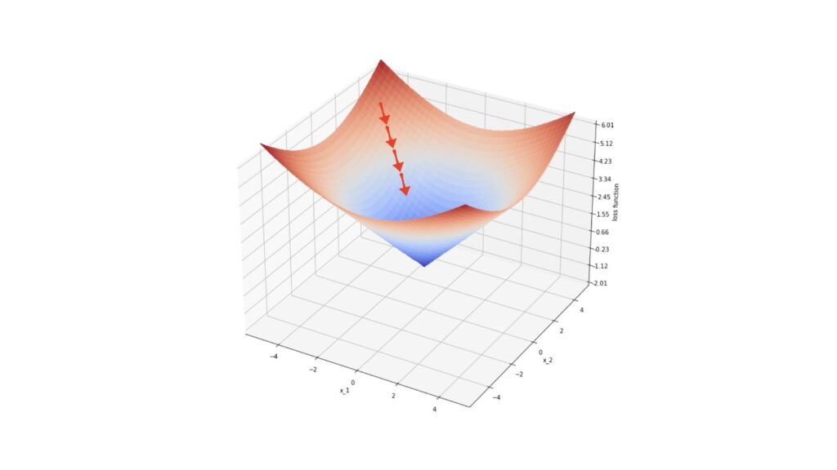

In the illustration, the red arrows represent gradients at specific points on the surface defined by ℓ. Each step in steepest descent moves our loss value closer to the local minimum.

With this understanding, let's outline the general gradient boosting regressor algorithm:

### Algorithm 1: Gradient_Boost

1. Initialize the ensemble:
$$E_{0}\left(x\right)=\arg{\min_{ρ}{\sum_{n=1}^{N}{l\left(y_{n},ρ\right)}}}=\text{median}\left(y\right)$$

2. For **m**=1 to **M**:
   1. Compute the negative gradients of the loss function with respect to the ensemble output at each data point **xn**​:
   2. Identify the weak learner $f$ that closely matches the gradients **gn**​, computed previously. This step generalizes the procedure to points **x** not included in the training data. Although various fitting procedures can be used, Friedman (2001) preferred least squares due to its computational properties.
   3. Determine the steepest descent multiplier $ρ_{m}$ ​, using the weak learner $f\left(x;θ_{m}\right)$ found in the previous step:
 $$ρ_{m} = arg⁡\min_{ρ}\sum_{n=1}^{N}{l\left(y_{n},E_{m-1}\left(x_{n}\right)+ρf\left(x_{n};θ_{m}\right)\right)}$$

  4. Update the ensemble:

$$E_{m}\left(x\right)=E_{m-1}\left(x\right)+ρ_{m}f\left(x;θ_{m}\right)$$

Each step in this algorithm can be explained in detail:

1. Initialize the ensemble to $E_{0}$
2. Compute the negative gradients of the loss function ℓ concerning the ensemble output at each data point **x­n**​. These gradients point towards the local minimum in the space defined by ℓ.
3. Identify the weak learner $f$ that correlates most closely with the gradients **gn** ​. Since the gradients are defined only at the points **x­n** ​, this step generalizes the procedure to other points. In Friedman (2001), least squares were used due to their computational advantages.
4. Determine the multiplier $ρ_{m}$ for steepest descent, using the weak learner $f\left(x;θ_{m}\right)$ identified in the previous step.
5. Increment the ensemble $E_{m}$ ​ using steepest descent.

### Derivation of the Gradient Boosting Tree Regression Algorithm

We can make Algorithm 1 more specific by defining the type of weak learner $f$ and loss function ℓ. Let's choose:

$$f\left(x;θ\right)=\sum_{j=1}^{J}{b_{j}I\left(x∈R_{j}\right)}, l\left(y,ρ\right)=\left|y-ρ\right|$$

Equation (4) describes a decision tree with $j = 1 …J$ terminal regions defined by $R_{j}$ ​ and $b_{j}$ ​ terminal values. Here, $I$ is the indicator function, and $θ=\{b_{j},R_{j}\}_{1…J}$. Equation (5) represents the absolute difference loss function.

Introducing equation (4) into Algorithm 1, Step 4 involves fitting the decision tree to the negative gradients ***g*** of the loss function using least squares. Step 5 is updated as follows:

$$ρ_{m}=arg{\min_{ρ}\sum_{n=1}^{N}{l\left(y_{n},E_{m-1}\left(x_{n}\right)\right)}}+ρ\sum_{j=1}^{J}{b_{j}I{(x}_{n}∈R_{jm})}$$

$$\{γ_{jm}\}_{1…J}=\arg{\min_{\{γ_{j}\}_{1…J}}{\sum_{n=1}^{N}{l\left(y_{n},E_{m-1}\left(x_{n}\right)+\sum_{j=1}^{J}{γ_{j}I\left(x_{n}∈R_{jm}\right)}\right)}}}$$

Here, $γ_{jm}$ ​ is a new optimum scaling factor over the possible $γ_{j}=ρb_{j}$ ​ values for region ***j*** at the ***m*** boosting step. Since the terminal regions produced by decision trees are disjoint, this expression can be simplified for a single value of j:

$$γ_{jm} = arg⁡\min_{γ}\sum_{x_{n}∈R_{jm}}{l\left(y_{n},E_{m-1}\left(x_{n}\right)+γ\right)})$$

Step 6 of Algorithm 1 is updated to:

$$E_{m}\left(x\right)=E_{m-1}\left(x\right)+ρ_{m}\sum_{j=1}^{J}{b_{jm}I\left(x∈R_{jm}\right)}$$

$$E_{m}\left(x\right)=E_{m-1}\left(x\right)+\sum_{j=1}^{J}{γ_{jm}I\left(x∈R_{jm}\right)}$$

### Updating the Loss Function

Introducing equation (5) into Algorithm 1, starting with Step 1, the argument minimum of $ρ$ is computed by taking the derivative and setting it to zero:

$$\frac{∂E_{0}\left(x\right)}{∂ρ}=\sum_{n=1}^{N}{\text{sign}\left(y_{n}-ρ\right)}=0 ⇒ E_{0}\left(x\right)=\text{median}\left(y\right)$$

Thus, our choice of loss function leads us to initialize the ensemble with the median of the training labels.

$$g_{n}=-\frac{∂\left|y_{n}-E\left(x_{n}\right)\right|}{∂E\left(x_{n}\right)}=\text{sign}\left(y_{n}-E\left(x_{n}\right)\right)$$

### Implementing the Algorithm with Decision Trees

To make the algorithm concrete, let’s specify decision trees as the weak learners $f$ and consider the absolute difference loss function $l\left(y,ρ\right)=\left|y-ρ\right|$

1. **Weak Learner**:

$$f\left(x;θ\right)=\sum_{j=1}^{J}{b_{j}I\left(x∈R_{j}\right)}$$

where 𝜃={𝑏j,𝑅j}​ are the terminal values and regions of the decision tree.

1. **Loss Function**:

$$l\left(y,ρ\right)=\left|y-ρ\right|$$

Using these specifications, we update the algorithm:

1. **Initialization**:
$$E_{0}=\text{median}\left(y\right)$$

2. **Negative Gradient**:
$$g_{n}=\text{sign}\left(y_{n}-E\left(x_{n}\right)\right)$$

3. **Fitting the Decision Tree** to the negative gradients:
$$θ_{m}=\arg{\min_{θ}{\sum_{n=1}^{N}{{\left[g_{n}-f\left(x_{n};θ\right)\right]}^{2}}}}$$

4. **Optimal Step Size**:
$$ρ_{m} = arg⁡\min_{ρ}\sum_{n=1}^{N}{l\left(y_{n},E_{m-1}\left(x_{n}\right)+ρf\left(x_{n};θ_{m}\right)\right)}$$

5. **Model Update**:

$$E_{m}\left(x\right)=E_{m-1}\left(x\right)+ρ_{m}f\left(x;θ_{m}\right)$$

In this detailed approach, each step incrementally improves the model by fitting a new decision tree to the current residuals (negative gradients) and updating the model in the direction that reduces the loss function, ultimately converging to a robust predictive model.

# 5. Dataset Creation

In this section, we delve into the methodology used to create the dataset for our research. Due to the sensitivity and constraints associated with acquiring real-world data, I opted to leverage the capabilities of the Mostly.AI platform to generate a comprehensive dataset.

## 5.1 Synthetic Data and Its Generation

Synthetic data refers to artificially created data rather than data collected from real-world sources. It is generated using algorithms or models to mimic the characteristics and distribution of real data. The process typically involves the following steps:

1. **Model Selection**: Choose an appropriate model or tool that can generate data similar to your real-world scenario.
2. **Parameterization**: Define the parameters and characteristics of the data you want to generate, such as distributions, correlations, and data types.
3. **Generation**: Utilize the selected model or tool to generate synthetic data based on the specified parameters.

### ****What is AI powered synthetic data generation and how does it work?****

Synthetic data generation is powered by deep generative algorithms. These algorithms use data samples as training data to learn the correlations, statistical properties, and data structures. Once trained, the algorithms can generate data that is statistically and structurally identical to the original training data, while ensuring all data points are synthetic.

### Key Points about synthetic data:

* **Synthetic data for AI and machine learning is more flexible than real data.** It accelerates analytics development cycles, reduces regulatory concerns, and lowers data acquisition costs by providing tailored datasets for specific applications.
* **An initial dataset is required.** An initial dataset needs to be constructed and fed to the synthetic data generation model in order to increase it’s volume in order to be substantial for the recommendation model

### Εικόνα που περιέχει κείμενο, στιγμιότυπο οθόνης, γραμματοσειρά, διάγραμμαMostly.AI Platform

The Mostly.AI platform provides robust capabilities for generating synthetic data. It employs advanced algorithms that mimic real data patterns while ensuring privacy and security. This platform was instrumental in creating our dataset, offering customizable options to tailor the data generation process to our specific research needs.

## 5.2 Foundational Dataset creation

### Features

The dataset used to train the model contains the following columns:

1. **ID**: A unique identifier for each record.
2. **TimeOfDay**: Indicates the time of day when the recommendation was generated (e.g., morning, afternoon, evening).
3. **Distance**: Distance from the user's location to the supermarket (in meters).
4. **WeatherCondition**: Describes the weather conditions at the time of recommendation (e.g., sunny, rainy, snowy).
5. **MeansOfTransport**: Specifies the mode of transportation considered for the recommendation (e.g., car, bike, walking).
6. **Cost**: Estimated cost of shopping at the supermarket based on a typical grocery list.
7. **Supermarket Rating**: The rating of the supermarket based on online reviews (scale 0 to 5)
8. **Score**: Numerical score indicating the suitability of the supermarket based on the above factors.

These features collectively enable the dataset to provide informed recommendations for grocery shopping based on user preferences and real-time environmental factors.

### Methodology for the creation of the foundational dataset

The foundational dataset creation process involved a structured methodology where raters sequentially evaluated each supermarket recommendation, with the ability to adjust ratings based on previous evaluations. Five groups of three raters where created with each group rating the suitability for recommendation of 100 supermarkets and conditions ranked on a scale from 0 to 100. Each group where given 100 different supermarkets from each other. The rating process is documented below.

1. **Sequential Rating Process**:
   * Raters for each group evaluated each supermarket recommendation one by one, starting from the first supermarket and moving sequentially through to the 100th supermarket.
   * For each supermarket, raters assessed its suitability for recommendation based on factors like TimeOfDay, Distance, WeatherCondition, MeansOfTransport, Cost, Supermarket Rating.
   * After rating a supermarket, raters recorded their numerical evaluation on a scale from 0 to 100.
2. **Dynamic Rating Adjustment**:
   * Crucially, raters had the flexibility to revisit and adjust their ratings for previously evaluated supermarkets based on subsequent evaluations.
   * Εικόνα που περιέχει κείμενο, στιγμιότυπο οθόνης, γραμματοσειρά, γραμμή

     Περιγραφή που δημιουργήθηκε αυτόματαThis dynamic adjustment allowed raters to refine their assessments as they progressed through the dataset, potentially modifying earlier ratings in light of new insights or patterns observed in later evaluations.
3. **Mean Calculation**:
   * Once all 100 supermarkets were rated by the three raters, the mean (average) rating for each supermarket recommendation was calculated.
   * Εικόνα που περιέχει κείμενο, στιγμιότυπο οθόνης, σχεδίαση

     Περιγραφή που δημιουργήθηκε αυτόματαThis mean value represented the consolidated rating derived from the collective evaluations of all three raters for that particular supermarket.
4. **Foundational dataset creation**

* The process described above was then repeated five more times with different participants and different supermarket data each time
* Merging all the five generated datasets resulted in the creation of the foundational dataset used in for the synthetic data generation
* 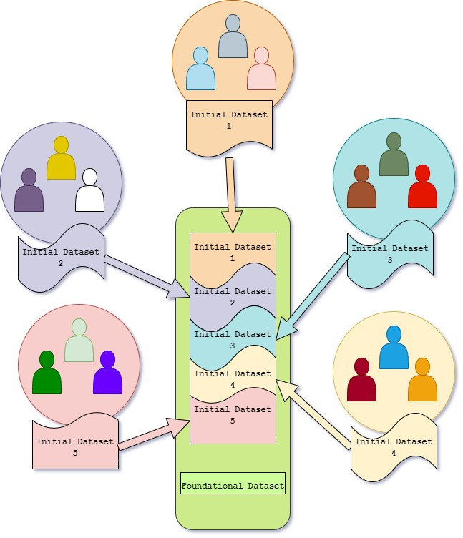The merging of the five datasets containing the mean ratings formed the foundational dataset, capturing aggregated assessments that balanced out individual biases or variations among the raters.

This iterative and adaptive rating process ensured that the foundational dataset's initial creation was robust and reflective of multiple perspectives, leveraging sequential evaluations and dynamic adjustments to refine the dataset's quality and reliability for subsequent analyses or machine learning model training.

Εικόνα που περιέχει κείμενο, στιγμιότυπο οθόνης, διάγραμμα, γραμματοσειρά

Περιγραφή που δημιουργήθηκε αυτόματαThe feature distribution of the dataset can be seen below.

As seen in the distribution graphs all the features are fairly even distributed resulting in a highly balanced dataset.

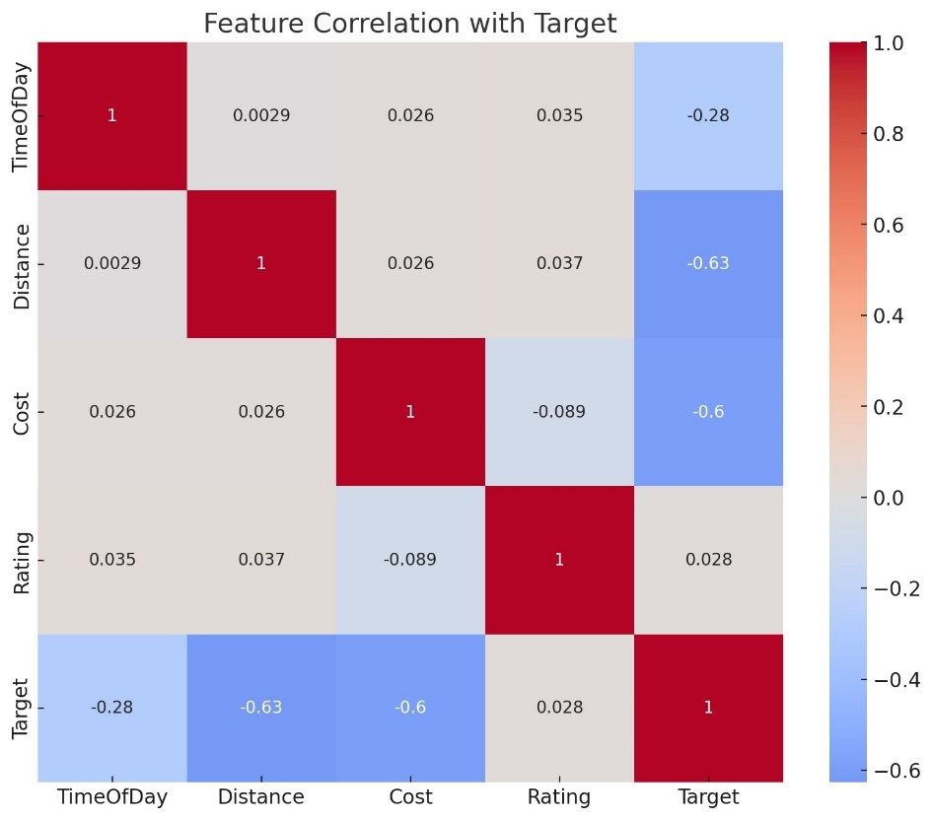Implementing A correlation matrix was created to understand the relationships between different variables. The key findings are:

* **Rating** has a very low positive correlation with the target (0.028), indicating that changes in ratings have little to no linear relationship with the target.
* **TimeOfDay** shows a moderate negative correlation with the target (-0.279), suggesting that as the time of day increases, the target tends to decrease.
* **Cost** has a strong negative correlation with the target (-0.600), indicating that higher costs are associated with lower target values.
* **Distance** shows the strongest negative correlation with the target (-0.627), suggesting that longer distances are strongly associated with lower target values.

Analyzing , the scatter plot between distance, cost and the score of the supermarket also results in the further findings:

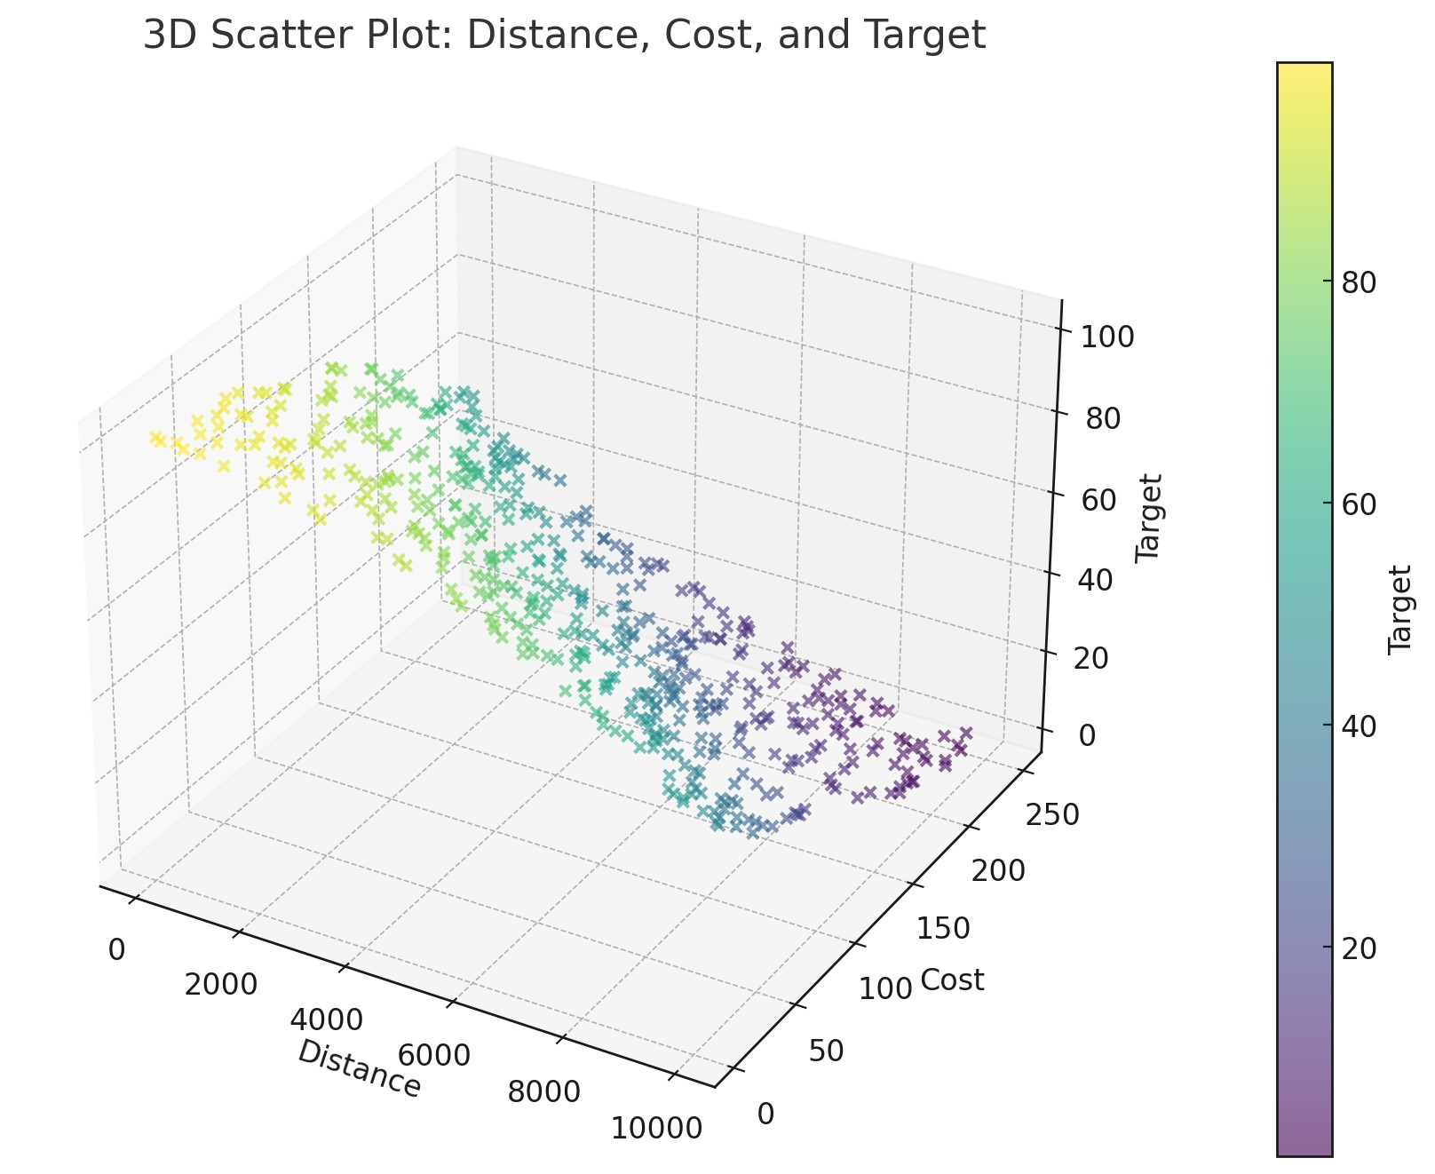

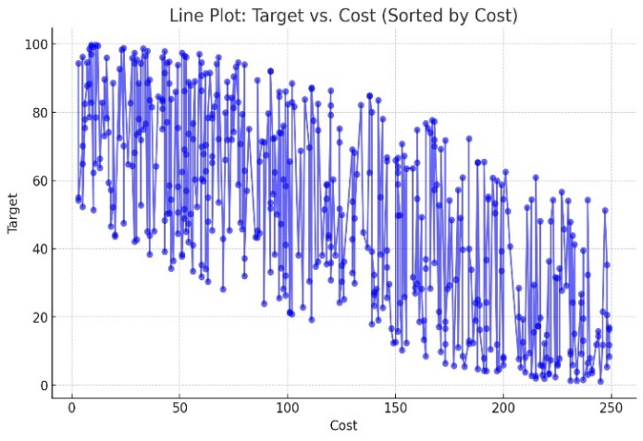We arrive to the same conclusion inspecting the diagrams between Distance-Score as well as Cost-Score, as seen below:

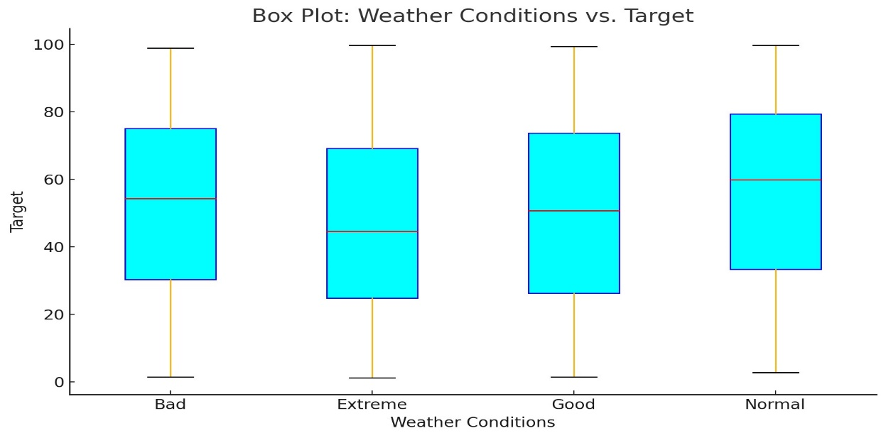Another interesting finding arises when we analyze the affect of the weather conditions to the score of the supermarket using box-plots:

This visualization suggests that better weather conditions are generally associated with higher target outcomes.

* **Extreme Weather**: Displays a wide range of target values with significant variability.
* **Bad Weather**: Generally lower target values compared to other weather conditions, indicating that adverse weather may negatively impact the target outcome.
* **Normal Weather**: Shows moderate target values with less variability compared to extreme weather.
* **Good Weather**: Associated with higher target values and less variability, suggesting favorable weather positively influences the target outcome.

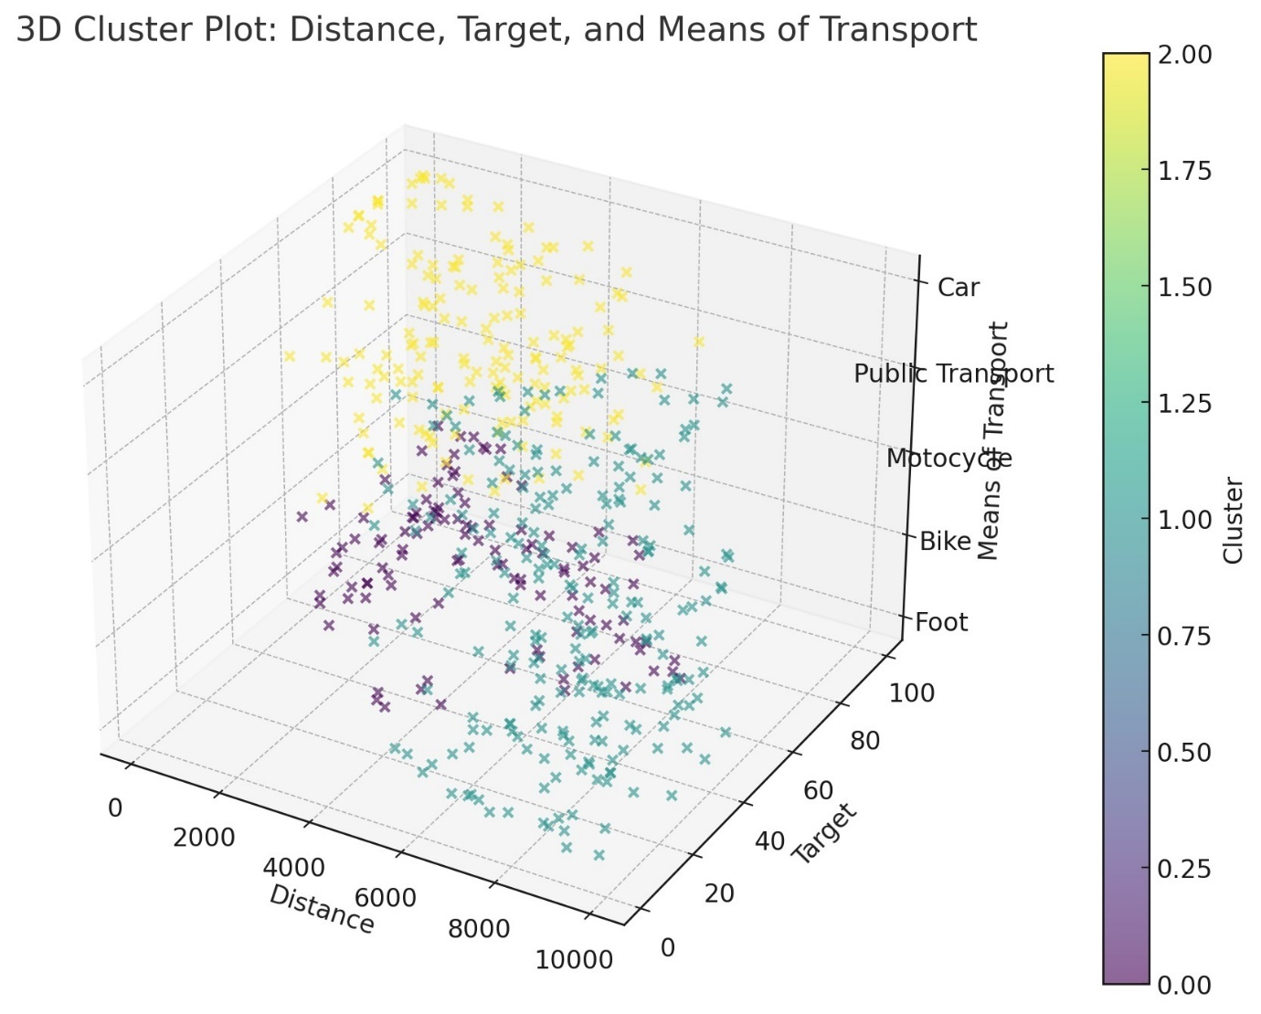Some really interesting insights arise when we perform clustering using the KMeans algorithm using Distance, Score and the means of transport. Three distinct clusters can be extracted each with their own characteristics:

1. **Cluster 0**:

* **Distance**: Short to moderate (mean: 3106.59)
* **Target**: High (mean: 71.46)
* **Means of Transport**: Predominantly on foot (mean: 0.39)

1. **Cluster 1**:

* **Distance**: Longest (mean: 7708.95)
* **Target**: Lowest (mean: 26.17)
* **Means of Transport**: Primarily uses bikes and motorcycles (mean: 1.91)

1. **Cluster 2**:

* **Distance**: Short to moderate (mean: 3152.18)
* **Target**: High (mean: 70.67)
* **Means of Transport**: Predominantly uses public transport and cars (mean: 3.12)

**Cluster 0 and Cluster 2** have similar distance and target means but differ significantly in their means of transport. Cluster 0 is primarily on foot, while Cluster 2 uses public transport and cars.

**Cluster 1** represents consumers with the longest distances and the lowest target values, primarily using bikes and motorcycles.

Finally extracting the correlation of cost to the score of the supermarket as weather conditions change we arrive to the conclusion that, although cost always seem to have a strong negative correlation to the score of the supermarket suggesting that higher cost supermarkets result in lower scores, the cost becomes less relevant the worse the weather gets. This conclusion ties to our previous findings that as the weather worsens, other factors play a more crucial role when picking the ideal supermarket for grocery shopping.

|  |  |
| --- | --- |
| Weather condition | Correlation of Cost to Score |
| Good | -0.727401 |
| Normal | -0.708640 |
| Bad | -0.655886 |
| Extreme | -0.655376 |

If we add for each weather condition the mean of transport and recalculate the correlation of Cost to Score for each pair we get the following results:

|  |  |  |
| --- | --- | --- |
| Weather condition | Means of Transport | Correlation of Cost to Score |
| Extreme | Car | -0.698002 |
| Extreme | Public Transport | -0.658392 |
| Extreme | Motocycle | -0.609832 |
| Extreme | Bike | -0.473445 |
| Extreme | Foot | -0.462175 |
| Bad | Car | -0.792045 |
| Bad | Public Transport | -0.789436 |
| Bad | Motocycle | -0.755315 |
| Bad | Bike | -0.579421 |
| Bad | Foot | -0.559963 |
| Normal | Car | -0.842332 |
| Normal | Public Transport | -0.859821 |
| Normal | Motocycle | -0.843765 |
| Normal | Bike | -0.762102 |
| Normal | Foot | -0.746648 |
| Good | Car | -0.862175 |
| Good | Public Transport | -0.828518 |
| Good | Motocycle | -0.838762 |
| Good | Bike | -0.794545 |
| Good | Foot | -0.789204 |

From these results it’s easy to deduce that to the consumer the cost of the supermarket, although still shows a pretty strong negative correlation to the score, the correlation get weaker in extreme cases such as when there is extreme weather at the time and the user doesn’t have a mean of transport that can provide him with more protection and coverage against the weather. (ex. Extreme weather and Foot, Bad weather and Bike).

On the contrary, if we now extract the same combination matrix but this time calculating the correlation between the distance and the score we arrive to the following results:

|  |  |  |
| --- | --- | --- |
| Weather condition | Means of Transport | Correlation of Distance to Score |
| Extreme | Car | -0.727564 |
| Extreme | Public Transport | -0.739902 |
| Extreme | Motorcycle | -0.780223 |
| Extreme | Bike | -0.887362 |
| Extreme | Foot | -0.879973 |
| Bad | Car | -0.621234 |
| Bad | Public Transport | -0.675332 |
| Bad | Motorcycle | -0.712345 |
| Bad | Bike | -0.723364 |
| Bad | Foot | -0.739902 |
| Normal | Car | -0.647653 |
| Normal | Public Transport | -0.646562 |
| Normal | Motorcycle | -0.650201 |
| Normal | Bike | -0.739321 |
| Normal | Foot | -0.759090 |
| Good | Car | -0.428742 |
| Good | Public Transport | -0.454421 |
| Good | Motorcycle | -0.438908 |
| Good | Bike | -0.709090 |
| Good | Foot | -0.760921 |

As expected we come the opposite conclusions from the one calculating the correlation between Cost and Score. This time, although distance always seems to have a strong correlation to how high a score of a supermarket is, with higher scores being granted to nearer supermarkets, we note higher correlation based on the mean of transport of the user, with Foot and Bike always making distance keep a really high correlation regardless of the weather conditions. Furthermore, in more favorable weather conditions, when the consumer uses a mean of transport that does not have distance restrictions the correlation seems to drop to relative low values, compared to a 50% decrease with the not favorable condition counterparts.

The analysis done above demonstrates the complex nature of the recommendation algorithm suggesting that a simple cost function would have not been enough to enough to tackle the problem. Instead we opt for a more robust and sophisticated approach which can handle multiple layers of decision making and come up with an accurate score to correctly mimic how a real world person would make his decision when grocery shopping, with the different variables present to them at that time.

## 5.3 Training/Testing Dataset Creation using Synthetic Data generators

In order for our recommendation model to be trained properly resulting in accurate and well justified recommendations we needed large volumes of data. This would ensure that the training accuracy for our model is high enough for it to be ready to make calculated recommendations when present with real world scenarios.

### Synthetic data generation

Although our foundation dataset was relatively large, compromised of 500 records, it would have to be far larger than that if we would want our model to mimic a multi-factored human decision making process when it comes to choosing the best destination for grocery shopping. Therefore, in our research we would have to size-up our dataset while maintaining it’s unique characteristics of capturing multiple individuals view and thought process, measured through the scoring procedure, when coming to making up their decisions. In order to achieve our goal we took advantage of synthetic data generators and more specifically, the well established Mostly AI synthetic data generation application. Mostly AI offers a user friendly UI and uses advanced

### Mostly AI generation process

The process of using the Mostly AI platform for synthetic data generation is pretty straightforward. We first upload the Foundational Dataset created in the previous steps in the platform. The dataset will be used to train an AI model making it an expert analyzing the dataset and creating data that mimic the properties of the original. After the original dataset is uploaded and analyzed we start a synthtetic dataset generation asking from the model to generate 1500 rows. This new dataset combined with the foundational one compose the training dataset of 2000 rows used from our model for training. The process can be seen in the diagram below.

Εικόνα που περιέχει κείμενο, διάγραμμα, στιγμιότυπο οθόνης, γραμμή

Περιγραφή που δημιουργήθηκε αυτόματα

Εικόνα που περιέχει κείμενο, στιγμιότυπο οθόνης, διάγραμμα, τετράγωνο

Περιγραφή που δημιουργήθηκε αυτόματαEnsuring that the generated data is as close and accurate to our foundational dataset records is key for making sure the final dataset is not only generated from actual real world data but also captures the decision making process of the human logic. The metrics for the dataset generated can be seen in the following report provided by the mostly AI platform.

Moreover the data distribution report is the following for the synthetic dataset.

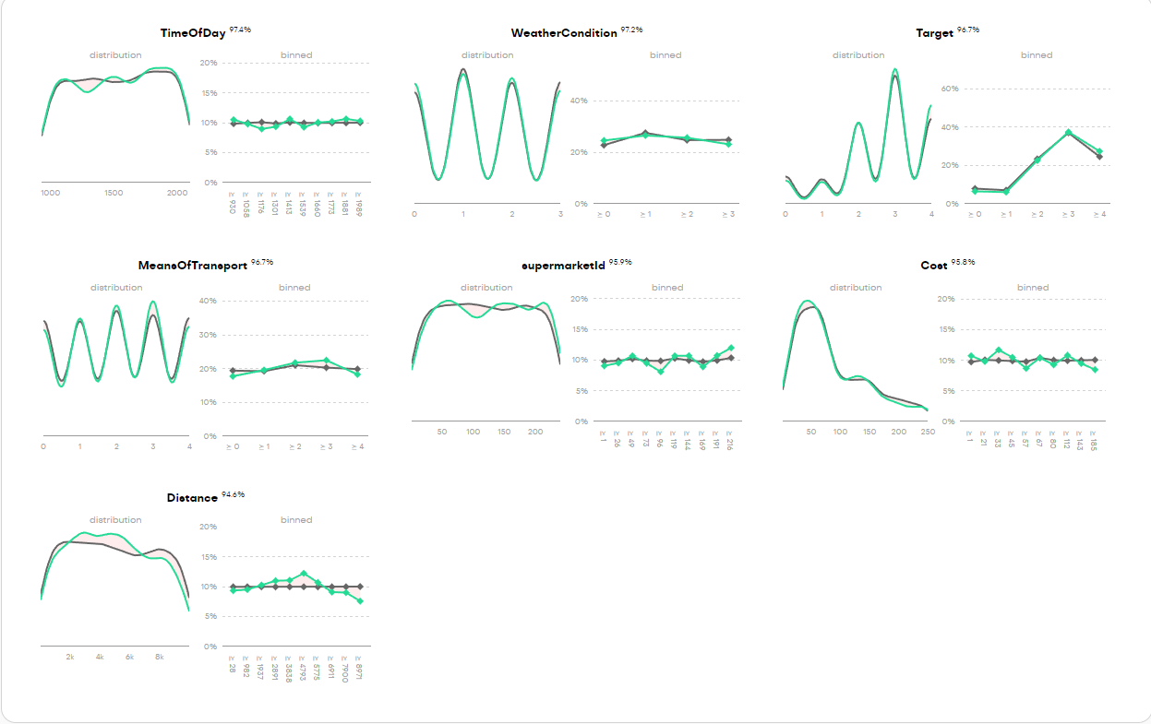

In order to check such characteristics we not only scanned the dataset records one by one for anomalies or data that seemed out of the ordinary, correcting potential out of place records using various excel. python and big data analysis techniques

# 6. Database

## The database is the core infrastructure supporting the location-based customer support application. It enables efficient storage, retrieval, and analysis of data to deliver personalized recommendations to users. This section outlines the database’s structure, focusing on the main entities and relationships, and provides details on how data is collected and managed using web scraping techniques.

## 6.1 Technologies used

### PostgreSQL overview

### PostgreSQL serves as the backend database for this application due to its scalability, robustness, and support for geospatial queries. PostgreSQL’s support for advanced indexing and data types, including geospatial data via the PostGIS extension, makes it ideal for this application, which relies heavily on location-based services. Key features of PostgreSQL that are leveraged in the application include:

* **PostGIS Geospatial Queries**: Used for efficiently querying nearby supermarkets based on the user's location.
* **ACID Compliance**: Ensures reliable transaction management, preserving data integrity.
* **Advanced Data Types**: Supports arrays, JSON, and other complex data types required for flexible storage of structured and unstructured data.

### pgAdmin overview

pgAdmin is the most popular and feature-rich tool for PostgreSQL database management. It allows users to interact with their databases through an intuitive graphical interface, making it ideal for both novice and advanced users. Key features of pgAdmin include:

* **Comprehensive Graphical Interface**: Provides a user-friendly interface for managing tables, views, functions, and triggers.
* **SQL Query Tool**: Offers a powerful SQL query editor for running ad-hoc SQL queries, making it easy to interact with the database without needing to write complex code.
* **Data Import/Export**: Supports importing and exporting data to and from CSV, Excel, or other formats.
* **Database Monitoring**: pgAdmin comes with tools to monitor database activity, resource consumption, and performance.

More importantly, since we are dealing with large volumes of data in our database pgAdmin was especially preferred for its ability to bulk import data with its built in Bulk API process

## 6.2 Database structure

The database is composed of multiple interconnected entities, each playing a specific role in storing and processing the data needed for the recommendation engine. The design includes core entities such as products, supermarkets, user information, and a historic tracking system for recommendations. Below, we describe the key entities, their fields, and their roles in the system.

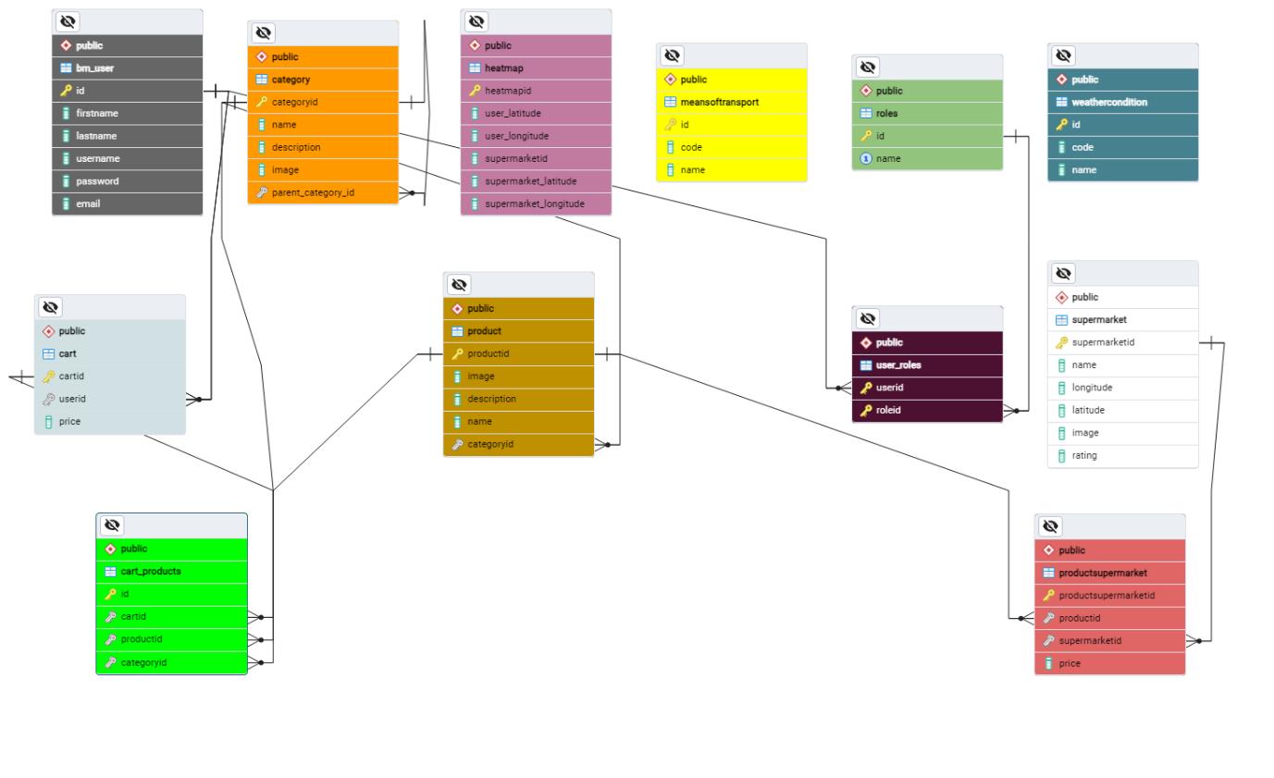

### Product

The product table is a central entity that stores information about all available products in the system. Each product in the database is not tied to a specific supermarket but can appear in multiple supermarkets with different prices.

* **Fields**: productid (Primary Key), name, description, image, categoryid
* **Purpose**: This table holds generic product details such as names, descriptions, and images. Each product can be linked to different supermarkets through the productsupermarket table.

### ProductSupermarket

* **Fields**: productsupermarketid (Primary Key), productid (Foreign Key), supermarketid (Foreign Key), price
* **Purpose**: By storing product-supermarket relationships, this table allows the application to deliver accurate price comparisons across different supermarkets, giving users location-based, real-time shopping recommendations.

### Supermarket

The supermarket table contains information about each supermarket, including its name and geographic coordinates. This data is critical for identifying which supermarkets are near the user’s current location.

* **Fields**: supermarketid (Primary Key), name, longitude, latitude, image, rating
* **Purpose**: The geographic data stored in this table is used in location-based queries to determine which supermarkets are nearby and to provide geolocation-based recommendations to the user.

### Category

The category table classifies products into categories. Categories are organized hierarchically, with support for parent-child relationships.

* **Fields**: categoryid (Primary Key), name, description, image, parent_category_id
* **Purpose**: Categories are used to filter and organize products. This hierarchical structure allows for better navigation and product discovery within the application.

### Cart and Cart_Products

The cart and cart_products tables store information about user shopping carts and the products they contain.

* **Cart Fields**: cartid (Primary Key), userid (Foreign Key), price
* **Cart_Products Fields**: id (Primary Key), cartid (Foreign Key), productid (Foreign Key), categoryid
* **Cart_Products Fields**: id (Primary Key), cartid (Foreign Key), productid (Foreign Key), categoryid

### User and User_Roles

The bm_user table stores user information, while the user_roles table defines the roles associated with each user, controlling access and permissions within the system.

* **bm_user Fields**: id (Primary Key), firstname, lastname, username, password, email
* **user_roles Fields**: userid (Foreign Key), roleid (Foreign Key)
* **Purpose**: These tables handle user authentication and role-based access control. Different roles allow for varying levels of access, ensuring that users can only perform actions allowed by their role.

### WeatherCondition

The weathercondition table tracks current weather conditions, which can influence shopping recommendations. For example, bad weather may prompt users to visit closer supermarkets.

* **Fields**: id (Primary Key), code, name
* **Purpose**: By integrating real-time weather data into the recommendation engine, the system can account for external factors that might affect a user's decision to travel to a specific supermarket.

### MeansOfTransport

The meansoftransport table stores information about the available transportation options for users (e.g., car, walking, bike), which impacts the recommendation engine's decision-making process.

* **Fields**: id (Primary Key), code, name
* **Purpose**: Depending on the user's mode of transport, the system may recommend supermarkets that are more accessible based on distance or transport efficiency.

### Heatmap

The heatmap table functions as a historic tracking data table, recording previous user recommendations and their geographic context. This data allows the system to analyze which supermarkets have been recommended most frequently within specific areas, providing useful insights into user behavior and recommendation trends. The previous trends are also available to the end user.

* **Fields**: heatmapid (Primary Key), user_latitude, user_longitude, supermarket_latitude, supermarket_longitude
* **Purpose**: This table tracks the geographic locations of both users and supermarkets at the time of a recommendation. By aggregating this data, the system can generate analytics that reveal the most frequently recommended supermarkets in a given area, helping to refine the recommendation algorithm further.

## 6.3 Queries for Data Retrieval and Analytics

Several SQL queries are integral to retrieving data from the database for both user-facing functionalities and backend analytics. These queries leverage PostgreSQL’s geospatial capabilities to efficiently handle location-based services.

### Query examples



This query retrieves products, supermarkets, and the corresponding prices for items that are located within a specified radius of the user's location. The query uses **PostGIS** functions to calculate the distance between the user's location and supermarkets, filtering the results to show only nearby stores that stock the requested products. Its main purpose is to enable the application to suggest nearby supermarkets that stock the products on a user's shopping list, along with the respective prices. It is crucial for providing real-time recommendations that are personalized based on the user's location and shopping preferences.



This query is used to analyze which supermarkets have been recommended most frequently in a given geographic area, based on historical data stored in the heatmap table. It counts the number of times each supermarket has been recommended and tracks the locations of users and supermarkets. Its main purpose is to help the system identify trends in supermarket recommendations within a specific area. By counting recommendations and associating them with user and supermarket locations, the system can generate insights into which supermarkets are most popular or effective in specific regions. This information can be used to improve the recommendation algorithm, provide business intelligence for supermarket operators. give the end user a glimpse of what previous users similar to his situation were recommended to and help admin operators identify possible trends among the supermarkets.

## 6.4 Collecting and importing large volumes of real world data

To ensure the consistency and the quality of the UX aspect of the application it was crucial to mimic real world aspects and volumes of data as closely as possible. To accomplish this several data gathering and engineering techniques were advised resulting in more than 4000 records split among multiple tables of real world anonymized data

### Gathering Data Using Web Scraping

The data required for populating the product, supermarket, and productsupermarket tables was collected using web scraping techniques. Specifically, product data from the **Sklavenitis** website was scraped to gather information about more than 3,000 products.

### Tools Used for Web Scraping

For the web scraping process, I used the **Open Web Scrapper** tool. This browser extension enabled efficient extraction of product data from the Sklavenitis website, including product names, prices, and categories. The extraction process involved around collecting html tags with specific html properties using a tree structure seen below and exporting the in excel files.

Εικόνα που περιέχει κείμενο, στιγμιότυπο οθόνης, διάγραμμα, παράλληλα

Περιγραφή που δημιουργήθηκε αυτόματα

### Data Engineering

Once the raw product data was collected, it needed to be processed and structured for use in the database. Using **Excel** and Python, I applied various data engineering techniques to clean the data and prepare it for import into PostgreSQL.

The following Python script was used to generate the productsupermarket table by creating combinations of products and supermarkets, each with a randomly assigned price:



This script populated the **productsupermarket** table with over 3,000 product-supermarket combinations, each with a unique price, making the data ready for integration into the recommendation engine.

# 7. Backend Architecture and Authentication

The backend architecture of this location-based customer support application is designed as a distributed system, involving both a Node.js server and a Flask (Python) server. This dual-server ecosystem enables efficient communication between the application’s frontend, the database, and machine learning models to provide real-time, location-sensitive recommendations for users based on their grocery cart and current conditions like weather or distance.

Εικόνα που περιέχει κείμενο, στιγμιότυπο οθόνης, διάγραμμα, λειτουργικό σύστημα

Περιγραφή που δημιουργήθηκε αυτόματα

## 7.1 Node.js Server

The **Node.js server** plays a central role in managing the interaction between the user interface and the database. Built on an asynchronous, event-driven architecture, Node.js provides high efficiency for managing multiple simultaneous connections, which is crucial for a real-time recommendation system like this. Node.js processes user requests by fetching data from the database, managing data inputs such as the user's grocery list, and formatting the data for further analysis.

In this system, when a user adds groceries to their shopping cart, the Node.js server retrieves location-sensitive data, including the availability and pricing of these items across various supermarkets. It communicates with the database (PostgreSQL) to ensure that all data points such as prices, proximity, and stock are up-to-date. After gathering the necessary data, Node.js formats it into a structured form that the Flask server can use for prediction.

The efficiency of Node.js allows the system to handle multiple data requests concurrently, making it ideal for applications where real-time data processing and low-latency responses are key performance indicators. Its non-blocking architecture ensures that the server can continue to process other requests while waiting for the database or other components to respond.

### Structure: Routes, Controllers, and Middleware

The backend server in this application follows a **modular architecture** that separates concerns and ensures maintainability, scalability, and efficient handling of requests. This architecture is built around three key components: **Routes**, **Controllers**, and **Middleware (MDW)**. This structure enables clear organization of logic, simplifies debugging, and allows for easy feature updates or expansions.

### Defining the API Endpoints

In the **Node.js** environment, routes are essential for defining the API endpoints that handle incoming requests from the frontend. The routes map the specific URLs and HTTP methods (GET, POST, PUT, DELETE) to the appropriate functions that process these requests.

### Authentication Routes and Controllers

The authentication routes enable users to sign up and sign in securely.

* **Route: /api/auth/signup**

Registers a new user by collecting their username, email, and password.

* **Route: /api/auth/signin**

Allows users to log in by verifying their credentials and, upon success, returns a JWT token for future authenticated requests.

**Authentication Controller Logic**

The authentication controller is responsible for managing user authentication through two main actions: signup and signin. The logic focuses on securely handling sensitive data such as passwords and tokens, ensuring safe access to the system.

**1. Signup Process**

* Password Hashing: When a user signs up, the bcrypt library is used to hash the password before storing it in the database. Password hashing is crucial for security, as storing plain-text passwords can expose users to risks if the database is compromised. The hashing algorithm produces an encrypted representation of the password that is difficult to reverse-engineer.
* Database Insertion: After hashing, the user’s credentials are inserted into the database using SQL queries. The controller uses the pg library to communicate with a PostgreSQL database, ensuring efficient data handling.

**2. Signin Process**

* Password Validation: During login, the entered password is compared with the stored hash using bcrypt.compareSync(). This function ensures that the entered password matches the one stored in the database.
* JWT Token Generation: If the login is successful, the jsonwebtoken (JWT) library is used to generate a token containing the user's ID. This token is encoded using a secret key and contains an expiration time (24 hours in this case). The generated token is crucial for stateless authentication:
  + Stateless Authentication: Once a user logs in and receives a JWT, they don’t need to re-authenticate until the token expires. The server doesn't store session data; instead, the token is passed with each request. This improves scalability and efficiency, particularly in distributed systems.

**Key Programming Techniques:**

* Asynchronous Database Operations: The controller uses async SQL queries with pg, ensuring non-blocking operations to handle multiple user requests simultaneously.
* Security Best Practices: By using bcrypt for password hashing and JWT for authentication, the system is built to prevent common security threats such as brute-force attacks and session hijacking.

### User edit Routes and Controllers

The user edit routes allow users to modify their account details (username and email) and fetch their current details.

* **Route: /api/editUserDetails**

**Lets a user update their username and/or email.**

* **Route: /api/getUserDetails**

Retrieves the current user’s details based on the user's token.

**Edit Controller Logic**

The edit controller handles user profile updates and retrieval, with a focus on database consistency and uniqueness checks.

1**. Edit User Details Process**

* Conflict Resolution: Before updating a user’s details, the controller first checks for conflicts. This is done by querying the database to ensure no other users share the same username or email. If a conflict is detected, the update is rejected with a meaningful message.
* Dynamic SQL Query Building: The controller dynamically builds the SQL query based on which fields (username, email) are being updated. This allows flexibility in partial updates, avoiding unnecessary overwrites.

**2. Get User Details Process**

* Token-based Authentication: When retrieving user details, the controller uses the user’s token to securely identify the user making the request. This ensures that each user can only access their own information.

**Programming Techniques:**

* Dynamic SQL Queries: By constructing SQL queries dynamically based on the provided data, the system avoids redundant database operations and ensures only relevant fields are updated.
* Asynchronous Operations: Like other controllers, it relies on async queries for non-blocking performance.

### Cart Management Routes and Controllers

The cart routes manage all operations related to a user’s shopping cart, such as saving, retrieving, deleting, and updating items.

* **Route: /api/saveCart**
  + Saves a new cart and its items for the user.
* **Route: /api/getCartProductsUserId**
  + Retrieves all products in the user’s cart based on their user ID.
* **Route: /api/deleteCart**
  + Deletes the user's cart and its associated products.
* **Route: /api/updateCart**
  + Updates the user's cart, allowing modifications to items or categories.

**Cart Management Controller Logic**

The cart controller manages cart operations, ensuring data integrity and seamless user interactions with their shopping carts.

**1. Saving a Cart**

* Multi-Table Inserts: When a user saves their cart, the controller inserts cart data into two tables: the main Cart table and the cart_products table that links products to carts. This relational approach ensures that each cart can have multiple products and can scale well as more users save items.

**2. Retrieving a Cart**

* Joins Across Multiple Tables: To retrieve cart products, the controller performs SQL joins across bm_user, cart, product, and category tables. This allows a comprehensive view of the user's cart, including product details, categories, and images.

**3. Updating a Cart**

* Delete-Insert Strategy: To update a cart, the controller first deletes all existing entries in the cart_products table for the given cart ID, then re-inserts the updated items. This approach ensures that the cart is fully synchronized with the user's latest modifications.

**Programming Techniques:**

* Joins for Data Aggregation: By using SQL joins, the controller efficiently aggregates data from multiple tables, providing a full view of the user’s cart in a single operation.
* Transaction Management: The controller likely operates within database transactions to ensure that if one operation (like inserting products) fails, the entire operation is rolled back, preventing partial data corruption.

### Recommendation Routes and Controllers

**Routes Overview**

The main store routes handle operations related to supermarket products and recommendations.

* **Route: /api/recommendation**

Generates personalized supermarket recommendations based on the user's cart, location, weather, and transportation method.

* **Route: /api/heatmap**

Provides heatmap data showing supermarket activity near the user's location.

**Recommendation Controller Logic**

The recommendation controller processes user input (such as cart items and location) to generate recommendations for the best supermarkets. This involves complex logic to optimize user experience and ensure accurate results.

**1. Recommendation Generation**

* Distance Calculation: The controller first calculates the distance between the user's location and nearby supermarkets using a formula to compute the distance from latitude and longitude values. This ensures the recommendations are proximity-based.
* Product Matching: The controller matches the products in the user's cart with the products available at nearby supermarkets, then calculates which supermarkets offer the most items from the cart. The logic here involves filtering and grouping products by supermarkets.
* Cost Calculation: Once a matching supermarket is found, the total cost of the cart at that supermarket is calculated using helper functions. This allows users to receive recommendations for the cheapest option available.

**2. Data Formatting for Machine Learning**

* formatSupermarketData: Before sending the recommendation data to the external machine learning server, the controller formats it using helper functions that take into account weather, transportation, and time of day. The formatSupermarketData function converts raw data into a structured format that the machine learning model can process. This structure includes:
  + **Weather condition codes**
  + **Transportation method codes**
  + **Time of day and distance**

In the recommendationController, the process of generating data for the machine learning (ML) model involves several steps, each designed to extract relevant features from user data (such as cart contents, location, and preferences) and format it in a way that the ML model can process. The model then predicts the best supermarket for the user based on various factors like cost, distance, weather, and transportation. Below is a detailed breakdown of the entire process leading up to the final data being fed into the ML model.

**Step-by-Step Breakdown of the Data Processing Pipeline**

**1. Retrieving Nearby Supermarkets**

The process begins by identifying supermarkets near the user based on their location. The user’s latitude and longitude are used to find supermarkets within a specific radius (e.g., 10 km). This is done through a geospatial query using PostgreSQL's earth-distance extension.

* Geospatial Query: The query finds supermarkets that are close to the user’s location. The query also retrieves product availability at each supermarket for the items in the user’s cart.
* Distance Calculation: After fetching nearby supermarkets, the getDistanceFromLatLonInKm function calculates the exact distance between the user and each supermarket in meters. This distance is crucial for determining how far a user must travel to each store.



**2. Filtering and Matching Products with Supermarkets**

Once the nearby supermarkets are identified, the system checks which products from the user’s cart are available in these supermarkets. This involves matching the product IDs from the user’s cart with the products stocked by the supermarkets.

* Product Matching: The controller filters the results to identify which supermarkets stock the items from the user's cart. This is essential because the goal is to recommend a supermarket where the user can purchase most, if not all, of their desired items.
* Grouping by Supermarket: Products are grouped by supermarket so that the controller can later evaluate how well each supermarket matches the user’s shopping list.

**3. Calculating Cart Cost for Each Supermarket**

For each supermarket, the controller calculates the total cost of the cart by summing up the prices of the items that are available at that supermarket. This calculation is done using the **calculateCostOfCart** helper function:



Quantity-based Pricing: The function multiplies the price of each item by the quantity specified in the user’s cart. This gives the total cost of purchasing the full cart from a specific supermarket.

Filtering Supermarkets by Cart Match: The controller also filters supermarkets based on how well they match the user’s cart. Only supermarkets that stock all or most of the items are considered for final recommendations.

**4. Formatting Data for the ML Model**

Once the controller has calculated the cart costs and distances for each supermarket, it formats the data to prepare it for input into the external ML model. The **formatSupermarketData** function is used to convert the supermarket data into a structured format that includes various features, such as weather conditions, means of transport, and time of day.

**Key Features Prepared for the ML Model:**

* **Supermarket Name**: The name or identifier of the supermarket.
* **Distance**: The calculated distance between the user and the supermarket.
* **Cost**: The total cost of the cart at each supermarket.
* **Rating**: The rating of each supermarket (if available).
* **Weather Condition**: A numerical code representing the current weather (e.g., rain, thunderstorm, sunshine).
* **Means of Transport**: A numerical code representing how the user plans to travel (e.g., walking, biking, driving).
* **Time of Day**: Encoded as a numerical value representing the current hour and minute.



**Time of Day:** The controller encodes the current time by extracting the hour and minute, which might influence the model's prediction.

**Weather Condition**: The weather is categorized into several types (e.g., sunny, rainy, thunderstorm) and is represented by a numerical code.

**Means of Transport**: The user’s selected means of transportation (walking, car, bike) is also encoded as a number, which may influence the model’s decision. For example, certain supermarkets may be more or less accessible based on the user’s transportation method.

**5. Sending Data to the ML Model**

Once the data is formatted, it is sent to an external Python server running a **machine learning model**. This model evaluates the supermarkets based on the input features and provides a ranked list of recommendations.

* **Asynchronous Request**: The controller uses the **fetch** API to make an asynchronous HTTP POST request to the Python server. The ML model on the Python server predicts the best supermarket based on the input data and returns a sorted list of recommendations.



**6. Receiving and Sorting the ML Model Output**

The output from the ML model consists of a scored list of supermarkets. The scores reflect how well each supermarket matches the user’s needs based on factors like cost, distance, and external conditions (weather, transport).

* **Sorting Recommendations**: The list of recommendations is sorted based on the scores provided by the model. The controller then selects the top recommendation (the supermarket with the highest score) and returns it to the frontend.



**7. Final Response to the User**

The final result returned to the frontend includes the best supermarket, as well as additional options like the **nearest** supermarket and the **cheapest** supermarket (based on cart cost). These recommendations help users make informed decisions about where to shop.

* **Heatmap Update**: The controller also updates the heatmap by logging the user's interaction with the recommended supermarket, adding the user's location and the supermarket's location to the heatmap data.



**Key Programming Techniques**

* **Data Formatting**: The data fed into the ML model is meticulously formatted using helper functions. This includes encoding categorical variables (like weather and transport) into numerical representations and ensuring that all features are normalized and structured for ML consumption.
* **Asynchronous Fetch Requests**: The controller uses asynchronous fetch requests to communicate with the external Python server, ensuring that the system remains non-blocking and responsive even when making external API calls.
* **Sorting Algorithms**: After receiving the recommendations from the ML model, the controller sorts the results by score and returns the best options to the user. This ensures that users receive the most relevant and optimal supermarket recommendations based on their specific needs.

### Product and Category Management Routes and Controllers

The **itemControllerl.js** file operates as a controller for retrieving product and category data from the database. It handles fetching categories, subcategories, and product details to support the main store routes.

**1. Fetching Parent Categories**

* **Purpose**: This function retrieves all parent categories (categories that have no parent themselves) from the database. These categories serve as the primary navigation points for users who are browsing the store.

**SQL Query**: The query looks for categories where the parent_category_id is NULL, indicating that these categories are not subcategories but parent categories.

**Use Case**: This function is triggered when the user opens the main store page to browse product categories.

**2. Fetching Subcategories by Parent ID**

* **Purpose**: Fetches subcategories for a given parent category, allowing users to navigate through hierarchical product groupings. For example, within the "Dairy" parent category, subcategories like "Milk" and "Yogurt" can be fetched.

**SQL Query**: This query retrieves all categories where the parent_category_id matches the given category ID. This allows the system to show users subcategories that belong to a parent category.

**Use Case**: When a user selects a parent category, this function fetches its subcategories for further navigation.

**3. Fetching Items by Category ID**

* **Purpose**: This function retrieves all products within a specific category, such as "Milk" within the "Dairy" category. This allows users to browse through items available in each category.

**SQL Query**: The query selects all products from the Product table where the categoryid matches the specified category. This provides users with a detailed view of the available products within the selected category.

**Use Case**: When a user clicks on a subcategory like "Milk," this function is triggered to retrieve all relevant products.

**4. Fetching Category Details by ID**

* **Purpose**: This function retrieves details about a specific category. It’s useful for displaying additional information about a category when a user selects it.

**SQL Query**: The query selects a category by its categoryid and retrieves its details, which can include its name, description, and image.

**Use Case**: This function is used to show category-specific information, such as when the user hovers over or clicks a category for more information.

## 7.2 Pre-Modeling Considerations

### 7.2.1 Overfitting

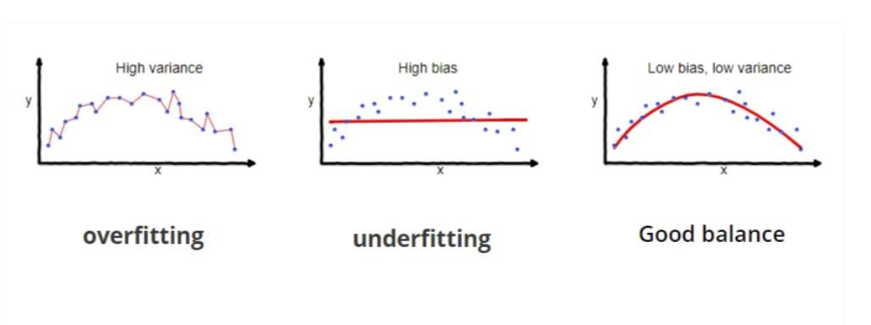

**Fig 25: Example of Overfitting [53].**

Overfitting primarily occurs in supervised learning and is characterized by a model's inability to generalize effectively from the training data to new, unseen data. This phenomenon is typically indicated by perfect or near-perfect performance during training and validation, but a marked decrease in performance when the model encounters the test set. However, if the test set closely resembles the training data, for instance, if both are derived from the same dataset through a train-validation-test split, the model may still exhibit high performance on the test set. Overfit models often memorize the data, including noise, instead of understanding and generalizing the underlying principles of the data [49].

To avoid overfitting in machine learning models, several strategies can be employed. Most notably:

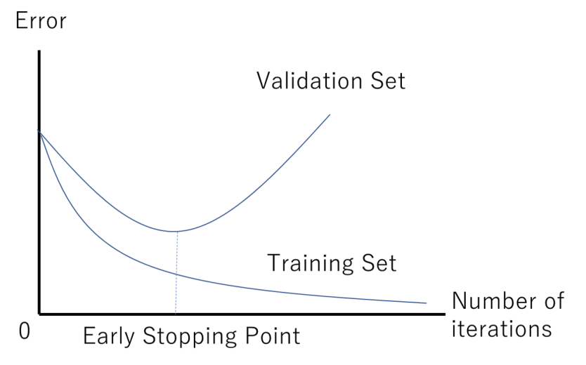

#### Fig 26: Example of Early Stopping Point [50]

* **Early Stopping:** This technique involves halting the training process when the model's performance on the validation set begins to decline. As illustrated in Figure 26, training ceases once the validation loss plateaus and then starts to increase. By implementing early stopping, we ensure that the model is retained in its optimal state of training. Continuing training beyond this point would likely lead to a deterioration

in the model's ability to generalize, to new data. Early Stopping is particularly useful in training neural networks where longer training times often lead to overfitting [49].

* **Data Augmentation:** This technique involves generating additional data by introducing variations to the existing dataset. It's achieved through modifications such as rotations, scaling, and other transformations in the case of image data, or synonym replacement and sentence restructuring for text data. Data augmentation not only helps in mitigating overfitting but is especially beneficial when dealing with small datasets that lack diversity. By expanding the dataset and introducing a wider range of examples, models can learn more robust and generalized patterns, enhancing their performance and reliability on unseen data [51][52].

* **Regularization:** This technique involves adding a penalty to the loss function to encourage simpler models. The three types of regularization are [53]:

* + **Lasso Regularization (L1)** plays a key role in inducing sparsity within a model by shrinking certain coefficients to zero, effectively aiding in feature selection. The mechanism of Lasso Regularization is analytically represented in the following equation:

𝒏 𝒎

𝑪𝒐𝒔𝒕 = 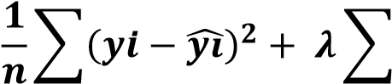|𝒘𝒊|

𝒊=𝟏 𝒊=𝟏

Where the first term of the equation is the mean squared error (MSE) over n samples, and the second term is the regularization term, where 𝜆 is a nonnegative hyperparameter that controls the strength of the regularization. The regularization term is the sum of the absolute values of the model coefficients 𝑤𝑖, summed over 𝑚 features.

* + **Ridge Regularization** (L2) minimizes coefficients but doesn't reduce them to zero, helping to manage multicollinearity and model complexity. The mechanism of Ridge Regularization is analytically represented in the following equation:

𝒏 𝒎

## 𝟏

𝑪𝒐𝒔𝒕 = ∑(𝒚𝒊 − 𝒚𝒊̂)𝟐 + 𝝀 ∑ 𝒘𝒊𝟐

𝒏

𝒊=𝟏 𝒊=𝟏

o **Elastic Net** combines both the L1 and L2 approaches, offering a balanced solution for enhanced model generalization. The algorithm for Elastic Net is analytically represented in the following equation.

𝒏 𝒎 𝒎

𝑪𝒐𝒔𝒕 = 𝟏 𝟐 + 𝝀((𝟏 − 𝜶) ∑|𝒘𝒊| + ∑ 𝒘𝒊𝟐)

∑(𝒚𝒊 − 𝒚𝒊̂)

𝒏

𝒊=𝟏 𝒊=𝟏 𝒊=𝟏

In this regularization technique a new hyperparameter is utilized 𝛼 which controls the ratio of the L1 and L2 regularization. When 𝛼 approaches zero then Elastic Net turns into L1 regularization and when 𝛼 approaches one then it turns into L2 regularization.

• **Cross-Validation:** This method serves as an important instrument for evaluating the generalizability of statistical analysis results to independent datasets but also functions as a tool to avoid overfitting. The intricacies of this technique, given its critical relevance to our research, will be explored in the subsequent section. **7.2.2 Cross-Validation**

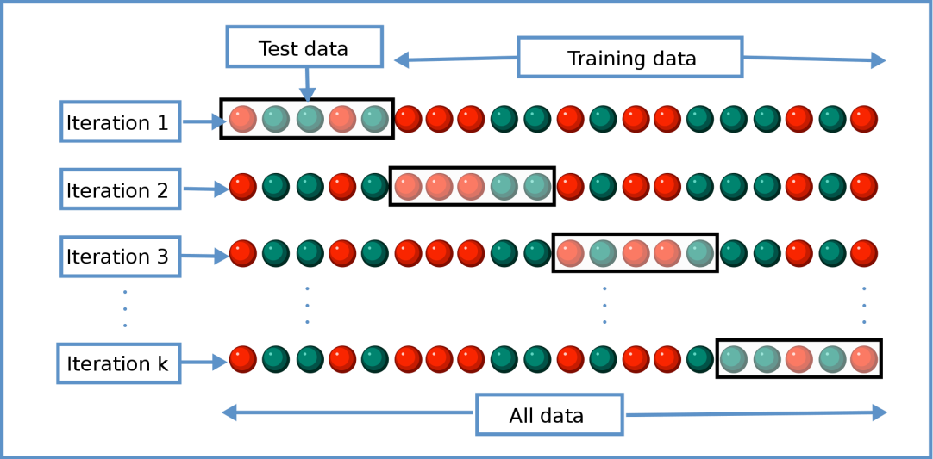

### Fig 27: Diagram of K-fold cross-validation [54]

Cross-validation operates as a statistical method to estimate the proficiency of machine learning models, evaluating their capacity to generalize to independent datasets. Additionally, it plays a pivotal role in preventing overfitting, an aspect that becomes particularly essential when working with limited data. The prevalent technique of cross-validation is K-Fold CrossValidation, which involves dividing the dataset into 'k' segments of equal size, known as 'folds.' The model undergoes training on 'k-1' of these folds and is evaluated on the remaining fold. This cycle is executed 'k' times, ensuring each fold is utilized once as the validation set, as illustrated in figure 27. The outcomes across all 'k' iterations are averaged to yield a comprehensive performance estimate. Typically, a 5-fold cross-validation is recommended for large datasets. However, for smaller datasets, such as in our study, increasing 'k' can yield a more reliable assessment. Consequently, we have selected 'k'=7 for our cross-validation process to align with the scale of our dataset [54].

### 7.2.3 Model Evaluation Metrics

As previously underscored, the evaluation of a model's performance is a critical element in the training process of machine learning models. Given that our task centers on binary classification, it is imperative to establish a foundational understanding related to the binary categorization of data, which will underpin all subsequent metrics.

* **True Positive Rate (TP):** The true positive rate is the count of data points correctly identified as belonging to the positive class.
* **True Negative Rate (TN):** The true negative rate is the count of data points correctly identified as belonging to the negative class.
* **False Positive Rate (FP):** The false positive rate is the count of data points incorrectly identified as belonging to the positive class when they actually belong to the negative class. In the context of this research this would mean a conversation is labelled as scam when in fact it is not.
* **False Negative Rate (FN):** The false negative rate is the count of data points incorrectly identified as belonging to the negative class when they actually belong to the positive class. This is of paramount importance to us since this would mean that a conversation is labelled as legitimate when in fact it is a scam.

The following section outlines the metrics that were employed to assess the performance of the models within the scope of this research.

* **Accuracy:** The percentage of correct predictions made by the model:

𝑻𝑷 + 𝑻𝑵

𝑨𝒄𝒄𝒖𝒓𝒂𝒄𝒚(𝑨𝑪𝑪) = 𝑷 + 𝑵

Where P is the total number of instances that belong to the positive class and N is the total number of instances that belong to the negative class.

* **Precision:** The ratio of correct positive predictions to the total predictions for the positive class. This metric is used in classification to measure the accuracy of the positive predictions made by a model.

𝑻𝑷

𝑷𝒓𝒆𝒄𝒊𝒔𝒊𝒐𝒏 = 𝑻𝑷 + 𝑭𝑷

* **Recall:** Recall, also referred to as sensitivity, is a vital metric in classification tasks, primarily focused on assessing a model's effectiveness in correctly identifying positive instances. This measure is especially critical in situations where the costs of missing a positive instance are significantly higher than those of wrongly categorizing a negative instance as positive.

𝑻𝑷

𝑹𝒆𝒄𝒂𝒍𝒍 =

𝑻𝑷 + 𝑭𝑵

* **F1-score:** This metric represents a balanced approach to evaluating both precision and recall, effectively accounting for both false positives and false negatives.

𝑷𝒓𝒆𝒄𝒊𝒔𝒊𝒐𝒏 × 𝑹𝒆𝒄𝒂𝒍𝒍

𝑭𝟏 − 𝒔𝒄𝒐𝒓𝒆 = 𝟐 ×

𝑷𝒓𝒆𝒄𝒊𝒔𝒊𝒐𝒏 + 𝑹𝒆𝒄𝒂𝒍𝒍

### 7.2.4 Optimizers

In the training of neural networks, the choice of optimizer plays a significant role in how quickly and effectively the model converges into a solution. This sub-section delves into the optimizers used in the context of training and tuning of the neural network based models for this research, namely Adam, Nadam, RMSprop, and SGD.

* **SGD**: Stochastic Gradient Descent (SGD), a variant of the Gradient Descent algorithm, is the most straightforward optimizer used in the training process of neural networks. It updates the model's parameters by taking the gradient of the loss function with respect to the parameters for a randomly selected batch of data instead of the whole dataset. Despite its inherent simplicity, SGD is computationally efficient when dealing with large datasets, especially when combined the tuning of its hyperparameters: momentum and learning rate [83][84].

* **RMSprop**: RMSProp, short for Root Mean Square Propagation, improves upon the concept of Gradient Descent by adapting the learning rate for each parameter. It calculates a moving average of squared gradients, allowing individual adjustments and preventing the learning rate from diminishing too quickly. This way of being able to make smooth adjustments on the learning rate for each parameter in the network makes RMSProp able to provide a better performance than regular Gradient Descent alone [85].

* **Adam:** Short for Adaptive Moment Estimation, combines the best properties of the AdaGrad and RMSprop algorithms to provide an optimization algorithm that can handle sparse gradients on noisy problems. It utilizes the concept of momentum by keeping track of an exponentially decaying average of past gradients (momentum) and an exponentially decaying average of past squared gradients (scale). This approach helps in navigating the rough landscapes of high-dimensional data, making it a preferred choice for training deep neural networks. Adam adjusts the learning rate for each parameter dynamically, giving it an edge in performance and efficiency [81][82].

* **Nadam:** Nadam, short for Nesterov-accelerated Adaptive Moment Estimation, merges the Adam optimization algorithm with Nesterov momentum. This approach considers the future location of parameters (thanks to the momentum term) and adjusts the updates accordingly. By this way it addresses a frequent challenge encountered in gradient descent optimization which is the issue of search progress deceleration, which can occur when encountering flat gradients or areas of large curvature in the loss landscape [86].

### 7.3 Model Architecture

Having established a foundational understanding, we now shift our discussion to the machine learning algorithms chosen for this research and their respective architectural frameworks.

#### 7.3.1 Logistic Regression

Logistic Regression, a supervised machine learning algorithm, is predominantly used for classification tasks and is particularly adept at binary classification. This predictive analysis technique models the probability of a binary outcome based on one or more predictor variables. It employs a logistic, or sigmoid, function that processes the independent variables to yield a probability value ranging between 0 and 1. While Logistic Regression shares similarities with Linear Regression in terms of its foundational principles, their applications differ significantly. Linear Regression is typically employed for regression problems where the goal is to predict a continuous outcome. In contrast, Logistic Regression is utilized for classification problems, especially where the objective is to categorize data into distinct classes. This key distinction lies in the nature of their output: Logistic Regression provides a probability score indicating class membership, as opposed to the continuous numerical output given by Linear Regression [56][57].

As mentioned above, the core of the algorithm is the logistic function or sigmoid function. This function maps any real-valued number into a range between 0 and 1. The function can be written as follows:

𝟏

𝝈(𝒛) = 𝟏 + 𝒆−𝒛

In this equation, ′𝑧′ represents the linear combination of the input features (X) and their corresponding weights (W), plus a bias term (b) and therefore we have the following:

𝒛 = (𝑾 × 𝑿) + 𝒃

The output given, is the probability 𝒑(𝒙 = 𝟏) = 𝝈(𝒛) = 𝟏+𝟏 𝒆−𝒛where 𝒑(𝒙 = 𝟏) is the probability that the sample belongs to the positive class, whereas 𝟏 − 𝝈(𝒛)is the probability that the sample belongs to the negative class.

To effectively train the Logistic Regression algorithm, it's crucial to adjust the weights to optimal values. This is achieved by minimizing a cost function. In Logistic Regression, this cost function is known as "log loss," which is represented in the following equation.

𝑵

𝟏

𝑪𝒐𝒔𝒕 = 𝑱(𝒃,𝑾) = − ∑[𝒚𝒊 × 𝒍𝒐𝒈(𝒚𝒊̂) + (𝟏 − 𝒚𝒊) × 𝒍𝒐𝒈(𝟏 − 𝒚𝒊̂)]

𝑵

𝒊=𝟏

Where ‘N’ is the number of samples, ′𝑦𝑖′ is the actual class label, and ′̂𝑦𝑖′ is the predicted probability that the sample belongs to the positive class.

Every time the cost function is calculated the weights are adjusted based on an optimization algorithm. Most of the time the optimization algorithm used is called “gradient descent” which is given in the following equation:

𝝏𝑱

𝑾𝒊𝒋 = 𝑾𝒊𝒋 − 𝒏 ×

𝝏𝑾𝒊𝒋

Where ′𝑛′ is called the learning rate. This crucial parameter is responsible for dictating the rate at which the algorithm's weights are adjusted. The learning rate controls how rapidly the model adapts to the problem: a smaller learning rate leads to slower learning and convergence, while a larger rate accelerates the learning process but may overshoot the optimal solution.

#### 7.3.2 Support Vector Machine

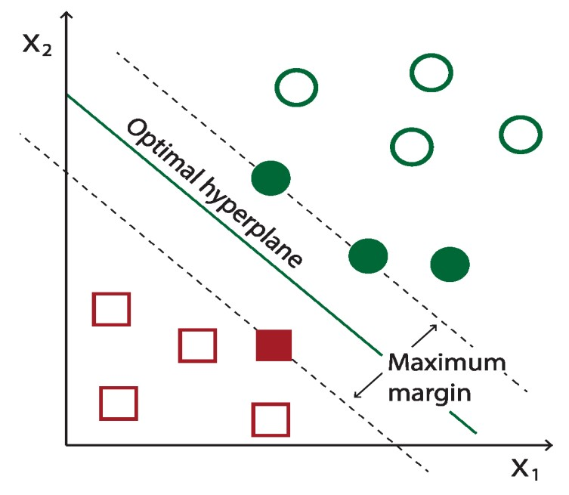

##### Fig 28: Example of SVM hyperplane [60]

The Support Vector Machine (SVM) stands as a powerful supervised learning algorithm, primarily applied in binary classification. Its primary function is to determine an ideal hyperplane that effectively divides two distinct classes within the feature space, ensuring the greatest possible margin, as illustrated in Figure 28. The fundamental objective is to accurately categorize new data points into one of the two classes, depending on their positioning in relation to this hyperplane [58][59].

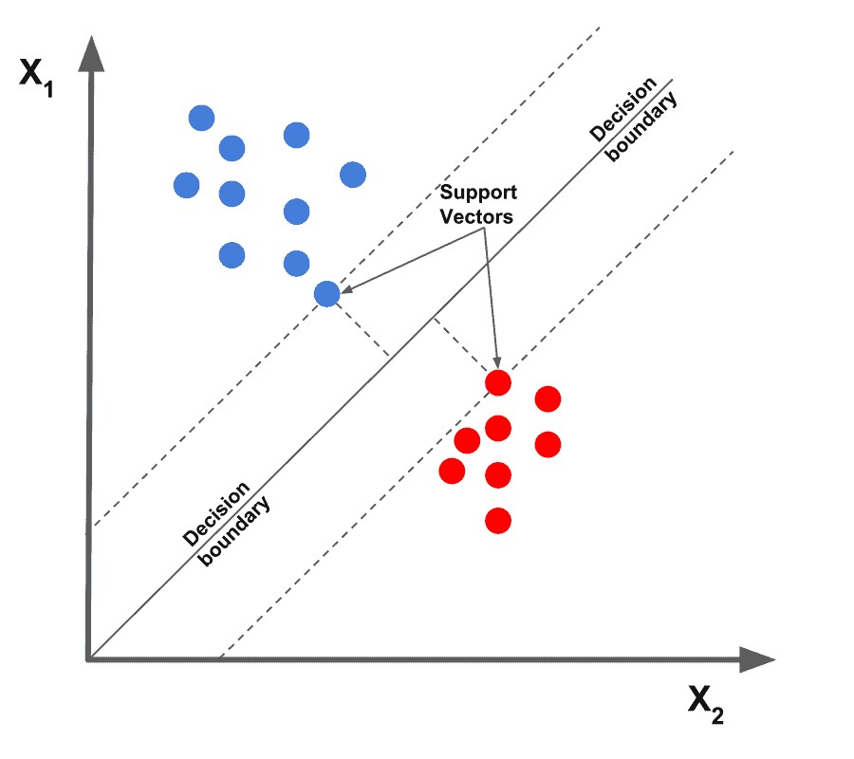

##### Fig 29: Support Vectors [61]

Central to the functionality of SVM are the support vectors, which are the data points nearest to the hyperplane. These points are instrumental in defining the hyperplane's position and orientation, as demonstrated in Figure 29. This hyperplane is often called the decision boundary. In two dimensions, it is a line; in three, a plane; and in higher dimensions, it is an N-1 dimensional subspace. The equation that describes the hyperplane is generally given by

[59]:

⃗𝒘⃗⃗ × 𝒙⃗ − 𝒃 = 𝟎

Where 𝑤⃗⃗ is the weight vector, 𝑥 is the feature vector and 𝑏 is the bias. Another fundamental concept in SVM is the 'margin,' which refers to the distance between the support vectors and the hyperplane. As previously noted, SVM's objective is to maximize this margin, enhancing the classifier's ability to distinguish between different classes effectively. The margin can be

𝟐 represented as [59]:

||𝒘⃗⃗⃗ ||

The training of an SVM model involves solving an optimization problem to find the vector 𝑤⃗⃗ and the bias 𝑏 that maximize the margin while correctly classifying the training data. To achieve this optimization the algorithm places a constraint that all data points must be on the correct side according to their label which is represented by the following equation:

𝒚𝒊(⃗𝒘⃗⃗ × ⃗𝒙⃗⃗ 𝒊  𝟏

Where ⃗𝒙⃗⃗ 𝒊 is a data point with label 𝑦𝑖 . To understand this constraint better, let’s see its functionality in depth. If 𝒚𝒊 is 1 (positive class), then ⃗𝒘⃗⃗ × ⃗𝒙⃗⃗ 𝒊 − 𝒃must be greater than or equal to 1, meaning the data point is correctly predicted as belonging to the positive class. On the contrary if 𝒚𝒊is -1 then ⃗𝒘⃗⃗ × ⃗𝒙⃗⃗ 𝒊 − 𝒃 must be less than or equal to -1, which after multiplying by 𝒚𝒊 = −𝟏, becomes greater than or equal to 1, ensuring correct classification.

Once the model is trained via the above procedure, classification of a new data point 𝒙⃗ is done using the sign of⃗𝒘⃗⃗ × 𝒙⃗ − 𝒃. If the sign is greater than zero then the data point is classified into one class, else into the other class [59].

#### 7.3.3 Random Forest

Before we delve into the Random Forest algorithm, chosen for its robust performance in our task, it is essential to first comprehend the workings of a decision tree, which serves as the foundational building block of the Random Forest.

##### 7.3.3.1 Decision Trees

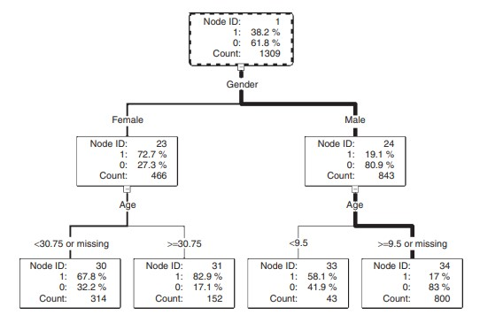

###### Fig 30: A decision tree illustrating analysis of survival in Titanic Sinking [62]

The decision tree stands as a formidable model in the realm of classification, functioning as a hierarchical decision support tool. This model is characterized by a tree-like structure of decisions, resembling a flowchart. At each internal node of the tree, a decision based on a feature (or attribute) is made. Branches extending from these nodes denote the possible outcomes of these decisions, leading to subsequent nodes or terminating at leaf nodes, which represent the final outcomes or classification labels. The root node sits at the apex of this structure, initiating the partitioning of the dataset. This partitioning unfolds in a recursive manner, a process known as recursive partitioning, where the dataset is successively split according to the most discriminative features until the termination criteria are met, and the leaf nodes are reached [63].

The construction of a decision tree is a sequential process. It begins with the division of the root node, creating branches that lead to subsequent nodes or leaves. The nodes within a decision tree group together observations that are similar to each other. This similarity is determined based on the chosen features within a node. However, these groups are distinct and different from the groups in other nodes at the same level of the tree, ensuring that each branch represents a unique partition of the data based on specific criteria. The branching decisions are derived from an exhaustive examination of the dataset to identify the most informative data fields, referred to as 'inputs', which can effectively partition and capture the variability present in the target variable as represented in the root node. Upon selection of an appropriate input, the tree grows by forming new descendant nodes [62].

A decision tree uses a collection of algorithms to decide how to split the data at each node. In this study, our attention is primarily on the CART (Classification and Regression Trees) algorithm, which is the underlying mechanism for both the Random Forest and Gradient Boosted Trees algorithms. CART employs the Gini Impurity metric to decide on the optimal way to split the data at each node. Gini Impurity quantifies the likelihood of incorrect classification of an element in the dataset if it were randomly labeled, based on the current composition of the node. Essentially, it measures the 'purity' of a node in the tree, with lower values indicating more homogeneous nodes. During the decision-making process, the algorithm selects the feature for splitting those results in the largest **decrease** in Gini Impurity. This metric is calculated using the following formula [64]:

𝒏

𝑮𝒊𝒏𝒊(𝑫) = 𝟏 − ∑ 𝒑𝒊𝟐

𝒊=𝟏

Where ‘**D**’ is the dataset or subset of the dataset and 𝒑𝒊represents the proportion (or frequency) of class ‘i’ within the set. The sum term of the equation is computed over all unique classes (n) present in the subset. Therefore, for a binary classification task the equation simplifies to:

𝑮𝒊𝒏𝒊(𝑫) = 𝟏 − (𝒑𝟏𝟐 + 𝒑𝟐𝟐)

The Random Forest algorithm operates as an ensemble of Decision Trees, where each tree independently contributes a prediction. The algorithm aggregates these individual predictions, employing a majority voting system for classification tasks, to arrive at a final decision. This ensemble approach effectively mitigates risks such as overfitting, which might be prevalent in a solitary Decision Tree [65].

To create the individual decision trees, the Random Forest algorithm relies upon the method of **bagging**.The bagging process involves creating numerous bootstrap samples from the original training dataset. For each bootstrap sample—randomly drawn with replacement and equal in size to the original dataset—a Decision Tree is trained, leading to slight variations in each tree due to the different subsets of data.

#### 7.3.4 Gradient Boosted Trees

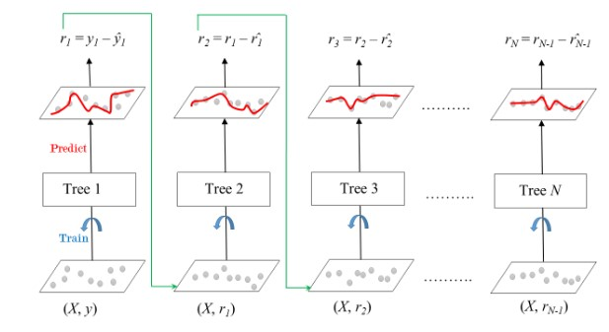

##### Fig 31: Sequential Construction of Trees in Gradient Boosting [68]

Gradient Boosted Trees (GBTs) are an ensemble learning technique that builds upon the concept of decision trees differing from those on how the trees are constructed. In Random Forests trees grow in parallel, whereas GBTs construct trees sequentially as depicted in Figure 31, where each new tree incrementally improves upon the previous trees by correcting the errors made by the predecessor. The "gradient boosting" part comes from the use of gradient descent to minimize the loss when adding new models. Each tree is fitted on the residual errors of the whole ensemble to date, effectively taking the gradient step in the space of possible predictions to reduce the loss. This compounding of small, weak decision trees continues until no significant improvements can be made or a specified number of trees is reached. The result is a potent predictive model that combines the strengths of numerous simple models into a single ensemble. The process of gradient boosting trees can be described by the following equations [67][68]:

The loss function, which is the difference between the actual and predicted values:

𝑵

𝑳(𝒚, 𝑭(𝒙)) = ∑ 𝑳(𝒚𝒊,𝑭(𝒙𝒊))

𝒊=𝟏

The goal of the gradient boosted algorithm is to minimize this loss. The process starts with the initial model 𝑭𝟎(𝒙)**.** For each data point (𝒙𝒊,𝒚𝒊) the residual is calculated which represents the error of the current model. This residual is calculated as follows:

𝝏𝑳(𝒚𝒊,𝑭(𝒙𝒊))

𝒓𝒕𝒊 = − 𝝏𝑭(𝒙𝒊)

Then, a new decision tree 𝒉𝒕(𝒙) is trained, not to predict the actual target values, but to predict these residuals. In essence the new tree is learning how to correct the mistakes of the previous tree and hence the updated model is given as follows:

𝑭𝒕(𝒙) = 𝑭𝒕−𝟏(𝒙) + 𝒏 × 𝒉𝒕(𝒙)

Where 𝒏is the learning rate of the algorithm. This process is repeated either for a specific preset number of iterations or until the improvement becomes negligible.

#### 7.3.5 Neural Networks

Neural networks represent a cornerstone of a specific area of modern machine learning called deep learning, drawing inspiration from the biological neural networks that constitute animal brains. At their core, neural networks are a series of algorithms designed to recognize underlying relationships in a set of data through a process that mimics the way the human brain operates.

A Neural Network operates through a network of interconnected neurons, collectively working to solve complex problems. Such a structure can be seen in Figure 30. In the following sections the workings and structure of Neural Networks will be thoroughly discussed.

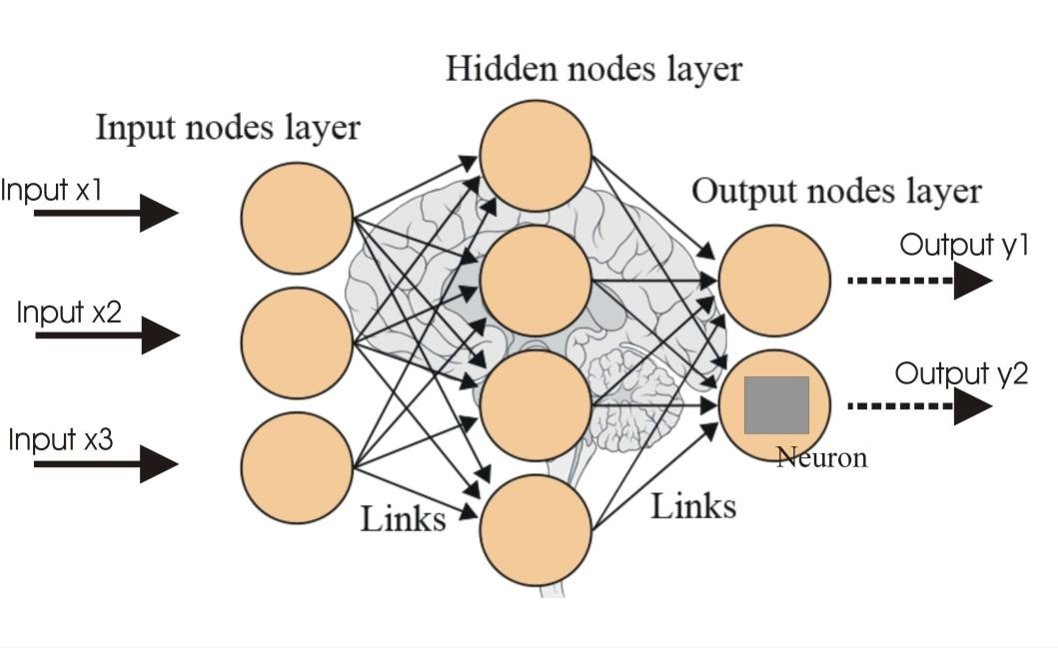

##### Fig 32: Depiction of the Structure of a Neural Network [69]

A Neural Network broadly consists of 3 consecutive layers of neurons. The first layer is called **input layer,** the layers following the input layer can be multiple in number and are called **hidden layers** and finally the last layer is called the **output layer**.

* **Input** **Layer**: The input layer serves as the initial point of data entry for the problem being addressed. It consists of input neurons, such as input x1, input x2, input x3 as illustrated in Figure 32. These neurons are responsible for receiving the input information but do not perform any computational processing. Instead, their role is to simply relay this information to the subsequent hidden layers.

* **Hidden Layers:** Hidden layers are composed of neurons that receive information from either the input layer or preceding hidden layers. Unlike neurons in the input layer, neurons in hidden layers actively perform computations. These computations depend on the information received from previous layers, combined with specific weights and biases. Each neuron in these layers applies an activation function to the weighted sum of its inputs, introducing non-linearities that enable the network to learn complex patterns and relationships in the data. The output of these neurons is then passed on to the next layer in the network, whether it's another hidden layer or the output layer.

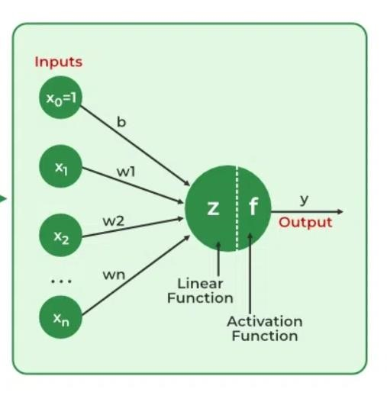

##### Fig 33: Depiction of Neuron’s Output Calculation [70]

Before exploring the neuron's output calculation, it's essential to understand the role of the **'Activation Function'**. This function takes the neuron's output and transforms it into a format suitable for the problem at hand, often introducing non-linearity into the model. Some of the most prominent activation functions used in neural networks include the following [71]:

* **Sigmoid**: The **Sigmoid** activation function is designed to constrain the output of a neuron to a value between 0 and 1. It is particularly useful in the output layer of binary classification tasks, where the outcomes are binary: 0 typically represents the negative class, and 1 represents the positive class. When the Sigmoid function outputs a prediction greater than 0.5, the model interprets the input data as belonging to the positive class; conversely, a prediction less than 0.5 is interpreted as belonging to the negative class. The equation of the sigmoid function is as follows:

𝟏

𝒇(𝒙) = 𝟏 + 𝒆−𝒙

* **Tanh:** The **tanh**, or hyperbolic tangent, activation function serves as a scaled version of the sigmoid, and it is commonly employed in the hidden layers of a neural network. Its output ranges between -1 and 1, effectively centering the data and bringing the mean output of the neurons closer to 0, which can improve learning in deeper layers. The mathematical representation of the tanh function can be written as follows:

𝟐

𝒇(𝒙) = 𝒕𝒂𝒏𝒉(𝒙) = 𝟏 + 𝒆−𝟐𝒙 − 𝟏

* **ReLU:** The **ReLU**, or Rectified Linear Unit, activation function is a widely used choice for the hidden layers in neural networks. If a neuron's output is positive, the ReLU function allows that value to pass without change; if the output is negative, ReLU sets it to 0. This function is computationally efficient compared to tanh and sigmoid functions, making it a preferred option in scenarios that demand rapid predictions. The mathematical representation of this function is given as follows:

|  |  |
| --- | --- |
| 𝟎,  𝒇(𝒙) = {  𝒙, | 𝒙 < 𝟎    𝒙 ≥ 𝟎 |

* **SoftMax:** The **SoftMax** function, an extension of the sigmoid, is mostly used for multiclass classification tasks within neural networks. Typically existing in the output layer when the network is designed to handle multiple classes, the SoftMax function normalizes the output into a probability distribution. It ensures that the output values fall between 0 and 1, and that the sum of all the probabilities equals 1. The function achieves this by exponentiating each output, then dividing each by the sum of all exponentiated outputs. This process allows the network to represent the probability that the input corresponds to each class. The formula for the SoftMax function can be written as follows [72]:

𝒆𝒛𝒊

𝒇(𝒛𝒊) = ∑𝑲𝒋=𝟏 𝒆𝒛𝒋

Where 𝒛𝒊is the input to the SoftMax function for the 𝒊 − 𝒕𝒉 class and 𝑲 is the total number of classes in the multiclass classification problem.

The comprehensive output of a neuron, as depicted in Figure 31, is calculated through a mathematical formula that uses the weighted sum of its inputs followed by the application of an activation function. This calculation can be mathematically expressed as follows:

𝒏

𝒚 = 𝒇(𝒛) = 𝒇(∑𝒘𝒊 × 𝒙𝒊 + 𝒃)

𝒊=𝟏

Where 𝒃is the bias term associated with the neuron, 𝒘𝒊represents the weight assigned to the 𝒊 − 𝒕𝒉input, 𝒙𝒊is the value of the 𝒊 − 𝒕𝒉input and 𝒏is the total number of inputs to the neuron. Finally, 𝒇(𝒛)is denotes the activation function which was discussed above. This process yields the neuron’s complete output which is then passed on to the following layers. This process of information passing through the network from one layer to another, with the mechanism outlined above, is called **Forward Propagation.**

* **Dropout Layer:** The dropout mechanism serves to randomly deactivate a subset of neurons in the layer during training, simulating sparse activation and introducing noise into the training process. This approach forces the remaining active nodes in the subsequent layer to adapt by either assuming more or less responsibility for the given inputs. Using dropout layers is an effective strategy for decreasing overfitting, as it prevents the model from becoming overly reliant on any specific set of neurons [73].

* **Output Layer:** This is the final layer of the neural network and is responsible for producing the end result that corresponds to the format required for the specific task the network

is designed for. For the problem at hand, the output will be a single value signifying the probability of the provided conversation being ‘Vishing’ or ‘Normal’.

Having discussed Forward Propagation, we must now turn to how the Neural Networks learn. In the learning process of a Neural Network, the primary objective is to minimize the output error. To achieve this, a loss function is employed that quantifies the difference between the network's predictions and the actual labels during each training epoch. For binary classification tasks, such as the one undertaken in this study, the most commonly used loss function is 'Binary Cross-Entropy'. As outlined in Chapter 7.2.1, coupling this loss function with a regularization term is crucial to prevent overfitting. The combined loss function, incorporating both Binary Cross-Entropy and regularization, can be mathematically represented as follows:

𝑵 𝒎 𝒎

𝑳 = − [𝒚𝒊 𝐥𝐨𝐠(𝒑𝒊) + (𝟏 − 𝒚𝒊)𝐥𝐨𝐠 (𝟏 − 𝒑𝒊)] + 𝝀𝟏 ∑|𝒘𝒋| + 𝝀𝟐 ∑ 𝒘𝒋𝟐

𝒊=𝟏 𝒋=𝟏 𝒋=𝟏

Where 𝒚𝒊is the actual label of the 𝒊 − 𝒕𝒉 observation (0 or 1) and 𝒑𝒊is the predicted probability of the 𝒊 − 𝒕𝒉observation. The term 𝝀𝟏 ∑𝒎𝒋=𝟏|𝒘𝒋| **,** also known as Ridge Regularization, is the first part of the regularization term and 𝝀𝟐 ∑𝒎𝒋=𝟏 𝒘𝒋𝟐**,** also known as Lasso Regularization, is the second part of the regularization term. As covered in chapter 7.2.1 those two terms together form the Elastic Net regularization with 𝝀𝟏and 𝝀𝟐being the regularization parameters that control the strength of each regularization term.

The loss function plays a primary role in helping the neural network update its weights and biases, thereby enabling the network to learn from its errors. This adjustment of weights and biases is accomplished using the gradient descent algorithm. Gradient descent aims to minimize the loss function by continuously modifying the neuron weights in the direction that most reduces the loss. This iterative process continues until the algorithm converges to a minimum, a point where further reductions in the loss function are not possible. The mathematical representation of the gradient descent algorithm can be written as follows [74]:

𝒍 = 𝑾𝒋𝒌𝒍 − 𝜸 𝝏𝑳 𝒍

𝑾𝒋𝒌

𝝏𝑾𝒋𝒌

Where 𝑳is the loss function, 𝑾𝒋𝒌𝒍is the weight for the 𝒋neuron that belongs to 𝒍layer with

𝝏𝑳

𝒌input. The term 𝜸is the learning rate and 𝝏𝑾𝒋𝒌𝒍is the gradient for that neuron.

The gradient descent algorithm serves as an optimization technique for minimizing the loss function in a neural network. However, it alone does not facilitate the communication of how each weight should be adjusted throughout the network. A common way to achieve this communication is via the process of **Back propagation** [75]. Back propagation is employed to calculate the gradients of the loss function with respect to each weight in the network and communicate these gradients back through the network's layers. This process enables the gradient descent algorithm to accurately adjust the weights, and by doing so optimize the network's performance.

To better understand the complete process of Forward propagation and Back propagation let us look at a simple example.

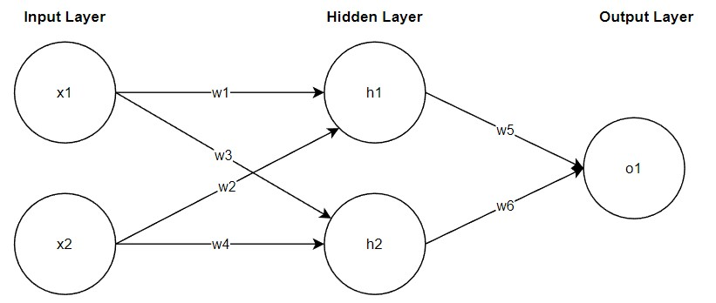

##### Fig 34: Simple Example of Neural network Structure

Assume the Neural Network structure depicted in Figure 34. This example Neural Network consists of two neurons in the input layer (x1, x2), two neurons in its single hidden layer (h1, h2) and a singular output neuron in the output layer (o1). Suppose that the activation function used throughout the network is the sigmoid activation function (σ).

Starting with the Forward Pass or Forward Propagation the output values of the neurons can be calculated as follows:

𝒉𝟏 = 𝝈(𝒘𝟏 ∗ 𝒙𝟏 + 𝒘𝟐 ∗ 𝒙𝟐 + 𝒃𝟏)

𝒉𝟐 = 𝝈(𝒘𝟑 ∗ 𝒙𝟏 + 𝒘𝟒 ∗ 𝒙𝟐 + 𝒃𝟏)

𝒐𝟏 = 𝝈(𝒘𝟓 ∗ 𝒉𝟏 + 𝒘𝟔 ∗ 𝒉𝟐 + 𝒃𝟐)

The output of the network is determined by the neuron 𝒐𝟏 in the output layer. This marks the end of the forward pass. Subsequently, the weights of the network need to be updated based on the calculated loss. In this example, we assume that the loss is calculated using the Mean

𝟏 𝟐where 𝒚is the

Squared Error (MSE) equation, which is given by: 𝑳 = 𝑴𝑺𝑬 = 𝟐 (𝒚 − 𝒐𝟏) target output (label).

To achieve this the back propagation process implements the following steps, which can be represented in mathematical form as written below:

Calculate Gradients for Output Layer:

* 𝝏𝝏𝑳𝒐𝟏 = (𝒐𝟏 − 𝒚) × 𝝈′(𝒐𝟏)

* 𝝏𝝏𝑳𝒘𝟓 = 𝝏𝝏𝑳𝒐𝟏 × 𝒉𝟏
* 𝝏𝝏𝑳𝒘𝟔 = 𝝏𝝏𝑳𝒐𝟏 × 𝒉𝟐

Propagate Error to Hidden Layer:

* 𝝏𝝏𝑳𝒉𝟏 = 𝝏𝝏𝑳𝒐𝟏 × 𝒘𝟓 × 𝝈′(𝒉𝟏)
* 𝝏𝝏𝑳𝒉𝟐 = 𝝏𝝏𝑳𝒐𝟏 × 𝒘𝟔 × 𝝈′(𝒉𝟐)

Calculate Gradients for Hidden Layer:

* 𝝏𝝏𝑳𝒘𝟏 = 𝝏𝝏𝑳𝒉𝟏 × 𝒙𝟏
* 𝝏𝝏𝑳𝒘𝟐 = 𝝏𝝏𝑳𝒉𝟏 × 𝒙𝟐
* 𝝏𝝏𝑳𝒘𝟑 = 𝝏𝝏𝑳𝒉𝟐 × 𝒙𝟏
* 𝝏𝝏𝑳𝒘𝟒 = 𝝏𝝏𝑳𝒉𝟐 × 𝒙𝟐

Having calculated all the gradients, the gradient descent algorithm can now update the weights as was shown previously using this equation:

𝒍 = 𝑾𝒋𝒌𝒍 − 𝜸 𝝏𝑾𝝏𝑳𝒋𝒌𝒍𝑾𝒋𝒌

##### 7.3.5.1 LSTM Neural Networks

Having established the foundational principles of how Neural Networks function, we now transition to exploring a specialized Neural Network architecture known as the Long ShortTerm Memory (LSTM) Network. This network is engineered to identify the relevance of information over extended sequences, essentially learning when to retain and when to discard certain pieces of information. Such capability enables the LSTM to identify and preserve information that may be useful later in a sequence while discarding what becomes irrelevant. A prime application of this is in natural language processing tasks, where the network adeptly grasps grammatical dependencies and other contextual nuances [76].

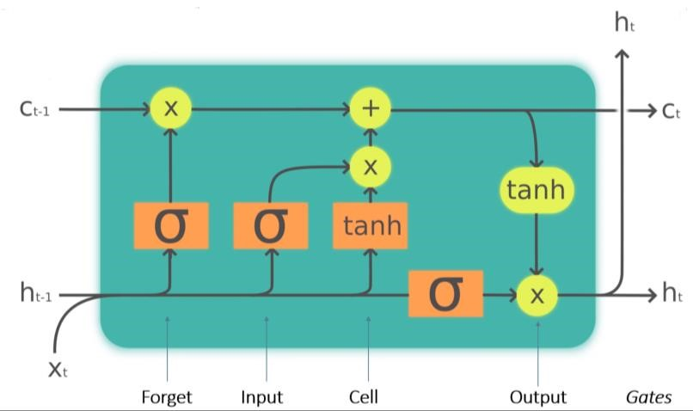

###### Fig 35: LSTM Cell Structure [78]

To achieve this functionality, the LSTM network makes use of LSTM cells that have the structure depicted in Figure 35. The key components and functions of the LSTM cell are the following [77]:

* **Cell State:** The cell state acts like the ‘memory’ of the LSTM cell. It carries information throughout the sequence of data. It has the ability to add or remove information using the gates.

* **Gates:** The gates are a way to optionally let information through. They are composed of a sigmoid net layer and a pointwise multiplication operation. There are three types of gates in an LSTM cell:

* + **Forget Gate:** This gate is responsible for discarding information deemed not useful. The gate takes two inputs, 𝑿𝒕(input at that particular time) and 𝒉𝒕−𝟏 (previous cell state). Those inputs are multiplied with weight matrices and are added with a bias. The result is passed through an activation function which outputs a binary result. If the output of that function is 0 then the piece of information is forgotten; in contrast if the output is 1 then the information is retained.

* + **Input Gate:** The input gate is responsible for integrating valuable information into the cell state. Initially, a sigmoid function regulates the incoming information, functioning analogously to the forget gate by filtering which values should be retained based on the inputs 𝒉𝒕−𝟏and 𝑿𝒕**.** Subsequently, a new vector is created with output values ranging from -1 to +1 using the tanh activation function. Finally, the product of the vector and the regulated values yields the information deemed useful for retention in the cell state.

* + **Output Gate:** The output gate’s function is to select valuable information from the current cell state to form the output of the cell. The process begins with the application of the tanh activation function to the cell state. This vector is modulated by a sigmoid function which filters the information based on the current inputs 𝒉𝒕−𝟏and 𝑿𝒕**.** The final step involves the multiplication of this vector with the sigmoid output resulting in the final output of the cell which also serves as the input to the subsequent cell.

* **Hidden State:** The hidden state in an LSTM cell, often denoted as 𝒉𝒕 is a dynamic component that carries information from one cell to the next time step within a sequence. As outlined above this hidden state along with the input 𝑿𝒕 regulates the gates and is also used to generate the output of the cell.

A complete structure example of an LSTM Neural Network can be seen in Figure 34. The link between LSTM Cell is the hidden state being passed from one cell to the next as mentioned above.

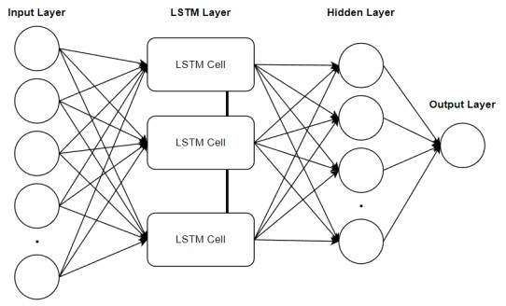

**Fig 36: LSTM Neural Network Structure Example**

### 7.4 Model Training - Tuning – Results

This section of the dissertation delves into the processes of model training, tuning, and the results obtained from validating these models. Each model underwent training using an identical dataset and was subsequently validated and tested using consistent sets to ensure comparability of results. The original dataset was divided as follows: 80% was allocated for training, which during the training phase was further split into a validation set constituting 20% of the training subset, with the remaining 80% used for the actual training. The final 20% of the original dataset was reserved for the test set. This structured approach to data allocation facilitates a thorough examination of each model's performance and generalization capabilities. In the following subsections, there will be a comprehensive analysis of how each model was trained and tuned along with its training results.

Given the nature of the task of this study, which emphasizes the importance of accurately identifying ‘Vishing’ conversations, all models were trained focusing on optimizing the ‘Recall’ metric. This approach helps the system minimize the risk of incorrectly classifying ‘Vishing’ conversations as ‘Normal’.

#### 7.4.1 Logistic Regression

The training of the Logistic Regression model was conducted within the PySpark framework. For this process, we employed the Logistic Regression library, along with the ParamGridBuilder and CrossValidator components, which were used in the tuning process for the model.

As outlined in Chapter 3.3.2.2, the ParamGridBuilder component, when used in conjunction with an evaluation tool, serves to hyperparameter tune the model through the exploration of a predefined grid of parameters. In essence, this process involves supplying a range of possible parameter values and testing each combination to identify the optimal configuration. The outcome of this procedure is the selection of the best-performing model variant based on the specified hyperparameter combinations.

For the training of the Logistic Regression model, three hyperparameters were used in the grid:

* **maxIter:** This parameter controls how many training epochs the model will be put through.
* **regParam:** This parameter controls the strength of the regularization applied to the model. A higher value means more regularization whereas a lower one means less regularization.
* **elasticNetParam:** This parameter handles the balance between L1 and L2 regularization, ranging from 0 to 1. A value of 0 indicates pure L2 regularization, whereas a value of 1 denotes exclusive L1 regularization, and values in between imply a mix of both.

The grid of values for these hyperparameters is the following:

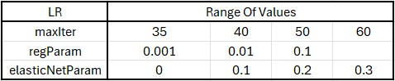

##### Fig 37: Hyperparameter range of values for Logistic Regression

During the training phase, cross-validation was employed, utilizing a seven-fold approach. Following the training and cross-validation, the optimal model was determined based on its hyperparameters. The best-performing model had a maxIter of 40, a regParam of 0.01, and an elasticNetParam set to 0.1. This combination of hyperparameters represented the most effective configuration for the task.

The results of the training process for the Logistic Regression model can be viewed in the following table.



##### Fig 38: Logistic Regression Training Results

The metrics indicate strong performance by the model on the test set, which suggests effective learning of data patterns and successful generalization without overfitting to the training data. High accuracy points to good overall performance, while the high precision, recall, and F1 score metrics demonstrate the model's capability to accurately identify 'Vishing' conversations while balancing between detecting as many true positives (‘Vishing’) instances as possible (high recall) and maintaining a low rate of false positives (high precision), as reflected in the balanced F1 score.

#### 7.4.2 Random Forest

Similarly, to the Logistic Regression model, the Random Forest model was trained within the PySpark framework and with the same components. For the training of the model three hyperparameters were used in the grid.

* **numTrees:** This parameter determines the number of trees in the forest. Increasing the number of trees typically results in higher variance and adds complexity to the model.
* **maxDepth:** This parameter specifies the maximum depth of each tree in the forest. A deeper tree introduces more complexity but also increases the risk of overfitting to the training data. Conversely, a shallower tree might underfit, failing to capture patterns.
* **maxBins:** This parameter sets the maximum number of bins used for splitting continuous features and choosing split points for categorical features. A larger maxBins value enables the algorithm to consider a greater number of split points, potentially leading to more accurate models, particularly for continuous features.

The grid of values for these hyperparameters is the following:

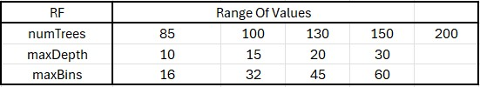

##### Fig 39: Hyperparameter range of values for Random Forest

Cross-validation with seven folds was similarly implemented in the training of this model. The process yielded an optimal set of hyperparameters for the Random Forest model. The best configuration identified from the training consisted of a numTrees set to 150, a maxDepth of 30, and a maxBins set to 16.

The results of the training process for the Random Forest model can be viewed in the following table.



##### Fig 40: Random Forest Training Results

Much like the Logistic Regression model, the Random Forest model's test set results are very encouraging. The model shows high performance across all metrics, indicating a strong capability to identify 'Vishing' conversations. Moreover, the balanced F1 Score indicates the model's proficiency in maintaining a balance between precision and recall, ensuring that it neither misses too many actual 'Vishing' instances nor misclassifies too many 'Normal' conversations as 'Vishing'.

#### 7.4.3 Support Vector Machines

For the training of the Support Vector Machine model, the following two hyperparameters were used in the grid.

* **regParam:** This is similar to the Logistic Regression’s regParam, and it controls the strength of the regularization used in training.
* **maxIter:** This parameter controls how many training epochs the model will be put through.

The grid of values for these hyperparameters is the following:

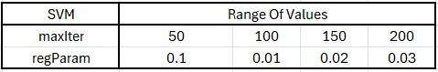

##### Fig 41: Hyperparameter range of values for Support Vector Machines

In this model training, cross validation with seven folds was used as well. The training process resulted in the following best performing parameter configuration. The optimal solution consisted of a maxIter of 200, and regParam equal to 0.02.

The results of the training process for the Support Vector Machines model can be viewed in the following table.



##### Fig 42: Support Vector Machines Training Results

The results of the Support Vector Machines algorithm are slightly worse than those of the previous two algorithms. However, the metrics still indicate very good performance from the model all around.

#### 7.4.4 Gradient Boosted Trees

For the training of the Gradient Boosted Trees model, the following three hyperparameters were used in the grid.

* **maxIter**: This parameter controls the maximum number of trees to be built.
* **maxDepth**: This parameter controls the maximum depth of each tree, and therefore how complex each tree can be.
* **stepSize**: This parameter regulates the contribution of each tree to the final model. A smaller step size means that each tree has a smaller impact, necessitating a larger number of trees for convergence but typically resulting in a better model.

The grid of values for these hyperparameters is the following:

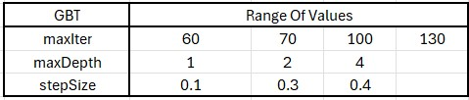

##### Fig 43: Hyperparameter Range of Values for Gradient Boosted Trees

Seven fold cross validation was also implemented in the training of this model. The optimal parameter configuration that resulted from the training process had maxIter equal to 130, maxDepth equal to 4 and stepSize equal to 0.4.

The results of the training process for the Support Vector Machines model can be viewed in the following table.



##### Fig 44: Gradient Boosted Trees Training Results

The Gradient Boosted Trees model's performance in comparison to the previous models stands as the best one. It displays all four metrics above the 90% threshold signifying very good overall performance.

#### 7.4.5 Neural Network

The training of the Neural Network model in this study deviated from the approach used for the previous models, as it was not executed within the PySpark framework. Instead, the Keras library, a high-level neural networks API, was employed for model construction.

The training and optimization of Neural Network models can be a complex and timeconsuming process, requiring careful selection of hyperparameters to ensure the best possible performance. In the optimization of the Neural Network model for this study, we employed the HyperModel and HyperBand classes from the Keras Tuner library to automate this process. The HyperModel class allowed for flexible definition of the model's hyperparameter search space, while HyperBand was used because of its efficient tuning algorithm based on adaptive resource allocation and early stopping. This combination enabled a search across a wide range of hyperparameters, such as layer configurations, dropout rates, and optimizer settings, to find the optimal model configuration with minimal computational overhead. By evaluating and discarding suboptimal models early in the training process, HyperBand ensures that computational resources are concentrated on the most promising models, which finally leads to the identification of an optimized Neural Network model [79][80].

The hyperparameters that were tuned as a part of this process are the following:

* **Number of Neurons:** The number of neurons in each of the three dense layers of the model were tuned. For the first, second, and third layers, the number of neurons varied between 16 and 128, in steps of 16. This range was chosen to explore the impact of model complexity on performance, from relatively simple models to more complex ones that can capture intricate patterns in the data.

* **Regularization:** L1 and L2 regularization was employed for each layer to mitigate the risk of overfitting by penalizing large weights. The regularization strength for both L1 and L2 regularization was tuned within the logarithmic range of 1e-7 to 1e-1.

* **Dropout Rate:** To further deal with overfitting and promote model generalization, dropout layers were introduced after each dense layer. The dropout rate varied from 0.0 to 0.7 in steps of 0.05, aiming to find the balance between retaining and discarding information during training across the layers.

* **Optimizer:** Four optimizers were considered: Adam, SGD (Stochastic Gradient Descent), RMSprop, and Nadam. For each of these optimizers their respective tunable hyperparameters were tested. In detail, for the “adam” optimizer the learning rate, beta_1 and beta_2 variables were tested; for the “sgd” optimizer the learning rate and momentum variables were tested; for the “nadam” optimizer the learning rate, beta_1 and beta_2 variables were tuned and finally for the “rmsprop” optimizer the learning rate and rho variables were tuned.

* **Learning Rate:** Associated with each optimizer choice, the learning rate was tuned within a logarithmic scale of 1e-5 to 1e-2. The learning rate dictates the size of the steps taken during optimization, affecting the speed and stability of the training process.

As a result, the final architecture of the best model contained the following hyperparameters:

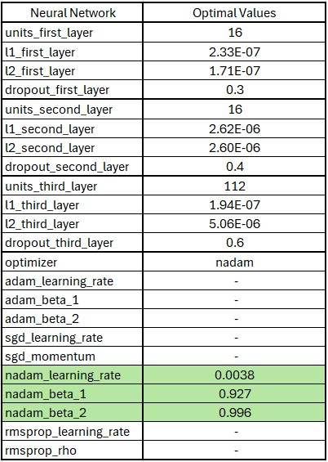

##### Fig 45: Optimal Hyperparameters as a result of the tuning process for the Neural Network

As can be seen in the above Figure, the optimal architecture output from the training and tuning process of the Neural Network is listed subsequently:

* **Input Layer:** 
  + Number of Neurons: The **first DENSE layer** consists of 16 neurons.
  + Regularization: L1 and L2 regularization strengths are set at approximately

2.33e-07 and 1.71e-07, respectively.

* + Dropout: A dropout rate of 30% is applied after the first dense layer.
  + Activation Function: The ‘ReLU’ activation function is employed in the first layer.
* **Second Layer (Hidden):** 
  + Number of Neurons: The **second DENSE layer** is composed of 16 neurons. o Regularization: For this layer, both L1 and L2 regularization strengths are finely tuned to approximately 2.62e-06 and 2.60e-06, respectively.
  + Dropout: A more moderate dropout rate of 40% is employed, balancing the need for regularization with the desire to preserve information flow through the network.
  + Activation Function: The ‘ReLU’ activation function is employed in the second layer.
* **Third Layer (Hidden):** 
  + Number of Neurons: The **third DENSE layer** contains 112 neurons.
  + Regularization: The L1 and L2 regularization strengths for this layer are approximately 1.94e-07 and 5.06e-06, respectively. o Dropout: The dropout rate climbs to 60%, in contrast to the previous layers, the dropout here is considerably higher. o Activation Function: Similarly to the previous layers, the ‘ReLU’ activation function is used once again in this Dense layer.
* **Output Layer:** 
  + The model concludes with a single-neuron output layer utilizing the sigmoid activation function.
* **Optimizer:** 
  + The optimizer that resulted in the best performance during the tuning process is the “nadam” optimizer with its beta_1 and beta_2 hyperparameters are 0.927 and 0.996 respectively and a learning rate of 0.0038 as shown in Figure 45.

The results of the training process can be seen in the following table.



##### Fig 46: Neural Network Training Numerical Results

The Neural Network model shows strong performance across various metrics, particularly excelling in precision. Although its accuracy is slightly lower compared to other metrics, the model still performs very well overall.

#### 7.4.6 LSTM Neural Network

Similar to the Neural Network model, the LSTM network was constructed using the Keras library and underwent training and tuning with Keras' HyperModel and HyperBand libraries. The hyperparameters adjusted during the tuning process were the same as those for the Neural Network and are outlined in the table below:

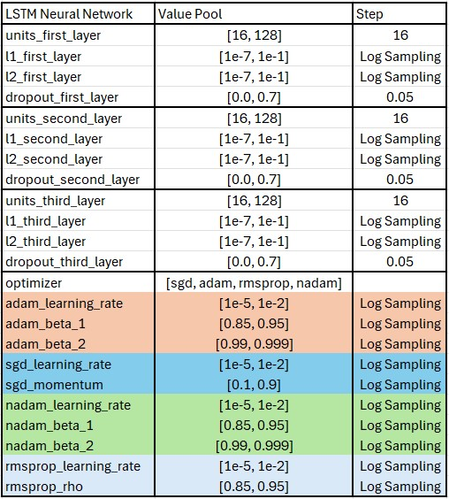

##### Fig 47: Hyperparameter Tuning Ranges for the LSTM Model Tuning

As a result, the final architecture of the best model contained the following hyperparameters:

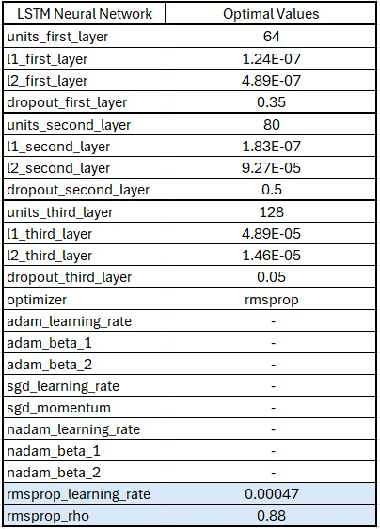

##### Fig 48: Optimal Hyperparameters as a result of the tuning process for the LSTM Network

As can be seen in the above Figure, the optimal architecture output from the training and tuning process of the LSTM Network is listed subsequently:

* **Input Layer:** 
  + Number of Neurons: The **first LSTM layer** consists of 64 neurons.
  + Regularization: L1 and L2 regularization strengths are set at approximately

1.24e-07 and 4.89e-07, respectively.

* + Dropout: A dropout rate of 35% is applied after the first LSTM layer.
* **Second Layer (Hidden):** 
  + Number of Neurons: The **second LSTM layer** is composed of 80 neurons.
  + Regularization: For this layer, both L1 and L2 regularization strengths are finely tuned to approximately 1.83e-07 and 9.27e-05, respectively. o Dropout: A balanced dropout rate of 50% is utilized, balancing the dropout and the flow of information across the network.
* **Third Layer (Hidden):** 
  + Number of Neurons: The **third DENSE layer** contains 128 neurons. o Regularization: The L1 and L2 regularization strengths for this layer are approximately 4.89e-05 and 1.46e-05, respectively. o Dropout: The dropout rate climbs to 5%, in contrast to the previous layers, the dropout here is considerably lower. Suggesting that the information from that layer is mandatory for the subsequent output layer.
  + Activation Function: In this Dense layer the ‘ReLU’ activation function is used.
* **Output Layer:** 
  + The model concludes with a single-neuron output layer utilizing the sigmoid activation function.
* **Optimizer:** 
  + The "rmsprop" optimizer emerged as the best-performing optimizer during the tuning process, with a rho hyperparameter set at 0.88. This rho value, acting as a decay factor, influences the adaptation of the learning rate by controlling the moving average of the squared gradients. The learning rate was optimized to 0.00047.

The results of the training process can be seen in the following table.



##### Fig 49: LSTM Network Training Results

Much like the previous models, the LSTM Network also shows strong performance on the test set, though it records the lowest accuracy among the metrics. However, it compensates with a high recall rate, which is crucial for this particular task.

#### 7.4.7 Overall Results

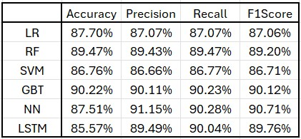

##### Fig 50: All Model Results

In summary, the Gradient Boosted Trees and Neural Network models demonstrate the best performance, with both achieving high scores across accuracy, precision, recall, and F1 metrics on the test set. These results suggest that they have learned to generalize well without overfitting to the training data.

However, the Logistic Regression model reveals some generalization challenges, as indicated by a noticeable performance drop compared to the other models.

Overall, while all models show potential, the Gradient Boosted Trees and Neural Network models stand out for their high performance metrics on the test set, while the rest of the models are not far behind in terms of performance.

# 8. Overall System Functionality

In this section, we delve into the operation of the complete system designed to detect 'Vishing' calls. We will dissect how each component within the system contributes to the identification of potential scam attempts during conversations. Initially, we will examine the system's overall functionality and then proceed to analyze the contribution of each individual component to the workflow of the complete system.

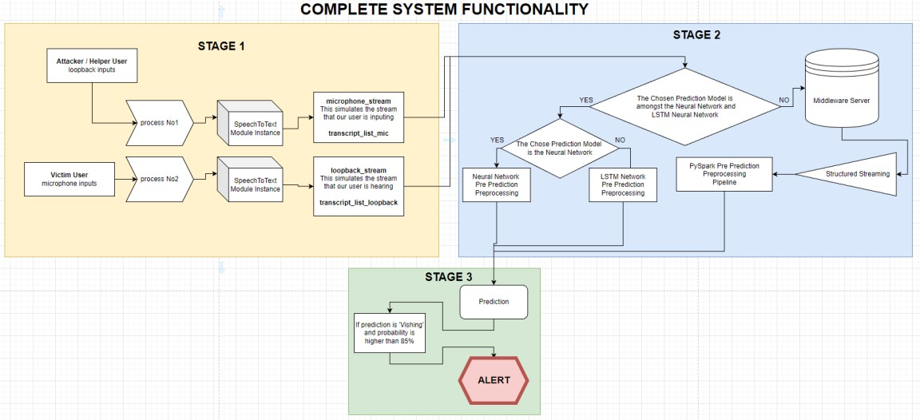

## Fig 51: Complete System Functionality Workflow

The proposed system is structured into three stages, each of which will be elaborated upon in the following sections. The first stage includes the mechanisms for capturing speech inputs and their subsequent conversion into text format, forming the basis of the conversation analysis. The second stage details the preprocessing of these textual inputs, preparing them for real-time prediction by the models. Lastly, the third stage focuses on the model predictions themselves and the specific criteria under which an alert for potential 'Vishing' activity is triggered.

## 8.1 Stage One

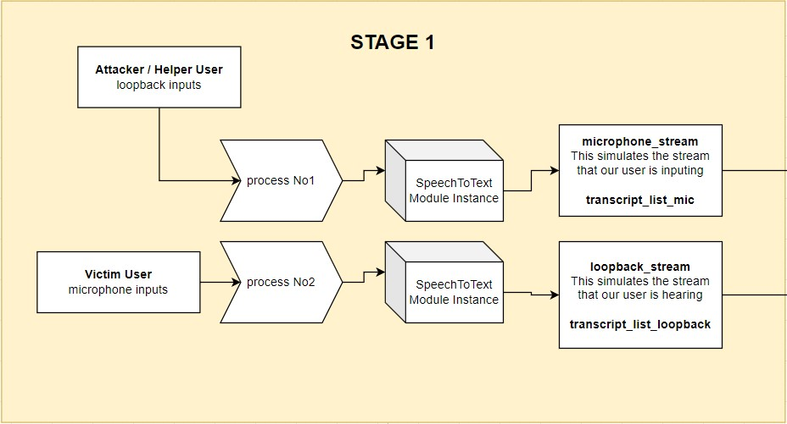

### Fig 52: Stage One of the Complete System Workflow

In the first stage of the system, two processes start at the same time, both using the SpeechTo-Text component described in Chapter 4, which utilizes the Google Api Speech Recognition engine. The first process turns on the Speech To Text feature and starts picking up sounds from the device's microphone. This microphone records what our user of interest is saying. At the same time, the second process starts another Speech To Text feature to record the device's loopback audio which is basically what the user hears on the phone’s speaker. Because of these two processes, we end up with two sets of data: one with words spoken by our user and the other with words spoken by the person on the other end of the call. These two sets of data are collected together as they happen at the same time and are stored in two data queues. These two queues are then passed on to stage two of the system. **8.2 Stage Two**

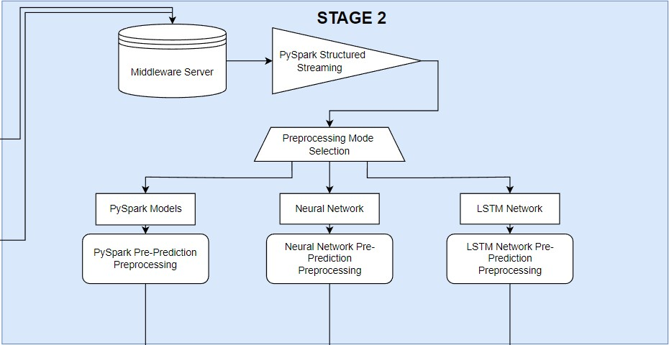

### Fig 53: Stage Two of the Complete System Workflow

Every time either of the two aforementioned data queues receive any piece of new data both data queues pass on to stage two of the complete system workflow. In this stage the data from the queues is sent to the middle-ware server whose job is to convert the data into a dataframe format and send it back to preprocessed depending on which preprocessing mode is selected. In total there are three preprocessing modes which can be outlined in the following points:

* **PySpark Preprocessing:** To support prediction from the PySpark models the data from the queues must pass through the Preprocessing pipeline for Deployment mentioned in chapter 6.3. Firstly, the text data from both queues are transformed into TF-IDF vectors, a numerical statistic that reflects how important a word is to a document in a collection. These two TF-IDF vectors (one for each data queue) are then combined to form one larger vector. This combined vector has twice the length of the individual vectors, totaling 400 elements. Initially, the process required converting these data queues into a DataFrame format for PySpark processing. This conversion was timeconsuming and increased response times. Therefore, to speed up the process, it was decided to send the data from the queues to a middleware server via a socket. This server handles the conversion more efficiently and streams the data back to the main application for faster preprocessing. For this process PySpark’s structured streaming feature was employed which allows for continuous processing of the streaming data. The outcome of this whole preprocessing is a single, 400-length vector which is in Dataframe format ready to be used by the PySpark models.

* **Neural Network Preprocessing:** As mentioned in Chapter 7.3.5, the Neural Network was developed independently of the PySpark framework. To ensure consistency across models, the same preprocessing pipeline designed for the PySpark models was applied to the Neural Network. Contrary to the PySpark models, this approach resulted in significantly longer response times for the Neural Network. While it is possible to reduce these delays by manually implementing the preprocessing steps included within the pipeline, this approach was not adopted in the current study.

* **LSTM Network Preprocessing:** The preprocessing needed for the LSTM Network is effectively the same as that of the Neural Network. However, the LSTM Network necessitates an additional step: the input data must be presented in a transposed format. This means that the data vector, typically a 400-length list as prepared for the Neural Network, is rearranged so that what were originally columns in the data become rows, and vice versa. This transposition aligns with the LSTM's requirement for sequential data input, where each element of the sequence (now a row in the transposed format) is fed into the network one at a time, facilitating the LSTM's ability to process and learn from sequential or time-series data effectively.  **8.3 Stage Three**

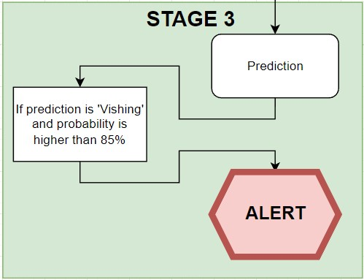

### Fig 54: Stage Three of the Complete System Workflow

In this final stage, the actual prediction by the selected algorithm occurs. The vector generated in the previous stage is inputted into the chosen model, which then provides a prediction along with its associated probability. Additionally, this stage might feature an option in the future to trigger an alert if the prediction is classified as 'Vishing' and the probability surpasses a specific threshold, such as 85%, as illustrated in Figure 54. This alert can vary in form according to the needs of the application, for example, it might be a simple pop up screen. For the PySpark models, the prediction output is presented in a DataFrame format. In contrast, for the Neural Network and LSTM Network models, the output is a simple list format that includes only the probability.

## 8.4 Challenges and Future Enhancements

During the development of our system, we encountered several challenges. One of the primary issues was the extended response time, which we managed to address using PySpark’s structured streaming. However, another significant challenge emerged with the PySpark models, particularly in implementing an alert system. The output from these models is in DataFrame format, which necessitates conversion into a more rapidly processable format for alerting purposes. This conversion adds an additional delay to the system's overall response time and is an area that requires further optimization in future iterations of the system.

Furthermore, a significant challenge encountered during system testing was the accuracy of the speech-to-text transcription. The performance of the Speech To Text module was notably affected by the user's accent, leading to instances where spoken words were inaccurately transcribed into text, which in turn contributed to errors in the system's output.

Additionally, there's the prospect of employing a different framework, such as PyTorch, instead of PySpark. PyTorch provides the flexibility of working with simple lists and arrays, as opposed to DataFrames. While this could potentially streamline the data processing and reduce response times, it's important to note that such a shift might impact the inherent scalability and fault tolerance provided by the Spark framework. Therefore, while considering PyTorch as an alternative, these trade-offs must be carefully weighed to ensure the system maintains its efficiency.

# 9. Experimental Results

Having thoroughly explored the generation and preprocessing of data, the training methodologies of the models, and their performance during training and validation in Chapter 7.4, as well as the comprehensive functioning of the complete system, our focus now shifts to the real-world efficacy of the models. This chapter is dedicated to evaluating the system's performance in live scenarios, specifically analyzing its responsiveness and accuracy across four distinct types of indicative conversations. The ensuing subsections will test the real-time outcomes of each model when confronted with these varied conversational contexts. Our objective is to assess the system's operational competence and to draw insights into its practical applicability, and reliability in dynamic, real-life settings that mimic actual user interactions.

The testing setup involves the use of two distinct speech input devices operating consecutively. The one device is designated to record the dialogue from the potential victim's perspective, while the second captures the words of the attacker or helper, simulating a real life scenario. The test workflow, which is diagrammatically represented in the subsequent figure 48, replicates the system's functionality similarly to Chapter 8. The key distinction in this setup from the one described in Chapter 8 is the use of two audio inputs where both capture audio data in a single computer but in different channels instead of one capturing the microphone data and the other one capturing the loopback data:

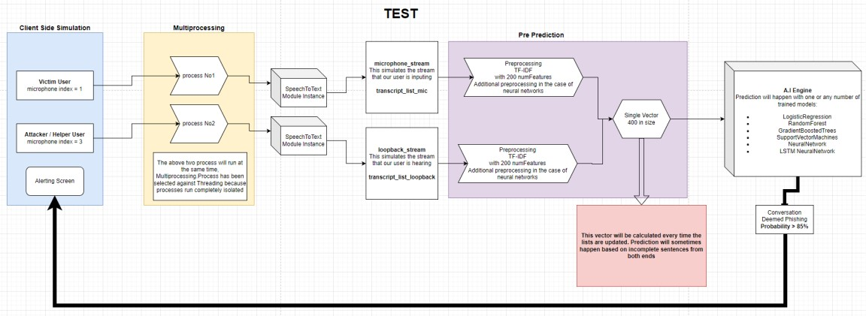

## Fig 55: Testing Workflow

The evaluation of our system's performance is structured around four conversation types as previously mentioned. These conversations are selected to gauge the adaptability and generalization capabilities of the algorithms in use. First, we analyze the system's response to a 'Vishing' conversation, a scenario that mirrors the context and structure the models have been trained on. Second, we assess the system's reaction to an unfamiliar 'Vishing' conversation—one with content and format not previously encountered during training. Moving forward, the third conversation type pertains to 'Non-Vishing' interactions that align closely with the models' training, allowing us to evaluate the system's accuracy in recognizing legitimate communications. The fourth and final conversation type presents a 'Non-Vishing' scenario that is new to the models, testing their ability to comprehend and correctly classify unseen and new formats. Through the examination of these four distinct conversational contexts, we aim to derive an understanding of the models' performance.

In this research, the Support Vector Machines (SVM) algorithm was determined to be unsuitable, because it does not provide probability estimates alongside its output predictions. As highlighted in Chapter 8, the ability to quantify prediction confidence in the form of probabilities is essential for the system's operation. Consequently, the results for the SVM algorithm will not be included in the forthcoming sections.

## 9.1 Model Performance on Familiar 'Vishing' Conversation

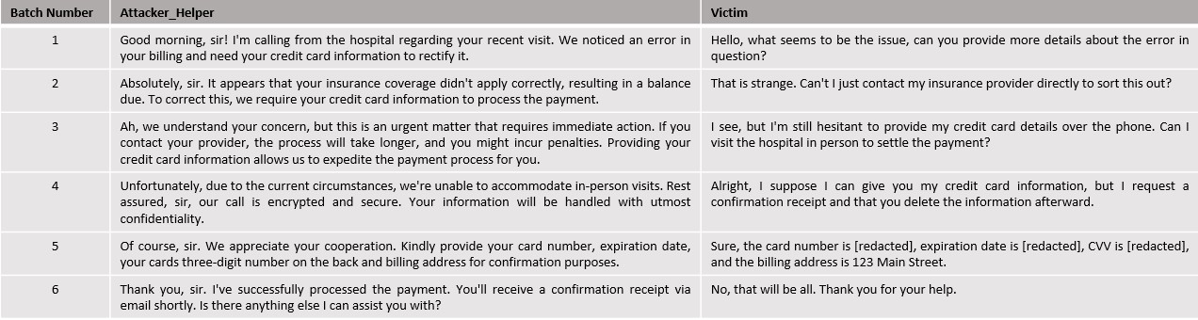

**Fig 56: ‘Vishing' Conversation with Known Formatting**

The context of the conversation depicted in figure 55 falls under the category of a "medical scam". In this scenario, the attacker attempts to deceive the victim by referencing a recent hospital visit, a tactic designed to instill a false sense of security in the victim. While all models in this study have been trained on various medical scam themes, this particular conversation has not been directly included in their training datasets. Our objective is to evaluate whether the models can identify that this conversation falls into the category of ‘Vishing’ sufficiently quick. The critical test in this case is to see if the algorithms can make the classification prior to the fifth batch of the conversation because in that batch the victim succumbs to the attack and provides the requested information to the attackers.

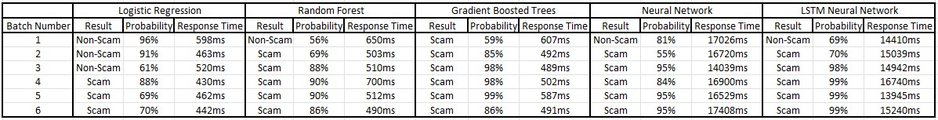

**Fig 57: Model Results on Familiar ‘Vishing’ Conversation**

* For the **Logistic Regression** model, the initial response is a categorization of 'NonScam' with a high probability. It's not until the fourth batch of the conversation that the model starts to indicate the possibility of a scam, and it is only in the fifth batch that it confidently categorizes the conversation as a scam with a high probability of 88%. Thus, the Logistic Regression model does succeed in identifying the conversation as a scam before the critical fifth batch.

* The performance of the **Random Forest** model contrasts with that of the Logistic Regression algorithm. Demonstrating a quicker response, the Random Forest model begins to suspect the 'Vishing' nature of the conversation earlier. By the fourth batch, it has already formed a relatively definitive conclusion, identifying the conversation as a scam with a probability of 90%. Given how quickly the model categorized the conversation correctly, the Random Forest algorithm can be regarded as successful in detecting the scam-like characteristics of the conversation.

* The response of the **Gradient Boosted Trees** model is immediately decisive. From the very first batch of the conversation, it identifies the scenario as a scam with a moderate probability of 59%. By the fourth batch, the probability of the conversation being a scam increases to 98%. This immediate level of confidence suggests that the model has recognized a pattern similar to what it encountered during training. However, this could also indicate potential overfitting, a hypothesis that requires further analysis in the subsequent discussion of model results, where more concrete data can increase our understanding of this matter.

* The **Neural Network** initially classifies the conversation as ‘Normal’ with a probability of 81% but then the model consistently classifies the conversation as a 'Scam' throughout the remainder of the duration of the conversation, increasing its probability from 55% on the second batch to 84% on the fourth batch. Therefore, the model successfully passes the challenge of this conversation which is to identify it correctly prior to the fifth batch of conversation.

* The **LSTM Neural Network** also successfully identifies the potential ‘scam’ nature of the conversation from the second batch, being more confident than the normal Neural Network model. Similarly, to the Gradient Boosted Trees algorithm, this model exhibits very high probabilities indicating that it too has identified a pattern similar to those witnessed in training.

The results of this test highlight the **Random Forest** algorithm as the best performer among all evaluated models. Its effectiveness is marked by a balanced approach, where it maintains neutrality where 'Vishing' characteristics in the conversation are ambiguous. Furthermore, the algorithm demonstrates the ability to discern suspicious elements in the conversation before the critical fifth batch, where the user falls victim to the scam. This quick classification is crucial, as any model that fails to detect the scam before this stage is deemed unsuccessful in this test.

**9.2 Model Performance on Unknown ‘Vishing’ Conversation**

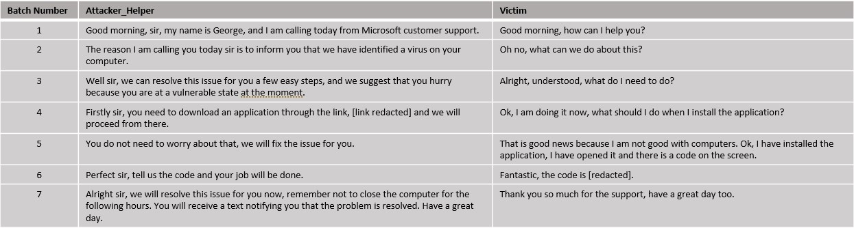

### Fig 58: Vishing conversation with Unknown formatting

The dialogue illustrated in figure 57 represents an example of a "technology scam." In this typical scenario, the scam revolves around deceiving the victim into believing there is a virus on their computer. The attackers then falsely claim they can remedy the issue, provided the victim follows a specific set of instructions they provide. The format and content of this conversation is unknown to the all the models. Our goal is to assess the models' ability to accurately categorize this conversation despite its novelty. Successfully doing so would be a good indicator of the models' capacity for generalization.

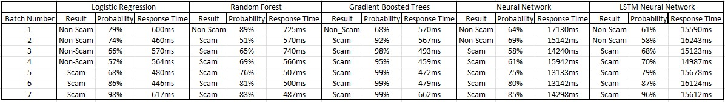

**Fig 59: Model Results on Unknown ‘Vishing’ Conversation**

* Much like in the previous conversation, the **Logistic Regression** model exhibits very good performance. It begins to exhibit signs of suspicion by the fourth batch. The fact that the model starts to identify the conversation as potentially suspicious in the fourth batch suggests that it maintains a balanced approach and it is not overly sensitive to the scam characteristics of the conversation.

* In contrast, the **Random Forest** model exhibits a more distinct level of suspicion. While it initially classifies the conversation as 'Non-Scam', it does so with relatively high confidence, with a probability of 89%. By the sixth batch, the model has formed its final stance, categorizing the conversation as a 'Scam' with a high probability of 81%.

* The **Gradient Boosted Trees** model exhibits very high certainty in correctly identifying the nature of the conversation. It consistently categorizes the conversation as ‘Scam' with its probability fluctuating around 95%.

* The **Neural Network model** initially identifies the conversation as 'Normal. It maintains this assessment until the third batch where it changes its opinion and suggests that the conversation is a possible ‘Scam’ with a probability of 58%. This is a very good performance since the model successfully predicts the conversation as it unfolds.

* Similar to the Neural Network model and the previous conversation example, the **LSTM Network** also successfully classifies the conversation, but with higher probability. This suggests that the LSTM model is more conservative in comparison to the Neural Network model since it is more sensitive to the ‘Scam’ characteristics of the conversation.

As a result, it appears that all models exhibit a desirable behavior with the **Neural Network** and **LSTM Network** showing the most promise. The **Logistic Regression** model also exhibits promising capabilities, as it successfully identifies the true nature of the conversation towards the middle. This indicates a gradual but accurate understanding of the conversation's context, highlighting the model's potential in effectively identifying such scenarios.

**9.3 Model Performance on Familiar ‘Normal’ Conversation**

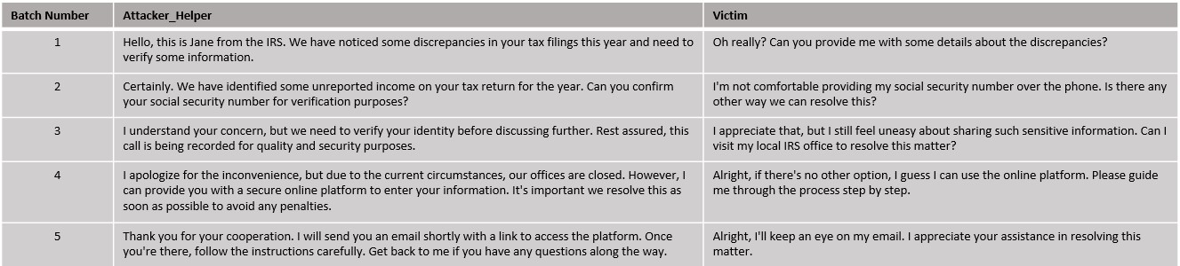

**Fig 60: Normal conversation with Known Formatting.**

The conversation illustrated in Figure 59 presents a scenario depicting an interaction between a person and an IRS officer. This conversation poses a unique challenge due to its ambiguous nature; it could easily be classified incorrectly as a scam. The format and content of this dialogue are familiar to the models since similar conversations have been included in the training data. The objective is to evaluate the models' ability to accurately identify and classify a normal, non-scam conversation.

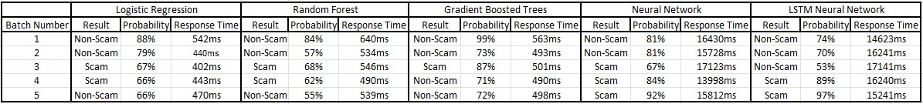

**Fig 61: Model Results on Familiar ‘normal’ Conversation**

* In analysis of the **Logistic Regression** model's performance, it's observed that the model initially classifies the conversation as 'normal' with a very high probability of around 84%. This high level of confidence is maintained up to the third batch of the conversation, after which the probability begins to fluctuate between 67% to 66%. This behavior suggests that while the algorithm initially recognizes a familiar pattern, it starts to exhibit skepticism by the fourth batch. On the fifth batch the model suggests that the conversation is indeed ‘Normal’ with a probability of 66%. Overall, despite these fluctuations, the model demonstrates a good performance in this test.

* The **Random Forest** model, like the Logistic Regression model, initially classifies the conversation as 'normal', starting with a lower probability of 84%. Its confidence plateaus at 57% for the second batch. By the third batch the model begins showing signs of suspicion which are maintained until the fourth batch. Similarly to the Logistic Regression model on the fifth batch it concludes that the conversation is indeed normal, and hence is deemed successful in this test.

* The **Gradient Boosted Trees** model immediately classifies the conversation as ‘normal’ with high probability, again indicating that the algorithm has identified a familiar pattern. This algorithm also exhibits significant suspicion on the third batch much like the other models but its quicker to overturn this suspicion by the fourth batch and solidify that choice in the fifth batch. Since the model successfully identifies the conversation and correctly displays suspicion where it is necessary, its performance is very good.

* Both the **Neural Network** and **LSTM Network** models exhibit similar behavior, classifying the conversation as ‘Vishing’ and maintaining that assessment throughout

the first two batches of conversation in the case of the Neural Network and three in the case of the LSTM Network. The Neural Network model suggests that the conversation is ‘Vishing’ by the third conversation and keeps this assessment throughout the remainder of the conversation while the LSTM Network does so by the fourth batch.

In conclusion, from this test, the **Logistic Regression**, **Random Forest**, and **Gradient Boosted Trees** models all exhibit good performance. Notably, the **Logistic Regression** and **Gradient Boosted Trees** models stand out, showing the most promise in their ability to accurately classify and adapt to the conversation presented.

**9.4 Model Performance on Unknown ‘Normal’ Conversation**

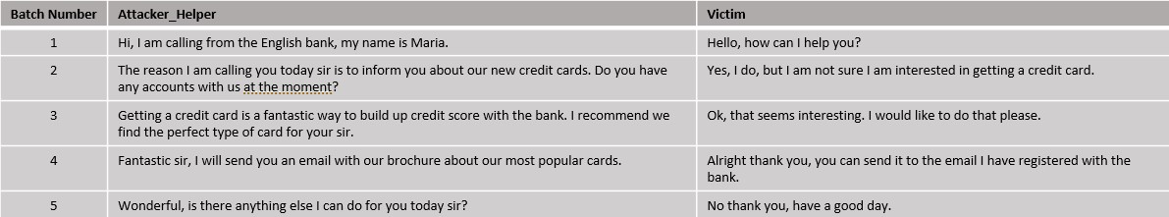

**Fig 62: Normal conversation with Unknown Formatting.**

The conversation depicted in the above Figure illustrates a phone conversation that revolves around the marketing of a bank’s new credit cards. Such a conversation has not been included in the training of the models and hence the challenge it poses is of critical importance. The aim of this test is to evaluate the model’s generalization abilities in a ‘normal’ unknown conversation.

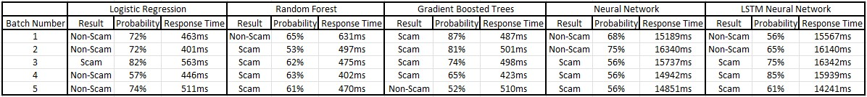

**Fig 63: Model Results on Unknown ‘normal’ Conversation**

* The performance of the **Logistic Regression** model in this scenario is impressive. Initially, the model classifies the conversation as 'normal' with a probability of 72% by the second batch. In the third batch, it alters its prediction to 'vishing', with a probability of 82%, suggesting it detected a feature it deemed suspicious. However, by the fourth batch, it reverts to its original classification of 'normal', again at 57% probability, and further reinforces this classification in the final batch with a heightened probability of 74%. This fluctuation and eventual stabilization in the model's predictions showcase its ability to dynamically assess and correctly categorize the conversation as 'normal', marking a successful performance in this test.

* The **Random Forest** model initially categorizes the conversation as 'normal', yet it does so with a relatively low confidence level, showing a probability of 65%. In the third batch, it changes its prediction to 'Vishing', assigning a probability of 53%. This probability level is approximately maintained for the remainder of the conversation. This pattern of behavior suggests that while the model's initial assessment is correct, it detects something potentially suspicious in the third batch and consequently maintains a state of alertness and suspicion for the duration of the conversation.

* The **Gradient Boosted Trees** model fails to pick up the ‘Normal’ characteristics of the conversation and maintains a suggestion of ‘Vishing’ up until the fourth batch of the conversation where it switches its decision to ‘Normal’ but with a low probability of 52%. This behavior suggests that the model eventually somewhat understands the meaning of the conversation as it progresses but in the context of this test it is considered failed.

* Both the **Neural Network** and **LSTM Network** models exhibit a similar pattern in their response to the conversation. They initially classify the conversation as ‘Normal’ right from the start and maintain this classification up until the second batch. Both models then switch their prediction to ‘Vishing’ with the Neural Network maintaining a probability of around 56% and the LSTM Networks probability ranging from 75% to 61% on the final batch.

As a result of this test, the **Logistic Regression** model emerges as the best performer among the algorithms evaluated, demonstrating a more accurate and consistent classification ability. This suggests that, of the five models tested, the Logistic Regression model possesses the strongest capability for generalization in ‘Normal’ scenarios, effectively adapting to and correctly identifying the conversational context.

## 9.5 Response Time Performance Evaluation

As emphasized in Chapter 8, the response time of the system is crucial for the task at hand. In terms of overall performance, the PySpark models (comprising Logistic Regression, Random Forest, and Gradient Boosted Trees) demonstrate a consistent response time within the full system functionality, averaging at about 500ms. On the other hand, the Neural Network model and the LSTM Network model show a response time of approximately 15 seconds. This discrepancy in response times between the PySpark models and the Neural Network-based models is in line with the expectations and analysis presented in Chapter 8.

## 9.6 Overall Results

In conclusion, the Logistic Regression and Random Forest models demonstrate the most effective performance among the tested algorithms, with Logistic Regression model being the better of the two. These models have successfully learned underlying patterns during training, enabling them to differentiate between 'Vishing' and 'Normal' conversations. Throughout the various conversation tests, they have shown an ability to make reasoned decisions and adapt their responses when necessary. This is observed in instances where a suspicious phrase is mentioned; both models show a shift in their probability predictions, as illustrated in the test example 9.4 for reference.

On the other hand, the Gradient Boosted Trees algorithm tends to perform well on data similar to its training set, often showing high confidence in its decisions. However, this behavior suggests a potential overfitting issue, as evidenced by its less effective performance on unfamiliar and ambiguous conversations.

The Neural Network and LSTM models also show great performance throughout but tend to label conversations as 'Vishing' more often than 'Normal', a behavior especially noticeable in the Neural Network model compared to the LSTM.

Overall, the Logistic Regression and Random Forest models demonstrate promising results, whereas the other models face challenges in accurately classifying conversations. This outcome aligns with expectations, given the relatively small size of the training dataset compared to what is typically required for such tasks. Nevertheless, the results are encouraging: the aforementioned models successfully identified 'Scam-like' characteristics in conversations that were new to them, indicating a good ability to generalize effectively despite the limited data and diversity of those data encountered during training.

# 10. Deductions, Limitations and Future Research

This dissertation aimed to explore the viability of a real-time voice phishing (vishing) detection system utilizing machine learning technologies. We delved into various components such as PySpark and the Speech-To-Text module, the creation and preprocessing of the dataset manufactured for this task, and the selection, functionality, training, and tuning of the models. As a result of the training process the Logistic Regression and Random Forest models stood out for their optimal performance in addressing our problem.

In the last chapters of this study, we demonstrated how these components and models integrate into a unified system, showcasing its real-time performance across four distinct conversational scenarios. Notably, the Logistic Regression and Random Forest models showed promising results, being able to adequately detect both ‘Vishing’ and ‘Normal’ conversations with the system's response times averaging around 500ms.

The research yielded encouraging outcomes, particularly with the strong real-time testing performance of the Logistic Regression and Random Forest models, showing that further exploration in this domain can result in the solution of the problem at hand which is identifying ‘Vishing’ conversations quickly.

However, the study faced challenges, notably the limited diversity in the training dataset created via the Chat GPT API, leading to a reduced generalization ability in the models. Additionally, the dataset's size was smaller than ideal for such a complex task, complicating the models' training and generalization. Despite implementing several techniques to mitigate overfitting and enhance generalization, these issues persisted in some models.

Future efforts should focus on developing a robust and diverse dataset. This dataset should include a wide range of everyday conversations and sophisticated scam dialogues, enabling the models to detect and counter advanced fraudulent tactics but understand at the same time when a conversation is completely normal.

This research paves the way for advancements in user protection against phone-based scams, a critical issue in today's technology-driven society. The development of an effective, sustainable system capable of real-time vishing detection could significantly enhance telephonic security.

Reflecting on this journey, the potential of machine learning in combating vishing is evident, yet the path consists of challenges as mentioned previously. The promising results from the Logistic Regression and Random Forest models underscore the feasibility of the task yet highlight the necessity for continued innovation and refinement. This dissertation adds valuable insights to the conversation about cybersecurity and highlights how important it is to keep people safe as we rely more on digital technology. Looking ahead, it's crucial to work on making our data more varied and our models more reliable. Doing so will help us fully unlock the possibilities of detecting vishing in real-time, leading to safer ways of communicating.

# Bibliography

1. “Inside the intricate world of voice phishing” [Online]. Available: [https://koreajoongangdaily.joins.com/2019/02/01/socialAffairs/Inside-the-intricate-worldof-voice-phishing/3059014.html](https://koreajoongangdaily.joins.com/2019/02/01/socialAffairs/Inside-the-intricate-world-of-voice-phishing/3059014.html)
2. “Voice Phishing” [Online]. Available: <https://en.wikipedia.org/wiki/Voice_phishing>
3. “What Is a Vishing Attack?” [Online]. Available: <https://www.fortinet.com/resources/cyberglossary/vishing-attack>
4. “What is Vishing?” [Online]. Available: <https://softwarelab.org/blog/what-is-vishing/>
5. “What is Dumpster Diving?” [Online]. Available: <https://www.techtarget.com/searchsecurity/definition/dumpster-diving>
6. Song, J., Kim, H., & Gkelias, A. (2014). iVisher: Real‐Time Detection of Caller ID Spoofing. *ETRI Journal*, *36*(5), 865-875.
7. Norris, G., & Brookes, A. (2021). Personality, emotion and individual differences in response to online fraud. *Personality and Individual Differences*, *169*, 109847.
8. Jones, K. S., Armstrong, M. E., Tornblad, M. K., & Siami Namin, A. (2021). How social engineers use persuasion principles during vishing attacks. *Information & Computer Security*, *29*(2), 314-331.
9. “What is a Vishing Attack | Examples & Preventions.” [Online]. Available: <https://www.imperva.com/learn/application-security/vishing-attack/>
10. Xing, J., Yu, M., Wang, S., Zhang, Y., & Ding, Y. (2020). Automated fraudulent phone call recognition through deep learning. *Wireless Communications and Mobile Computing*, *2020*, 1-9.
11. Lee, M., & Park, E. (2023). Real-time Korean voice phishing detection based on machine learning approaches. *Journal of Ambient Intelligence and Humanized Computing*, *14*(7), 8173-8184.
12. Tran, M. H., Hoai, T. H. L., & Choo, H. (2020). A third-party intelligent system for preventing call phishing and message scams. In *Future Data and Security Engineering. Big Data, Security and Privacy, Smart City and Industry 4.0 Applications: 7th International Conference, FDSE 2020, Quy Nhon, Vietnam, November 25–27, 2020, Proceedings 7* (pp. 486492). Springer Singapore.
13. Salloum, S., Dautov, R., Chen, X., Peng, P. X., & Huang, J. Z. (2016). Big data analytics on Apache Spark. *International Journal of Data Science and Analytics*, *1*, 145-164.
14. Assefi, M., Behravesh, E., Liu, G., & Tafti, A. P. (2017, December). Big data machine learning using apache spark MLlib. In *2017 ieee international conference on big data (big data)* (pp. 3492-3498). IEEE.
15. Armbrust, M., Xin, R. S., Lian, C., Huai, Y., Liu, D., Bradley, J. K., ... & Zaharia, M. (2015, May). Spark sql: Relational data processing in spark. In *Proceedings of the 2015 ACM SIGMOD international conference on management of data* (pp. 1383-1394).
16. “The Spark Cluster architecture for resource allocation and data transfer.” [Online]. Available: [https://www.researchgate.net/figure/The-Spark-cluster-architecture-forresource-allocation-and-data-transfer_fig3_337305063](https://www.researchgate.net/figure/The-Spark-cluster-architecture-for-resource-allocation-and-data-transfer_fig3_337305063)
17. “Apache Spark Components.” [Online]. Available:

<https://intellipaat.com/blog/tutorial/spark-tutorial/apache-spark-components/>

1. “Key features of Spark’s MLlib.” [Online]. Available: [https://www.researchgate.net/figure/Key-features-of-Sparks-MLlib-asparkmllib-is-built-ontop-of-RDDs-bsparkml-is-built_fig6_309138349](https://www.researchgate.net/figure/Key-features-of-Sparks-MLlib-asparkmllib-is-built-on-top-of-RDDs-bsparkml-is-built_fig6_309138349)
2. Meng, X., Bradley, J., Yavuz, B., Sparks, E., Venkataraman, S., Liu, D., ... & Talwalkar, A. (2016). Mllib: Machine learning in apache spark. *The journal of machine learning research*, *17*(1), 1235-1241.
3. “Optimization – RDD - based API.” [Online]. Available: <https://spark.apache.org/docs/latest/mllib-optimization.html>
4. “Broyden-Fletcher-Goldfarb-Shanno algorithm.” [Online]. Available:

[https://en.wikipedia.org/wiki/Broyden%E2%80%93Fletcher%E2%80%93Goldfarb%E2%80%9 3Shanno_algorithm](https://en.wikipedia.org/wiki/Broyden%E2%80%93Fletcher%E2%80%93Goldfarb%E2%80%93Shanno_algorithm)

1. “Spark Machine Learning Pipelines.” [Online]. Available: <https://spark.apache.org/docs/latest/ml-pipeline.html>
2. “Spark Machine Learning Pipeline for regression.” [Online]. Available: <https://gbhat.com/spark/spark_ml_regression_pipeline.html>
3. “Spark Streaming Guide.” [Online]. Available: <https://spark.apache.org/docs/latest/streaming-programming-guide.html>
4. “What is Speech to Text?” [Online]. Available: [https://aws.amazon.com/whatis/speech-to-text/](https://aws.amazon.com/what-is/speech-to-text/)
5. Trivedi, A., Pant, N., Shah, P., Sonik, S., & Agrawal, S. (2018). Speech to text and text to speech recognition systems-Areview. *IOSR J. Comput. Eng*, *20*(2), 36-43.
6. “Speech-to-Text: Automatic Speech Recognition.” [Online]. Available: <https://cloud.google.com/speech-to-text/?hl=en#all-features>
7. “Generative pre-trained transformer.” [Online]. Available: <https://en.wikipedia.org/wiki/Generative_pre-trained_transformer>
8. “Transformer” [Online]. Available: <https://en.wikipedia.org/wiki/Transformer_(machine_learning_model)>
9. “What is a Transformer?” [Online]. Available: [https://medium.com/inside-machinelearning/what-is-a-transformer-d07dd1fbec04](https://medium.com/inside-machine-learning/what-is-a-transformer-d07dd1fbec04)
10. “Prompt Engineering” [Online]. Available: <https://en.wikipedia.org/wiki/Prompt_engineering>
11. “Master the Perfect ChatGPT Prompt Formula” [Online]. Available:

[Campaign_GRE_Tell2_Instream (youtube.com)](https://www.youtube.com/watch?v=jC4v5AS4RIM)

1. “What is Tokenization?” [Online]. Available: [What is Tokenization? Types, Use Cases, Implementation | DataCamp](https://www.datacamp.com/blog/what-is-tokenization)
2. “Tokenization in Natural Language Processing” [Online]. Available: [Tokenization in Natural Language Processing | by Mohammad Derakhshan | Medium](https://medium.com/@m.derakhshan/tokenization-in-natural-language-processing-86e4e235a2aa)
3. Perkins, J. (2010). *Python text processing with NLTK 2.0 cookbook*. PACKT publishing.
4. “NLTK Documentation” [Online]. Available: <https://www.nltk.org/api/nltk.tokenize.word_tokenize.html>
5. “Introduction to Stemming” [Online]. Available: <https://www.geeksforgeeks.org/introduction-to-stemming/>
6. “All you need to know about text preprocessing for NLP and Machine Learning” [Online]. Available: [https://www.kdnuggets.com/2019/04/text-preprocessing-nlp-machinelearning.html](https://www.kdnuggets.com/2019/04/text-preprocessing-nlp-machine-learning.html)
7. “Stemming” [Online]. Available: <https://en.wikipedia.org/wiki/Stemming>
8. “Flatten PySpark function” [Online]. Available: [https://spark.apache.org/docs/latest/api/python/reference/pyspark.sql/api/pyspark.sql.fun ctions.flatten.html](https://spark.apache.org/docs/latest/api/python/reference/pyspark.sql/api/pyspark.sql.functions.flatten.html)
9. “Tf-Idf” [Online]. Available: <https://en.wikipedia.org/wiki/Tf%E2%80%93idf>[42] “Feature Hashing” [Online]. Available: <https://en.wikipedia.org/wiki/Feature_hashing>
10. “Machine Learning” [Online]. Available: <https://en.wikipedia.org/wiki/Machine_learning>
11. Hastie, T., Tibshirani, R., Friedman, J., Hastie, T., Tibshirani, R., & Friedman, J. (2009). Overview of supervised learning. *The elements of statistical learning: Data mining, inference, and prediction*, 9-41.
12. “Supervised Learning” [Online]. Available: <https://en.wikipedia.org/wiki/Supervised_learning>
13. “Unsupervised Learning” [Online]. Available: <https://en.wikipedia.org/wiki/Unsupervised_learning>
14. James, G., Witten, D., Hastie, T., Tibshirani, R., & Taylor, J. (2023). Unsupervised learning. In *An Introduction to Statistical Learning: with Applications in Python* (pp. 503-556). Cham: Springer International Publishing.
15. Mnih, V., Kavukcuoglu, K., Silver, D., Rusu, A. A., Veness, J., Bellemare, M. G., ... & Hassabis, D. (2015). Human-level control through deep reinforcement learning. *nature*, *518*(7540), 529-533.
16. Ying, X. (2019, February). An overview of overfitting and its solutions. In *Journal of physics: Conference series* (Vol. 1168, p. 022022). IOP Publishing.
17. “Underfitting and Overfitting in machine learning and how to deal with it.” [Online]. Available: [https://towardsdatascience.com/underfitting-and-overfitting-in-machinelearning-and-how-to-deal-with-it-6fe4a8a49dbf](https://towardsdatascience.com/underfitting-and-overfitting-in-machine-learning-and-how-to-deal-with-it-6fe4a8a49dbf)
18. Shorten, C., Khoshgoftaar, T. M., & Furht, B. (2021). Text data augmentation for deep learning. *Journal of big Data*, *8*, 1-34.
19. “Data augmentation” [Online]. Available: <https://en.wikipedia.org/wiki/Data_augmentation>
20. “Regularization in Machine Learning” [Online]. Available: <https://www.geeksforgeeks.org/regularization-in-machine-learning/>
21. “Cross-validation (statistics)” [Online]. Available: [https://en.wikipedia.org/wiki/Crossvalidation_(statistics)](https://en.wikipedia.org/wiki/Cross-validation_(statistics))
22. “Binary Classification” [Online]. Available: <https://en.wikipedia.org/wiki/Binary_classification>
23. “Logistic Regression in Machine Learning” [Online]. Available: <https://www.geeksforgeeks.org/understanding-logistic-regression/>
24. “Logistic Regression” [Online]. Available: <https://en.wikipedia.org/wiki/Logistic_regression>
25. “Support Vector Machine (SVM) Algorithm” [Online]. Available: <https://www.geeksforgeeks.org/support-vector-machine-algorithm/>
26. “Support Vector Machine” [Online]. Available: <https://en.wikipedia.org/wiki/Support_vector_machine>
27. “Support Vector Machine-Based EMG Signal Classification Techniques: A Review” [Online]. Available: <https://www.mdpi.com/2076-3417/9/20/4402>
28. “Support Vector Machines (SVM)” [Online]. Available: <https://learnopencv.com/support-vector-machines-svm/>
29. De Ville, B. (2013). Decision trees. *Wiley Interdisciplinary Reviews: Computational Statistics*, *5*(6), 448-455.
30. “Decision Tree” [Online]. Available: <https://en.wikipedia.org/wiki/Decision_tree>
31. “What is a Decision Tree?” [Online]. Available: <https://www.geeksforgeeks.org/decision-tree/>[65] “Random Forest” [Online]. Available: <https://en.wikipedia.org/wiki/Random_forest>
32. “Bootstrap aggregating” [Online]. Available:

<https://en.wikipedia.org/wiki/Bootstrap_aggregating>

1. “Gradient boosting” [Online]. Available: <https://en.wikipedia.org/wiki/Gradient_boosting#Gradient_tree_boosting>
2. “Gradient Boosting in Machine Learning” [Online]. Available: <https://www.geeksforgeeks.org/ml-gradient-boosting/>
3. “The Evolution and Core Concepts of Deep Learning and Neural Networks” [Online]. Available: [https://www.analyticsvidhya.com/blog/2016/08/evolution-core-concepts-deeplearning-neural-networks/](https://www.analyticsvidhya.com/blog/2016/08/evolution-core-concepts-deep-learning-neural-networks/)
4. “What is a neural network?” [Online]. Available: <https://www.geeksforgeeks.org/neural-networks-a-beginners-guide/>
5. “Activation functions in Neural Networks” [Online]. Available: <https://www.geeksforgeeks.org/activation-functions-neural-networks/>
6. “Softmax function” [Online]. Available: [https://www.geeksforgeeks.org/activationfunctions-neural-networks/](https://www.geeksforgeeks.org/activation-functions-neural-networks/)
7. “A Gentle Introduction to Dropout for Regularizing Deep Neural Networks” [Online]. Available: [https://machinelearningmastery.com/dropout-for-regularizing-deep-neuralnetworks/](https://machinelearningmastery.com/dropout-for-regularizing-deep-neural-networks/)
8. “Gradient Descent Algorithm in Machine Learning” [Online]. Available: <https://www.geeksforgeeks.org/gradient-descent-algorithm-and-its-variants/>
9. “Backpropagation in Data Mining” [Online]. Available: <https://www.geeksforgeeks.org/backpropagation-in-data-mining/>
10. “Long short-term memory” [Online]. Available: <https://en.wikipedia.org/wiki/Long_short-term_memory>
11. “Understanding of LSTM Networks” [Online]. Available: <https://www.geeksforgeeks.org/understanding-of-lstm-networks/>
12. “Understanding LSTMs” [Online]. Available: [https://kushalj001.github.io/black-boxml/lstm/pytorch/gates/vanishing%20gradient/2019/12/28/Understanding-LSTMs.html](https://kushalj001.github.io/black-box-ml/lstm/pytorch/gates/vanishing%20gradient/2019/12/28/Understanding-LSTMs.html)
13. “Introduction to the Keras Tuner” [Online]. Available: <https://www.tensorflow.org/tutorials/keras/keras_tuner>
14. “Hyperband Tuner” [Online]. Available: <https://keras.io/api/keras_tuner/tuners/hyperband/>
15. Kingma, D. P., & Ba, J. (2014). Adam: A method for stochastic optimization. *arXiv preprint arXiv:1412.6980*.
16. “Intuition of Adam Optimizer” [Online]. Available: <https://www.geeksforgeeks.org/intuition-of-adam-optimizer/>
17. “Stochastic Gradient Descent (SGD)” [Online]. Available: <https://www.geeksforgeeks.org/ml-stochastic-gradient-descent-sgd/>
18. “Tuning Your Keras SGD Neural Network Optimizer” [Online]. Available: [https://kyle-rkieser.medium.com/tuning-your-keras-sgd-neural-network-optimizer-768536c7ef0](https://kyle-r-kieser.medium.com/tuning-your-keras-sgd-neural-network-optimizer-768536c7ef0)
19. “Gradient Descent With RMSProp from Scratch” [Online]. Available: <https://www.geeksforgeeks.org/gradient-descent-with-rmsprop-from-scratch/>
20. “Gradient Descent Optimization With Nadam From Scratch” [Online]. Available: [https://machinelearningmastery.com/gradient-descent-optimization-with-nadam-fromscratch/](https://machinelearningmastery.com/gradient-descent-optimization-with-nadam-from-scratch/)